CHAPTER I AMPLITUDE MODULATION
  - PREREQUISTING ABOUT MODULATION:
In this chapter we discussed about Modulation is the process of varying one or more properties of a periodic waveform, called the carrier signal (high frequency signal), with a modulating signal that typically contains information to be transmitted.

Need for modulation:
- Antenna Height
- Narrow Banding
- Poor radiation and penetration
- Diffraction angle
- Multiplexing.
- Functions of the Carrier Wave:
The main function of the carrier wave is to carry the audio or video signal from the transmitter to the receiver. The wave that is resulted due to superimposition of audio signal and carrier wave is called the modulated wave.
- Types of modulation:
The sinusoidal carrier wave can be given by the equation, v_{c} = V_{c} Sin(w_{c}t + θ) = V_{c} Sin(2f_{c}t + θ)
V_{c} – Maximum Value
f_{c} – Frequency
θ – Phase Relation
Since the three variables are the amplitude, frequency, and phase angle, the modulation can be done by varying any one of them. Thus there are three modulation types namely:

Amplitude Modulation (AM)
  - Frequency Modulation (FM)

Phase Modulation (PM)
  - We have introduced linear modulation. In particular,
    - DSB-SC, Double sideband suppressed carrier
    - DSB-LC, Double sideband large carrier (AM)

    - SSB, Single sideband
    - VSB, Vestigial sideband

CONTENT:
      - AMPLITUDE MODULATION

AM TRANSMITTER
      - SSB - SC

VSB - SC
      - DSB - SC

HILBERT TRANSFORM

      - SUPER HETERODYNE RECEIVER
- COMPARISION OF VARIOUS AM TECHNIQUES
  - AMPLITUDE MODULATION:
"Modulation is the process of superimposing a low frequency signal on a high frequency carrier signal."
OR
"The process of modulation can be defined as varying the RF carrier wave in accordance with the intelligence or information in a low frequency signal."
OR
"Modulation is defined as the precess by which some characteristics, usually amplitude, frequency or phase, of a carrier is varied in accordance with instantaneous value of some other voltage, called the modulating voltage."
    - Need For Modulation

- If two musical programs were played at the same time within distance, it would be difficult for anyone to listen to one source and not hear the second source. Since all musical sounds have approximately the same frequency range, form about 50 Hz to 10KHz. If a desired program is shifted up to a band of frequencies between 100KHz and 110KHz, and the second program shifted up to the band between 120KHz and 130KHz, Then both programs gave still 10KHz bandwidth and the listener can (by band selection) retrieve the program of his own choice. The receiver would down shift only the selected band of frequencies to a suitable range of 50Hz to 10KHz.
- A second more technical reason to shift the message signal to a higher frequency is related to antenna size. It is to be noted that the antenna size is inversely proportional to the

frequency to be radiated. This is 75 meters at 1 MHz but at 15KHz it has increased to 5000 meters (or just over 16,000 feet) a vertical antenna of this size is impossible.
- The third reason for modulating a high frequency carrier is that RF (radio frequency) energy will travel a great distance than the same amount of energy transmitted as sound power.

Types of Modulation
The carrier signal is a sine wave at the carrier frequency. Below equation shows that the sine wave has three characteristics that can be altered.
Instantaneous voltage (E) =E_{c(max)}Sin(2πf_{c}t + θ)
The term that may be varied are the carrier voltage Ec, the carrier frequency fc, and the carrier
phase angle θ. So three forms of modulations are possible.
- AmplitudeModulation
Amplitude modulation is an increase or decrease of the carrier voltage (Ec), will all other factors remaining constant.
- FrequencyModulation
Frequency modulation is a change in the carrier frequency (fc) with all other factors remaining constant.
- PhaseModulation
Phase modulation is a change in the carrier phase angle (θ). The phase angle cannot change without also affecting a change in frequency. Therefore, phase modulation is in reality a second form of frequency modulation.
- EXPLAINATION OF AM:
The method of varying amplitude of a high frequency carrier wave in accordance with the
information to be transmitted, keeping the frequency and phase of the carrier wave unchanged is called Amplitude Modulation. The information is considered as the modulating signal and it is superimposed on the carrier wave by applying both of them to the modulator. The detailed diagram showing the amplitude modulation process is given below.

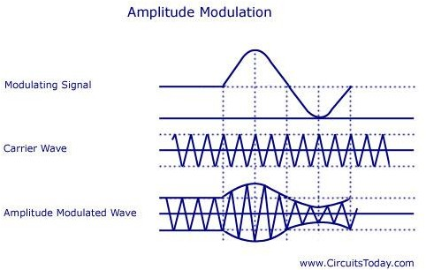

V_{c} – Peak value of the carrier

FIG 1.1 Amplitude Modulation

As shown above, the carrier wave has positive and negative half cycles. Both these cycles are varied according to the information to be sent. The carrier then consists of sine waves whose amplitudes follow the amplitude variations of the modulating wave. The carrier is kept in an envelope formed by the modulating wave. From the figure, you can also see that the amplitude variation of the high frequency carrier is at the signal frequency and the frequency of the carrier wave is the same as the frequency of the resulting wave.
- Analysis of Amplitude Modulation Carrier Wave:
Let v_{c} = V_{c} Sin w_{c}t v_{m} = V_{m} Sin w_{m}t
v_{c} – Instantaneous value of the carrier
W_{c} – Angular velocity of the carrier
v_{m} – Instantaneous value of the modulating signal V_{m} – Maximum value of the modulating signal w_{m} – Angular velocity of the modulating signal f_{m} – Modulating signal frequency
It must be noted that the phase angle remains constant in this process. Thus it can be ignored.
The amplitude of the carrier wave varies at f_{m}.The amplitude modulated wave is given by the equation A = V_{c} + v_{m} = V_{c} + V_{m} Sin w_{m}t = V_{c} [1+ (V_{m}/V_{c} Sin w_{m}t)]
= V_{c} (1 + mSin w_{m}t)

12

m – Modulation Index. The ratio of V_{m}/V_{c}.
Instantaneous value of amplitude modulated wave is given by the equation v = A Sin w_{c}t = Vc (1 + m Sin w_{m}t) Sin wct
= V_{c} Sin w_{c}t + mVc (Sin w_{m}t Sin w_{c}t)
v = V_{c} Sin wct + [mV_{c}/2 Cos (wc-wm)t – mVc/2 Cos (wc + wm)t]
The above equation represents the sum of three sine waves. One with amplitude of Vc and a frequency of w_{c}/2 , the second one with an amplitude of mV_{c}/2 and frequency of (w_{c} – w_{m})/2 and the third one with an amplitude of mV_{c}/2 and a frequency of (w_{c} + w_{m})/2 .
In practice the angular velocity of the carrier is known to be greater than the angular velocity of the modulating signal (w_{c} >> w_{m}). Thus, the second and third cosine equations are more close to
the carrier frequency. The equation is represented graphically as shown below.
- Frequency Spectrum of AM Wave:
Lower side frequency – (w_{c} – w_{m})/2 Upper side frequency – (w_{c} +w_{m})/2
The frequency components present in the AM wave are represented by vertical lines approximately located along the frequency axis. The height of each vertical line is drawn in proportion to its amplitude. Since the angular velocity of the carrier is greater than the angular velocity of the modulating signal, the amplitude of side band frequencies can never exceed half of the carrier amplitude.
Thus there will not be any change in the original frequency, but the side band frequencies (w_{c} – w_{m})/2 and (w_{c} +w_{m})/2 will be changed. The former is called the upper side band (USB) frequency and the later is known as lower side band (LSB) frequency.
Since the signal frequency w_{m}/2 is present in the side bands, it is clear that the carrier voltage

component does not transmit any information.
Two side banded frequencies will be produced when a carrier is amplitude modulated by a single frequency. That is, an AM wave has a band width from (w_{c} – w_{m})/2 to (w_{c} +w_{m})/2 , that is, 2w_{m}/2 or twice the signal frequency is produced. When a modulating signal has more than one frequency, two side band frequencies are produced by every frequency. Similarly for two frequencies of the modulating signal 2 LSB‘s and 2 USB‘s frequencies will be produced.
The side bands of frequencies present above the carrier frequency will be same as the ones present below. The side band frequencies present above the carrier frequency is known to be the upper side band and all those below the carrier frequency belong to the lower side band. The USB
frequencies represent the some of the individual modulating frequencies and the LSB frequencies
represent the difference between the modulating frequency and the carrier frequency. The total bandwidth is represented in terms of the higher modulating frequency and is equal to twice this frequency.

Modulation Index (m):
The ratio between the amplitude change of carrier wave to the amplitude of the normal carrier wave is called modulation index. It is represented by the letter ‗m‘.
It can also be defined as the range in which the amplitude of the carrier wave is varied by the modulating signal. m = V_{m}/V_{c.}
Percentage modulation, %m = m*100 = V_{m}/V_{c} * 100 The percentage modulation lies between 0 and 80%.
Another way of expressing the modulation index is in terms of the maximum and minimum values of the amplitude of the modulated carrier wave. This is shown in the figure below.

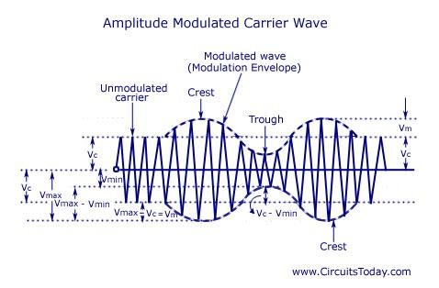
FIG 1.2 Amplitude Modulation Carrier Wave 2 Vin = Vmax – Vmin
V_{in} = (V_{max} – V_{min})/2
Vc = Vmax – Vin
= V_{max} – (V_{max}-V_{min})/2
=(V_{max} + V_{min})/2
Substituting the values of Vm and Vc in the equation m = Vm/Vc , we get
M = Vmax – Vmin/Vmax + Vmin

As told earlier, the value of ‗m‘ lies between 0 and 0.8. The value of m determines the strength and the quality of the transmitted signal. In an AM wave, the signal is contained in the variations of the carrier amplitude. The audio signal transmitted will be weak if the carrier wave is only modulated to a very small degree. But if the value of m exceeds unity, the transmitter output produces erroneous distortion.

Power Relations in an AM wave:
A modulated wave has more power than had by the carrier wave before modulating. The total power components in amplitude modulation can be written as:
Ptotal = Pcarrier + PLSB + PUSB Considering additional resistance like antenna resistance R.
P_{carrier} = [(V_{c}/√2)/R]² = V²_{C}/2R
Each side band has a value of m/2 V_{c} and r.m.s value of mV_{c}/2√2. Hence power in LSB and USB can be written as
P_{LSB} = P_{USB} = (mV_{c}/2√2)²/R = m²/4*V²C/2R = m₂/4 P_{carrier}
Ptotal = V2
_{C}/2R + [m /4*V C/2R] + [m /4*V C/2R] = V /2R (1 + m /2) = P_{carrier} (1 + m /2)
2 2
2 2
2
C
2
2
In some applications, the carrier is simultaneously modulated by several sinusoidal modulating signals. In such a case, the total modulation index is given as
Mt = √(m1² + m2² + m3² + m4² + …..
If Ic and It are the r.m.s values of unmodulated current and total modulated current and R is the resistance through which these current flow, then
P_{total}/P_{carrier} = (It.R/Ic.R)² = (It/Ic)² Ptotal/Pcarrier = (1 + m2/2)
It/Ic = 1 + m²/2

Limitations of Amplitude Modulation:

- Low Efficiency- Since the useful power that lies in the small bands is quite small, so the efficiency of AM system is low.
- Limited Operating Range – The range of operation is small due to low efficiency. Thus, transmission of signals is difficult.
- Noise in Reception – As the radio receiver finds it difficult to distinguish between the amplitude variations that represent noise and those with the signals, heavy noise is prone to occur in its reception.

- Poor Audio Quality – To obtain high fidelity reception, all audio frequencies till 15 KiloHertz must be reproduced and this necessitates the bandwidth of 10 KiloHertz to minimise the interference from the adjacent broadcasting stations. Therefore in AM broadcasting stations audio quality is known to be poor.

AM TRANSMITTERS:
Transmitters that transmit AM signals are known as AM transmitters. These transmitters are used in medium wave (MW) and short wave (SW) frequency bands for AM broadcast. The MW band has frequencies between 550 KHz and 1650 KHz, and the SW band has frequencies ranging from 3 MHz to 30 MHz. The two types of AM transmitters that are used based on their transmitting powers are:
- High Level
- Low Level
High level transmitters use high level modulation, and low level transmitters use low level modulation. The choice between the two modulation schemes depends on the transmitting power of the AM transmitter. In broadcast transmitters, where the transmitting power may be of the order of kilowatts, high level modulation is employed. In low power transmitters, where only a few watts of transmitting power are required , low level modulation is used.
High-Level and Low-Level Transmitters Below figure's show the block diagram of high-level and low-level transmitters. The basic difference between the two transmitters is the power amplification of the carrier and modulating signals
Figure (a) shows the block diagram of high-level AM transmitter.

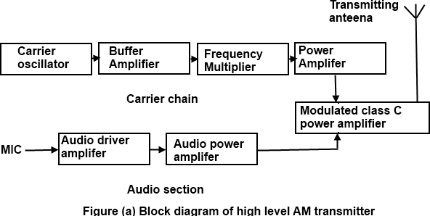

Figure (a) is drawn for audio transmission. In high-level transmission, the powers of the carrier and modulating signals are amplified before applying them to the modulator stage, as shown in figure (a). In low-level modulation, the powers of the two input signals of the modulator stage are not amplified. The required transmitting power is obtained from the last stage of the transmitter, the class C power amplifier.
The various sections of the figure (a) are:
    - Carrier oscillator
    - Buffer amplifier
    - Frequency multiplier
    - Power amplifier
- Audio chain
- Modulated class C power amplifier
- Carrier oscillator
The carrier oscillator generates the carrier signal, which lies in the RF range. The frequency of the carrier is always very high. Because it is very difficult to generate high frequencies with good frequency stability, the carrier oscillator generates a sub multiple with the required carrier frequency. This sub multiple frequency is multiplied by the frequency multiplier stage to get the required carrier frequency. Further, a crystal oscillator can be used in this stage to generate a low frequency carrier with the best frequency stability. The frequency multiplier stage then increases the frequency of the carrier to its requirements.
- Buffer Amplifier
The purpose of the buffer amplifier is twofold. It first matches the output impedance of the carrier oscillator with the input impedance of the frequency multiplier, the next stage of the carrier
oscillator. It then isolates the carrier oscillator and frequency multiplier.
This is required so that the multiplier does not draw a large current from the carrier oscillator. If this occurs, the frequency of the carrier oscillator will not remain stable.

Frequency Multiplier
The sub-multiple frequency of the carrier signal, generated by the carrier oscillator , is now applied to the frequency multiplier through the buffer amplifier. This stage is also known as harmonic generator. The frequency multiplier generates higher harmonics of carrier oscillator frequency. The frequency multiplier is a tuned circuit that can be tuned to the requisite carrier frequency that is to be transmitted.

Power Amplifier
The power of the carrier signal is then amplified in the power amplifier stage. This is the basic requirement of a high-level transmitter. A class C power amplifier gives high power current pulses of the carrier signal at its output.

Audio Chain
The audio signal to be transmitted is obtained from the microphone, as shown in figure (a). The audio driver amplifier amplifies the voltage of this signal. This amplification is necessary to drive the audio power amplifier. Next, a class A or a class B power amplifier amplifies the power of the audio signal.

Modulated Class C Amplifier
This is the output stage of the transmitter. The modulating audio signal and the carrier signal, after power amplification, are applied to this modulating stage. The modulation takes place at this stage. The class C amplifier also amplifies the power of the AM signal to the reacquired transmitting power. This signal is finally passed to the antenna., which radiates the signal into space of transmission.
Figure (b) shows the block diagram of a low-level AM transmitter.
The low-level AM transmitter shown in the figure (b) is similar to a high-level transmitter, except that the powers of the carrier and audio signals are not amplified. These two signals are directly applied to the modulated class C power amplifier.
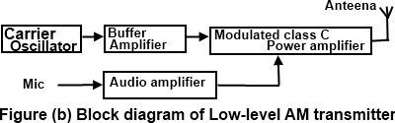
Modulation takes place at the stage, and the power of the modulated signal is amplified to the required transmitting power level. The transmitting antenna then transmits the signal.

Coupling of Output Stage and Antenna
The output stage of the modulated class C power amplifier feeds the signal to the transmitting antenna. To transfer maximum power from the output stage to the antenna it is necessary that the impedance of the two sections match. For this , a matching network is required. The matching between the two should be perfect at all transmitting frequencies. As the matching is required at

different frequencies, inductors and capacitors offering different impedance at different frequencies are used in the matching networks.
The matching network must be constructed using these passive components. This is shown in figure ©

The matching network used for coupling the output stage of the transmitter and the antenna is called double π-network. This network is shown in figure (c). It consists of two inductors , L₁ and L₂ and two capacitors, C₁ and C₂. The values of these components are chosen such that the input impedance of the network between 1 and 1'. Shown in figure (c) is matched with the output impedance of the output stage of the transmitter. Further, the output impedance of the network is matched with the impedance of the antenna.
The double π matching network also filters unwanted frequency components appearing at the output of the last stage of the transmitter. The output of the modulated class C power amplifier may contain higher harmonics, such as second and third harmonics, that are highly undesirable. The frequency response of the matching network is set such that these unwanted higher harmonics
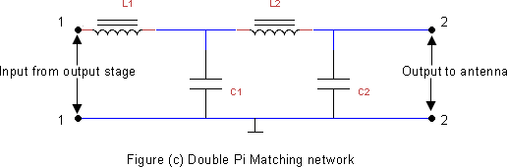

are totally suppressed, and only the desired signal is coupled to the antenna.

Comparision of Am and Fm Signals
Both AM and FM system are used in commercial and non-commercial applications. Such as radio broadcasting and television transmission. Each system has its own merits and demerits. In a Particular application, an AM system can be more suitable than an FM system. Thus the two are equally important from the application point of view.

Advantage of FM systems over AM Systems
The advantages of FM over AM systems are:
    - The amplitude of an FM wave remains constant. This provides the system designers an opportunity to remove the noise from the received signal. This is done in FM receivers by

employing an amplitude limiter circuit so that the noise above the limiting amplitude is suppressed. Thus, the FM system is considered a noise immune system. This is not possible in AM systems because the baseband signal is carried by the amplitude variations it self and the envelope of the AM signal cannot be altered.
    - Most of the power in an FM signal is carried by the side bands. For higher values of the modulation index, mc, the major portion of the total power is contained is side bands, and the carrier signal contains less power. In contrast, in an AM system, only one third of the total power is carried by the side bands and two thirds of the total power is lost in the form of carrier power.
    - In FM systems, the power of the transmitted signal depends on the amplitude of the
unmodulated carrier signal, and hence it is constant. In contrast, in AM systems, the power depends on the modulation index ma. The maximum allowable power in AM systems is 100 percent when ma is unity. Such restriction is not applicable int case of FM systems. This is because the total power in an FM system is independent of the modulation index, mf and frequency deviation fd. Therefore, the power usage is optimum in an FM system.
- In an AM system, the only method of reducing noise is to increase the transmitted power of the signal. This operation increases the cost of the AM system. In an FM system, you can increase the frequency deviation in the carrier signal to reduce the noise. if the frequency deviation is high, then the corresponding variation in amplitude of the baseband signal can be easily retrieved. if the frequency deviation is small, noise 'can overshadow this variation and the frequency deviation cannot be translated into its corresponding amplitude variation. Thus, by increasing frequency deviations in the FM signal, the noise
effect can he reduced. There is no provision in AM system to reduce the noise effect by
any method, other than increasing itss transmitted power.
    - In an FM signal, the adjacent FM channels are separated by guard bands. In an FM system there is no signal transmission through the spectrum space or the guard band. Therefore, there is hardly any interference of adjacent FM channels. However, in an AM system, there is no guard band provided between the two adjacent channels. Therefore, there is always interference of AM radio stations unless the received signalis strong enough to suppress the signal of the adjacent channel.

The disadvantages of FM systems over AM systems
    - There are an infinite number of side bands in an FM signal and therefore the theoretical bandwidth of an FM system is infinite. The bandwidth of an FM system is limited by

Carson's rule, but is still much higher, especially in WBFM. In AM systems, the bandwidth is only twice the modulation frequency, which is much less than that of WBFN. This makes FM systems costlier than AM systems.
    - The equipment of FM system is more complex than AM systems because of the complex circuitry of FM systems; this is another reason that FM systems are costlier AM systems.
    - The receiving area of an FM system is smaller than an AM system consequently FM channels are restricted to metropolitan areas while AM radio stations can be received anywhere in the world. An FM system transmits signals through line of sight propagation, in which the distance between the transmitting and receiving antenna should not be much. in an AM system signals of short wave band stations are transmitted through
atmospheric layers that reflect the radio waves over a wider area.
  - SSB TRANSMISSION:
There are two methods used for SSB Transmission.
    - Filter Method
    - Phase Shift Method
    - Block diagram of SSB
- Filter Method:
This is the filter method of SSB suppression for the transmission. Fig 1.3

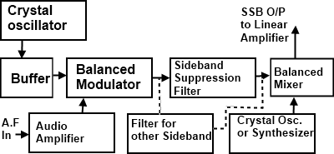

FIG 1.3 Filter Method
- A crystal controlled master oscillator produces a stable carrier frequency fc (say 100 KHz)
- This carrier frequency is then fed to the balanced modulator through a buffer amplifier which isolates these two satges.
- The audio signal from the modulating amplifier modulates the carrier in the balanced modulator. Audio frequency range is 300 to 2800 Hz. The carrier is also suppressed in this stage but allows only to pass the both side bands. (USB & LSB).

- A band pass filter (BPF) allows only a single band either USB or LSB to pass through it. It depends on our requirements.
- This side band is then heterodyned in the balanced mixer stage with 12 MHz frequency produced by crystal oscillator or synthesizer depends upon the requirements of our transmission. So in mixer stage, the frequency of the crystal oscillator or synthersizer is added to SSB signal. The output frequency thus being raised to the value desired for transmission.
- Then this band is amplified in driver and power amplifier stages and then fed to the aerial for the transmission.

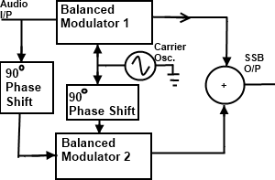
Phase Shift Method:
The phaseing method of SSB generation uses a phase shift technique that causes one of the side
bands to be conceled out. A block diagram of a phasing type SSB generator is shown in fig 1.4.
FIG 1.4 Phase Shift Method
It uses two balanced modulators instead of one. The balanced modulators effectively eliminate
the carrier. The carrier oscillator is applied directly to the upper balanced modulator along with the audio modulating signal. Then both the carrier and modulating signal are shifted in phase by 90º and applied to the second, lower, balanced modulator. The two balanced modulator output are then added together algebraically. The phase shifting action causes one side band to be canceled out when the two balanced modulator outputs are combined.

Block diagram of SSB:

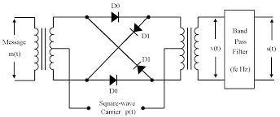
FIG 1.5 Balance Ring Modulator

Operation of Balance Ring Modulator:
- Ring modulation is a signal-processing function in electronics, an implementation of amplitude modulation or frequency mixing, performed by multiplying two signals, where one is typically a sine-wave or another simple waveform. It is referred to as "ring" modulation because the analog circuit of diodes originally used to implement this technique took the shape of a ring. This circuit is similar to a bridge rectifier, except that instead of the diodes facing "left" or "right", they go "clockwise" or "anti-clockwise". A ring modulator is an effects unit working on this principle.
- The carrier, which is AC, at a given time, makes one pair of diodes conduct, and reverse- biases the other pair. The conducting pair carries the signal from the left transformer secondary to the primary of the transformer at the right. If the left carrier terminal is positive, the top and bottom diodes conduct. If that terminal is negative, then the "side" diodes conduct, but create a polarity inversion between the transformers. This action is
much like that of a DPDT switch wired for reversing connections.
- Ring modulators frequency mix or heterodyne two waveforms, and output the sum and difference of the frequencies present in each waveform. This process of ring modulation produces a signal rich in partials. As well, neither the carrier nor the incoming signal is prominent in the outputs, and ideally, not at all.
- Two oscillators, whose frequencies were harmonically related and ring modulated against each other, produce sounds that still adhere to the harmonic partials of the notes, but contain a very different spectral make up. When the oscillators' frequencies are not harmonically related, ring modulation creates inharmonic, often producing bell-like or otherwise metallic sounds.

- If the same signal is sent to both inputs of a ring modulator, the resultant harmonic spectrum is the original frequency domain doubled (if f₁ = f₂ = f, then f₂ − f₁ = 0 and f₂ + f₁
= 2f). Regarded as multiplication, this operation amounts to squaring. However, some distortion occurs due to the forward voltage drop of the diodes.
- Some modern ring modulators are implemented using digital signal processing techniques by simply multiplying the time domain signals, producing a nearly-perfect signal output. Before digital music synthesizers became common, at least some analog synthesizers (such as the ARP 2600) used analog multipliers for this purpose; they were closely related to those used in electronic analog computers. (The "ring modulator" in the ARP 2600 could multiply control voltages; it could work at DC.)
- Multiplication in the time domain is the same as convolution in the frequency domain, so the output waveform contains the sum and difference of the input frequencies. Thus, in the basic case where two sine waves of frequencies f₁ and f₂ (f₁ < f₂) are multiplied, two new sine waves are created, with one at f₁ + f₂ and the other at f₂ - f₁. The two new waves are unlikely to be harmonically related and (in a well designed ring modulator) the original signals are not present. It is this that gives the ring modulator its unique tones.
- Inter modulation products can be generated by carefully selecting and changing the frequency of the two input waveforms. If the signals are processed digitally, the frequency- domain convolution becomes circular convolution. If the signals are wideband, this will cause aliasing distortion, so it is common to oversample the operation or low-pass filter the signals prior to ring modulation.
- One application is spectral inversion, typically of speech; a carrier frequency is chosen to
be above the highest speech frequencies (which are low-pass filtered at, say, 3 kHz, for a

carrier of perhaps 3.3 kHz), and the sum frequencies from the modulator are removed by more low-pass filtering. The remaining difference frequencies have an inverted spectrum - High frequencies become low, and vice versa.

Advantages:
- It allows better management of the frequency spectrum. More transmission can fit into a given frequency range than would be possible with double side band DSB signals.
All of the transmitted power is message power none is dissipate as carrier power.

Disadvantages:
- The cost of a single side band SSB receiver is higher than the double side band DSB counterpart be a ratio of about 3:1.

- The average radio user wants only to flip a power switch and dial a station. Single side band SSB receivers require several precise frequency control settings to minimize distortion and may require continual readjustment during the use of the system.

VESTIGIAL SIDE BAND (VSB) MODULATION:
    - The following are the drawbacks of SSB signal generation:
- Generation of an SSB signal is difficult.
- Selective filtering is to be done to get the original signal back.
- Phase shifter should be exactly tuned to 90°.
    - To overcome these drawbacks, VSB modulation is used. It can view as a compromise between SSB and DSB-SC. Figure1.5 shows all the three modulation schemes.

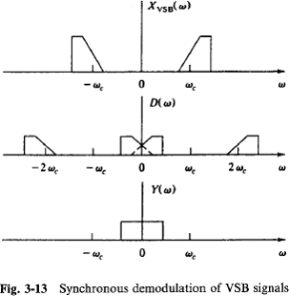

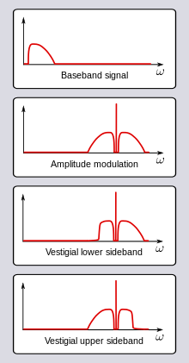
Spectrum of VSB Signals:

FIG 1.6 Spectrum of VSB Signals
- Vestigial sideband (VSB) transmission is a compromise between DSB and SSB
- In VSB modulation, one passband is passed almost completely whereas only a residual
portion of the other sideband is retained in such a way that the demodulation process can still reproduce the original signal.
- VSB signals are easier to generate because some roll-off in filter edges is allowed. This results in system simplification. And their bandwidth is only slightly greater than that of SSB signals (-25 %).
- The filtering operation can be represented by a filter H(f) that passes some of the lower (or upper) sideband and most of the upper (or lower) sideband.

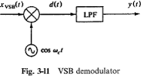

- Heterodyning means the translating or shifting in frequency.
- By heterodyning the incoming signal at ωRF with the local oscillator frequency
ωLO, the message is translated to an intermediate frequency
ωIF, which is equal to either the sum or the difference of ωRF and ωIF.
- If ωIF = 0, the bandpass filter becomes a low-pass filter and the original baseband signal is presented at the output. This is called homodyning

Heterodyning: Image Response:
Methods to solve the image response in heterodyne receiver
- Careful selection of intermediate frequency ωIF for a given frequency band.
- Attenuate the image signal before heterodyning.
  - Advantages:
    - VSB is a form of amplitude modulation intended to save bandwidth over regular AM. Portions of one of the redundant sidebands are removed to form a vestigial side band signal.
    - The actual information is transmitted in the sidebands, rather than the carrier; both sidebands carry the same information. Because LSB and USB are essentially mirror images of each other, one can be discarded or used for a second channel or for diagnostic purposes.
  - Disadvantages:
- VSB transmission is similar to (SSB) transmission, in which one of the sidebands is completely removed. In VSB transmission, however, the second sideband is not completely removed, but is filtered to remove all but the desired range of frequencies.

DSB-SC:
Double-sideband suppressed-carrier transmission (DSB-SC) is transmission in which frequencies produced by amplitude modulation (AM) are symmetrically spaced above and below the carrier frequency and the carrier level is reduced to the lowest practical level, ideally being completely suppressed.

Spectrum:
DSB-SC is basically an amplitude modulation wave without the carrier, therefore reducing power waste, giving it a 50% efficiency. This is an increase compared to normal AM transmission (DSB), which has a maximum efficiency of 33.333%, since 2/3 of the power is in the carrier

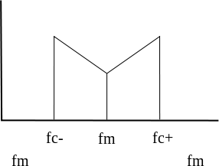
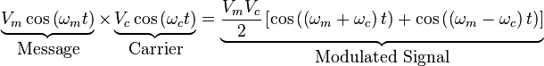
which carries no intelligence, and each sideband carries the same information. Single Side Band (SSB) Suppressed Carrier is 100% efficient.
FIG 1.7 Spectrum plot of an DSB-SC signal
- Generation:
DSB-SC is generated by a mixer. This consists of a message signal multiplied by a carrier signal. The mathematical representation of this process is shown below, where the product-to-sum trigonometric identity is used.

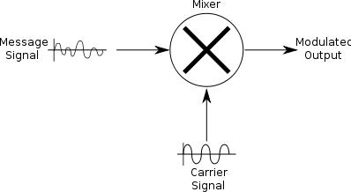
FIG 1.8 Generation of DSB-SC signal

Demodulation:
Demodulation is done by multiplying the DSB-SC signal with the carrier signal just like the modulation process. This resultant signal is then passed through a low pass filter to produce a scaled version of original message signal. DSB-SC can be demodulated if modulation index is less than unity.

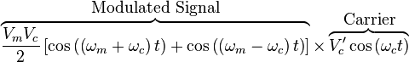
The equation above shows that by multiplying the modulated signal by the carrier signal, the result is a scaled version of the original message signal plus a second term. Since , this second term is much higher in frequency than the original message.
Once this signal passes through a low pass filter, the higher frequency component is removed,
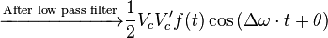
leaving just the original message.
- Distortion and Attentuation:
For demodulation, the demodulation oscillator's frequency and phase must be exactly the same as modulation oscillator's, otherwise, distortion and/or attenuation will occur.
To see this effect, take the following conditions:
- Message signal to be transmitted:
- Modulation (carrier) signal:
- Demodulation signal (with small frequency and phase deviations from the modulation signal):
The resultant signal can then be given by

The terms results in distortion and attenuation of the original message signal. In particular, contributes to distortion while adds to the attenuation.

HILBERT TRANSFORM:
(t) of a signal x(t) is defined by the equation
1 x(s)
(t) = ds, t-s

where the integral is the Cauchy principal value integral. The reconstruction formula
1 (s)
x(t) = - ds, t-s

defines the Hilbert inverse transform.

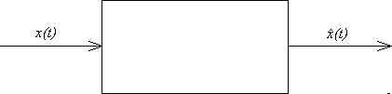
Hilbert transformer:

FIG 1.9 Block diagram of Hilbert Transform Pair
The pair x(t), (t) is called a Hilbert transform pair is an LTI system whose transfer function is H(v) = - j · sgn v,because (t) = (1/ t) * x(t) which, by taking the Fourier transform implies
(v) = - j (sgn v) X(v).
A Hilbert transformer produces a -90 degree phase shift for the positive frequency components of the input x(t), the amplitude doesn't change.
- Properties of the Hilbert transform:
A signal x(t) and its Hilbert transform (t) have
- the same amplitude spectrum
- the same autocorrelation function
- x(t) and (t) are orthogonal
- The Hilbert transform of (t) is -x(t)
- Pre envelope:
The pre envelope of a real signal x(t) is the complex function
x₊(t) = x(t) + j (t).
The pre envelope is useful in treating band pass signals and systems. This is due to the result
2 X(v), v > 0
X(0), v = 0

Complex envelope:
X₊(v) =
0, v < 0

The complex envelope of a band pass signal x(t) is

(t) = x₊(t) 𝑒^{−𝑗2𝜋𝑓𝑐𝑡} .
  - SUPERHETERODYNE RECEIVER:
A superheterodyne receiver(often shortened to superhet) uses frequency mixing to convert a received signal to a fixed intermediate frequency (IF) which can be more conveniently processed than the original radio carrier frequency.
- Basic Superheterodyne Block Diagram and Functionality:
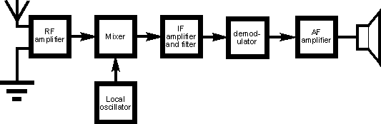
The basic block diagram of a basic superhet receiver is shown below. This details the most basic form of the receiver and serves to illustrate the basic blocks and their function.

FIG 1.10 Block Diagram of a Basic Superheterodyne Radio Receiver
The way in which the receiver works can be seen by following the signal as is passes through the receiver.
- Front end amplifier and tuning block: Signals enter the front end circuitry from the antenna. This circuit block performs two main functions:
o Tuning: Broadband tuning is applied to the RF stage. The purpose of this is to reject the signals on the image frequency and accept those on the wanted
frequency. It must also be able to track the local oscillator so that as the receiver is
tuned, so the RF tuning remains on the required frequency. Typically the selectivity provided at this stage is not high. Its main purpose is to reject signals on the image frequency which is at a frequency equal to twice that of the IF away from the wanted frequency. As the tuning within this block provides all the rejection for the image response, it must be at a sufficiently sharp to reduce the image to an acceptable level. However the RF tuning may also help in preventing strong off- channel signals from entering the receiver and overloading elements of the receiver, in particular the mixer or possibly even the RF amplifier.
o Amplification: In terms of amplification, the level is carefully chosen so that it does not overload the mixer when strong signals are present, but enables the signals

to be amplified sufficiently to ensure a good signal to noise ratio is achieved. The amplifier must also be a low noise design. Any noise introduced in this block will be amplified later in the receiver.
- Mixer / frequency translator block: The tuned and amplified signal then enters one port of the mixer. The local oscillator signal enters the other port. The performance of the mixer is crucial to many elements of the overall receiver performance. It should eb as linear as possible. If not, then spurious signals will be generated and these may appear as 'phantom' received signals.
- Local oscillator: The local oscillator may consist of a variable frequency oscillator that can be tuned by altering the setting on a variable capacitor. Alternatively it may be a
frequency synthesizer that will enable greater levels of stability and setting accuracy.
- Intermediate frequency amplifier, IF block : Once the signals leave the mixer they enter the IF stages. These stages contain most of the amplification in the receiver as well as the filtering that enables signals on one frequency to be separated from those on the next. Filters may consist simply of LC tuned transformers providing inter-stage coupling, or they may be much higher performance ceramic or even crystal filters, dependent upon what is required.
- Detector / demodulator stage: Once the signals have passed through the IF stages of the superheterodyne receiver, they need to be demodulated. Different demodulators are required for different types of transmission, and as a result some receivers may have a variety of demodulators that can be switched in to accommodate the different types of transmission that are to be encountered. Different demodulators used may include:
o AM diode detector: This is the most basic form of detector and this circuit block

would simple consist of a diode and possibly a small capacitor to remove any remaining RF. The detector is cheap and its performance is adequate, requiring a sufficient voltage to overcome the diode forward drop. It is also not particularly linear, and finally it is subject to the effects of selective fading that can be apparent, especially on the HF bands.
  - Synchronous AM detector: This form of AM detector block is used in where improved performance is needed. It mixes the incoming AM signal with another on the same frequency as the carrier. This second signal can be developed by passing the whole signal through a squaring amplifier. The advantages of the synchronous

AM detector are that it provides a far more linear demodulation performance and it is far less subject to the problems of selective fading.
  - SSB product detector: The SSB product detector block consists of a mixer and a local oscillator, often termed a beat frequency oscillator, BFO or carrier insertion oscillator, CIO. This form of detector is used for Morse code transmissions where the BFO is used to create an audible tone in line with the on-off keying of the transmitted carrier. Without this the carrier without modulation is difficult to detect. For SSB, the CIO re-inserts the carrier to make the modulation comprehensible.
  - Basic FM detector: As an FM signal carries no amplitude variations a
demodulator block that senses frequency variations is required. It should also be insensitive to amplitude variations as these could add extra noise. Simple FM detectors such as the Foster Seeley or ratio detectors can be made from discrete components although they do require the use of transformers.
- PLL FM detector: A phase locked loop can be used to make a very good FM demodulator. The incoming FM signal can be fed into the reference input, and the VCO drive voltage used to provide the detected audio output.
- Quadrature FM detector: This form of FM detector block is widely used within ICs. IT is simple to implement and provides a good linear output.
- Audio amplifier: The output from the demodulator is the recovered audio. This is passed into the audio stages where they are amplified and presented to the headphones or loudspeaker.
1.8 COMPARISION OF VARIOUS AM:

PARAMETER | VSB - SC | SSB - SC | DSB-SC
Definition | A vestigial sideband (in radio communication) is a sideband that has been only partly cut off or suppressed. | Single-sideband modulation (SSB) is a refinement of amplitude modulation that more efficiently uses electrical power and bandwidth. | In radio communications, asidebandis  a band of frequencies hig her than or lower thanthe carrier frequency, containing power as a result of  the modulation process.
Application | Tv broadcastings & Radio broadcastings | Tv broadcastings &  ShortwaveRadio broadcastings | Tv broadcastings &  Radio broadcastings Garage door opens

 |  |  | keyless remotes
Uses | Transmits TV signals | Short wave radio  communications | Two way radio  communications.

1.9 APPLICATION & ITS USES:
- Radio broadcastings
- Tv broadcastings
- Garage door opens keyless remotes
- Transmits TV signals
- Short wave radio communications
- Two way radio communication.
REFERENCES:
- P. Lathi, Communication Systems, John Wiley and Sons, 2005.
- Simon Haykins - ―Communication Systems‖ John Wilsey 2005.
- J.G Prokias, M.Salelhi,‖Fundamental Of Communication Systems‖ Pearson Education 2006.
- Muralibabu – ―Communication Theory‖.
GLOSSARY TERMS:
- Amplitude modulation: The modulation of a wave by varying its amplitude, used especially as a means of broadcasting an audio signal by combining it with a radio carrier wave.
- The modulation index: (modulation depth) of a modulation scheme describes by how much the modulated variable of the carrier signal varies around its unmodulated level.
- NarrowbandFM: If the modulation index of FM is kept under 1, then the FM produced is
regarded as narrow band FM.
  - Frequency modulation (FM): the encoding of information in a carrier wave by varying the instantaneous frequency of the wave.
  - Amplication: The level is carefully chosen so that it does not overload the mixer when strong signals are present, but enables the signals to be amplified sufficiently to ensure a good signal to noise ratio is achieved.
  - Modulation: The process by which some of the characteristics of carrier wave is varied in accordance with the message signal.

TUTORIAL PROBLEMS:
- A 400 watts carrier is modulated to a depth of 75% calculate the total power in a double side band full carrier AM wave.

Solution:
Carrier power Pc = 400 watts, m= 0.75
Total power in a DSB-FC AM Wave = pt = 𝐩(𝟏 + 𝒎𝟐)
𝟐
= 400(1+^{(𝟎.𝟕𝟓)}𝟐)
𝟐
= 512.5 watts.

- For the maximum envelope voltage Vmax = 20V and a minimum positive envelope voltage of Vmin = 6V Determine Modulation Index.
Solution:
Vmax = 20V ; Vmin = 6V
(a) Modulation index, m = ^{𝒗𝒎𝒂𝒙−𝒗𝒎𝒊𝒏}
𝒗𝒎𝒂𝒙+𝒗𝒎𝒊𝒏
= 14/26
= 0.538.
(b) Carrier Wave Vc:

Vmax = Vc+ Vm
20 = Vc+ Vm Vmin = Vc - Vm
6 = Vc - Vm
Vc = 13V.

WORKED OUT PROBLEMS:

- Calculate the % power saving when the carrier and one of the sidebands are suppressed in an am wave modulated to depth of 60%.
  - Total transmitted power 𝒑𝒕 = 𝒑𝒄 = (𝟏 + 𝒎𝟐)
𝟐

(b) 𝐏𝐒𝐁 = 𝐩(𝒎𝟐)
𝟒
(c)

𝐩𝐭−𝐏𝐒𝐁

% 𝐩𝐨𝐰𝐞𝐫 𝐬𝐚𝐯𝐢𝐧𝐠𝐬 = (
𝐏𝐓
) ∗ 𝟏𝟎𝟎 Ans : 92.37%.

- For an AM DSBFC envelope with Vmax = 40V and Vmin = 10V , determine the
  - Unmodulated carrier wave ; Vmax = Vc +Vm ; Vmin = Vc –Vm Ans : Vc = 25V.
(b) % Modulation index = ^{(𝑽𝒎𝒂𝒙−𝑽𝒎𝒊𝒏)} *100.
(𝑽𝒎𝒂𝒙+𝑽𝒎𝒊𝒏)

CHAPTER 2 ANGLE MODULATION
2.0 PREREQUISTING ABOUT ANGLE MODULATION:
Angle modulation is a class of analog modulation. These techniques are based on altering the angle (or phase) of a sinusoidal carrier wave to transmit data, as opposed to varying the amplitude, such as in AM transmission.
Angle Modulation is modulation in which the angle of a sine-wave carrier is varied by a modulating wave. Frequency Modulation (FM) and Phase Modulation (PM) are two types of angle modulation. In frequency modulation the modulating signal causes the carrier frequency to
vary. These variations are controlled by both the frequency and the amplitude of the modulating wave. In phase modulation the phase of the carrier is controlled by the modulating waveform.
The two main types of angle modulation are:
- Frequency modulation (FM), with its digital correspondence frequency-shift keying (FSK).
- Phase modulation (PM), with its digital correspondence phase-shift keying (PSK).
CONTENT:
  - FREQUENCY & PHASE MODULATION
  - NARROW BAND FM
  - WIDE BAND FM
  - GENERATION OF WIDE BAND FM
  - TRANSMISSION BANDWIDTH
  - FM TRANSMITTER
2.1 FREQUENCY & PHASE MODULATION:
Besides using the amplitude of carrier to carrier information, one can also use the angle of a carrier to carrier information. This approach is called angle modulation, and includes frequency modulation (FM) and phase modulation (PM). The amplitude of the carrier is maintained constant. The major advantage of this approach is that it allows the trade-off between bandwidth and noise performance.
An angle modulated signal can be written as
s(t) = Acosθ(t)
where θ(t) is usually of the form θ(t) = 2πfct + ∅(t) and fc is the carrier frequency. The signal
∅(t) is derived from the message signal m(t) . If ∅(t) = kpm(t) for some constant kp ,the resulting modulation is called phase modulation. The parameter kp is called the phase

sensitivity.In telecommunications and signal processing, frequency modulation (FM) is the encoding of information in a carrier wave by varying the instantaneous frequency of the wave. (Compare with amplitude modulation, in which the amplitude of the carrier wave varies, while the frequency remains constant.) Frequency modulation is known as phase modulation when the carrier phase modulation is the time integral of the FM signal.
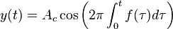
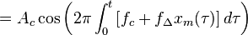
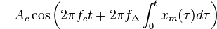
If the information to be transmitted (i.e., the baseband signal) is and the sinusoidal carrier is , where f_{c} is the carrier's base frequency, and A_{c} is the carrier's amplitude, the modulator combines the carrier with the baseband data signal to get the transmitted signal:
In this equation,
is the instantaneous frequency of the oscillator and
is the frequency
deviation, which represents the maximum shift away from f_{c} in one direction, assuming x_{m}(t) is limited to the range ±1.
While most of the energy of the signal is contained within f_{c} ± f_{Δ}, it can be shown by Fourier analysis that a wider range of frequencies is required to precisely represent an FM signal. The frequency spectrum of an actual FM signal has components extending infinitely, although
their amplitude decreases and higher-order components are often neglected in practical design

problems.
Sinusoidal baseband signal:
Mathematically, a baseband modulated signal may be approximated by a sinusoidal continuous wave signal with a frequency f_{m}.
The integral of such a signal is:
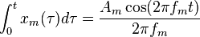
In this case, the expression for y(t) above simplifies to:
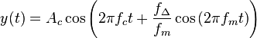

where the amplitude of the modulating sinusoid is represented by the peak deviation
The harmonic distribution of a sine wave carrier modulated by such a sinusoidal signal can be represented with Bessel functions; this provides the basis for a mathematical understanding of frequency modulation in the frequency domain.

Modulation index:
As in other modulation systems, the value of the modulation index indicates by how much the modulated variable varies around its unmodulated level. It relates to variations in the carrier frequency:
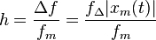
where
is the highest frequency component present in the modulating signal x_{m}(t), and
is
the peak frequency-deviation—i.e. the maximum deviation of the instantaneous frequency from the carrier frequency. For a sine wave modulation, the modulation index is seen to be the ratio of
the amplitude of the modulating sine wave to the amplitude of the carrier wave (here unity).
If
, the modulation is called narrowband FM, and its bandwidth is approximately
.
For digital modulation systems, for example Binary Frequency Shift Keying (BFSK), where a
binary signal modulates the carrier, the modulation index is given by:
where
is the symbol period, and
is used as the highest frequency of the
modulating binary waveform by convention, even though it would be more accurate to say it is the
highest fundamental of the modulating binary waveform. In the case of digital modulation, the carrier is never transmitted. Rather, one of two frequencies is transmitted, either or , depending on the binary state 0 or 1 of the modulation signal.
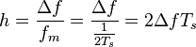
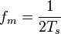
If , the modulation is called wideband FM and its bandwidth is approximately . While wideband FM uses more bandwidth, it can improve the signal-to-noise ratiosignificantly; for example, doubling the value of , while keeping constant, results in an eight-fold improvement in the signal-to-noise ratio. (Compare this with Chirp spread spectrum, which uses extremely wide frequency deviations to achieve processing gains comparable to traditional, better- known spread-spectrum modes).

With a tone-modulated FM wave, if the modulation frequency is held constant and the modulation index is increased, the (non-negligible) bandwidth of the FM signal increases but the spacing between spectra remains the same; some spectral components decrease in strength as others increase. If the frequency deviation is held constant and the modulation frequency increased, the spacing between spectra increases.
Frequency modulation can be classified as narrowband if the change in the carrier frequency is about the same as the signal frequency, or as wideband if the change in the carrier frequency is much higher (modulation index >1) than the signal frequency. ^{[6]} For example, narrowband FM is used for two way radio systems such as Family Radio Service, in which the carrier is allowed to deviate only 2.5 kHz above and below the center frequency with speech signals of no more than
3.5 kHz bandwidth. Wideband FM is used for FM broadcasting, in which music and speech are transmitted with up to 75 kHz deviation from the center frequency and carry audio with up to a 20-kHz bandwidth.
Carson's rule:
BT = 2(∆f + fm).
2.2 PHASE MODULATION:
Phase Modulation (PM) is another form of angle modulation. PM and FM are closely related to each other. In both the cases, the total phase angle θ of the modulated signal varies. In an FM wave, the total phase changes due to the change in the frequency of the carrier corresponding to the changes in the modulating amplitude.
In PM, the total phase of the modulated carrier changes due to the changes in the instantaneous phase of the carrier keeping the frequency of the carrier signal constant. These two types of
modulation schemes come under the category of angle modulation. However, PM is not as

extensively used as FM.

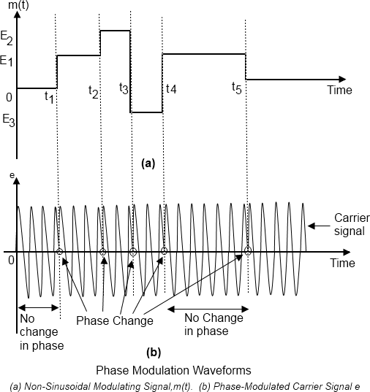

At time t1, the amplitude of m(t) increases from zero to E1. Therefore, at t1, the phase modulated carrier also changes corresponding to E1, as shown in Figure (a). This phase remains to this attained value until time t2, as between t1 and t2, the amplitude of m(t) remains constant at El. At t2, the amplitude of m(t) shoots up to E2, and therefore the phase of the carrier again increases corresponding to the increase in m(t). This new value of the phase attained at time t2remains constant up to time t3. At time t3, m(t) goes negative and its amplitude becomes E3. Consequently, the phase of the carrier also changes and it decreases from the previous value attained at t2. The decrease in phase corresponds to the decrease in amplitude of m(t). The phase
of the carrier remains constant during the time interval between t3 and t4. At t4, m(t) goes positive
to reach the amplitude El resulting in a corresponding increase in the phase of modulated carrier at time t4. Between t4 and t5, the phase remains constant. At t5 it decreases to the phase of the unmodulated carrier, as the amplitude of m(t) is zero beyond t5.

Equation of a PM Wave:
To derive the equation of a PM wave, it is convenient to consider the modulating signal as a pure sinusoidal wave. The carrier signal is always a high frequency sinusoidal wave. Consider the modulating signal, em and the carrier signal ec, as given by, equation 1 and 2, respectively.
e_{m} = E_{m} cos ω_{m} t (1)
e_{c} = E_{c} sin ω_{c} t (2)

The initial phases of the modulating signal and the carrier signal are ignored in Equations (1) and
(2) because they do not contribute to the modulation process due to their constant values. After PM, the phase of the carrier will not remain constant. It will vary according to the modulating signal em maintaining the amplitude and frequency as constants. Suppose, after PM, the equation of the carrier is represented as:
e = E_{c} Sin θ (3)
Where θ, is the instantaneous phase of the modulated carrier, and sinusoid ally varies in proportion to the modulating signal. Therefore, after PM, the instantaneous phase of the modulated carrier can be written as:
θ = ω_{c} t + K_{p} e_{m} (4)
Where,
kp
is
the
constant
of
proportionality
for
phase modulation.
Substituting Equation (1) in Equation (4), yon get:
θ = ω_{c} t + K_{p} E_{m} Cos ω_{m} t (5)
In Equation (5), the factor, kpEm is defined as the modulation index, and is given as:
m_{p} = K_{p} E_{m} (6)
where, the subscript p signifies; that mp is the modulation index of the PM wave. Therefore, equation (5) becomes
θ = ω_{c} t + m_{p} Cos ω_{m} t (7)
Substituting Equation (7) and (3), you get:
e = E_{c} sin (ω_{c}t + m_{p} cos ω_{m}t) (8)
2.3 NARROW BAND FM MODULATION:
The case where |θm(t)| ≪ 1 for all t is called narrow band FM. Using the approximations
cos x ≃ 1 and sin x ≃ x for |x| ≪ 1, the FM signal can be approximated as:
s(t) = Ac cos[ωct + θm(t)]
= Ac cos ωct cos θm(t) − Ac sin ωctsin θm(t)
≃ Ac cos ωct − Acθm(t) sin ωct
or in complex notation
s(t) = ACRE{e^{jwct} (1 + jθm(t)}
This is similar to the AM signal except that the discrete carrier component Ac coswc(t) is 90° out of phase with the sinusoid Ac sinwc(t) multiplying the phase angle θm(t). The spectrum of narrow band FM is similar to that of AM.

The Bandwidth of an FM Signal:
The following formula, known as Carson‘s rule is often used as an estimate of the FM signal bandwidth: BT = 2(∆f + fm) Hz
where ∆f is the peak frequency deviation and fm is the maximum baseband message frequency component.

FM Demodulation by a Frequency Discriminator:
A frequency discriminator is a device that converts a received FM signal into a voltage that is proportional to the instantaneous frequency of its input without using a local oscillator and, consequently, in a non coherent manner.
- When the instantaneous frequency changes slowly relative to the time-constants of the quasi-static analysis can be used.
- In quasi-static operation the filter output has the same instantaneous frequency as the
filter, a
input but
with an envelope that varies according to the amplitude response of the filter at the instantaneous frequency.
- The amplitude variations are then detected with an envelope detector like the ones used for AM demodulation.
  - An FM Discriminator Using the Pre-Envelope:
When θm(t) is small and band-limited so that cos θm(t) and sinθm(t) are essentially band-limited signals with cut off frequencies less than fc, the pre-envelope of the FM signal is
s+(t) = s(t) + jˆs(t) = Ace^{j}(ωct+θm(t)) The angle of the pre-envelope is φ'(t) = arctan[ˆs(t)/s(t)] = ωct + θm(t)
The derivative of the phase is =ωct+ kθm(t)

t d s(t)
dφ(t) = s(t)d − s dt

= ωct + kωm (t)

dt dts(t) s2(t)+s^2(t)
which is exactly the instantaneous frequency. This can be approximated in discrete-time by using FIR filters to form the derivatives and Hilbert transform. Notice that the denominator is the squared envelope of the FM signal.
This formula can also be derived by observing,

d
s(t) =
dt
d
ACcos[ωct + θm(t)] = −AC[ωct + kωm(t)]sin⁡[ωct + θm(t)]
dt

So,
d
s^(t) =
dt
d
ACsin[ωct + θm(t)] = AC[ωct + kωm(t)]cos⁡[ωct + θm(t)]
dt

s(t)d dts^(t)
− s^(t)d = AC²[ωct + kωm(t)] ∗ cos2[wct + θm(t) + sin2[wct + θm(t)
dts(t)

The bandwidth of an FM discriminator must be at least as great as that of the received FM signal which is usually much greater than that of the baseband message. This limits the degree of noise reduction that can be achieved by preceding the discriminator by a bandpass receive filter.

Using a Phase-Locked Loop for FM Demodulation:
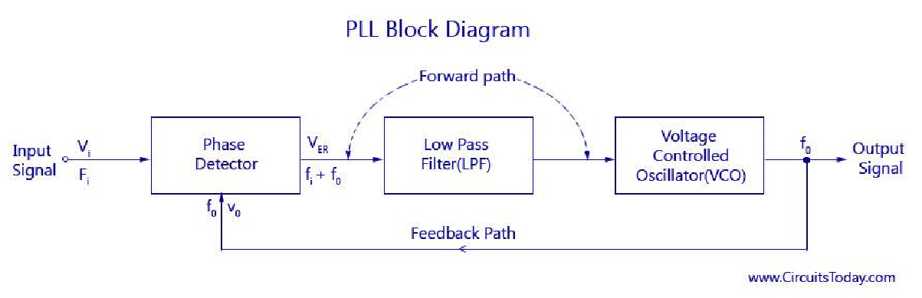
A device called a phase-locked loop (PLL) can be used to demodulate an FM signal with better
performance in a noisy environment than a frequency discriminator. The block diagram of a
discrete-time version of a PLL as shown in figure,
FIG 2.2 PLL Block diagram
The block diagram of a basic PLL is shown in the figure below. It is basically a flip flop consisting of a phase detector, a low pass filter (LPF),and a Voltage Controlled Oscillator (VCO) The input signal Vi with an input frequency fi is passed through a phase detector. A phase detector

basically a comparator which compares the input frequency fiwith the feedback frequency fo .The phase detector provides an output error voltage Ver (=fi+fo),which is a DC
voltage. This DC voltage is then passed on to an LPF. The LPF removes the high frequency noise and produces a steady DC level, Vf (=Fi-Fo). Vf also represents the dynamic characteristics of the PLL.
The DC level is then passed on to a VCO. The output frequency of the VCO (fo) is directly proportional to the input signal. Both the input frequency and output frequency are compared and adjusted through feedback loops until the output frequency equals the input frequency. Thus the PLL works in these stages – free-running, capture and phase lock.

As the name suggests, the free running stage refer to the stage when there is no input voltage applied. As soon as the input frequency is applied the VCO starts to change and begin producing an output frequency for comparison this stage is called the capture stage. The frequency comparison stops as soon as the output frequency is adjusted to become equal to the input frequency. This stage is called the phase locked state.

Comments on PLL Performance:
- The frequency response of the linearized loop characteristics of a band-limited differentiator.
- The loop parameters must be chosen to provide a loop bandwidth that passes the desired baseband message signal but is as small as possible to suppress out-of-band noise.
- The PLL performs better than a frequency discriminator when the FM signal is corrupted by
additive noise. The reason is that the bandwidth of the frequency discriminator must be large enough to pass the modulated FM signal while the PLL bandwidth only has to be large enough to pass the baseband message. With wideband FM, the bandwidth of the modulated signal can be significantly larger than that of the baseband message.
- Bandwidth of FM PLL vs. Costas Loop:
The PLL described in this experiment is very similar to the Costas loop presented in coherent demodulation of DSBSC-AM. However, the bandwidth of the PLL used for FM demodulation must be large enough to pass the baseband message signal, while the Costas loop is used to generate a stable carrier reference signal so its bandwidth should be very small and just wide enough to track carrier drift and allow a reasonable acquisition time.
2.4 WIDE-BAND FM:
s(t) = ACcos(2πfct + φ(t)
Finding its FT is not easy:ϕ(t) is inside the cosine.
To analyze the spectrum, we use complex envelope.
s(t) can be written as: Consider single tone FM: s(t) =ACcos(2πfct + βsin2πfm(t))
Wideband FM is defined as the situation where the modulation index is above 0.5. Under these circumstances the sidebands beyond the first two terms are not insignificant. Broadcast FM stations use wideband FM, and using this mode they are able to take advantage of the wide bandwidth available to transmit high quality audio as well as other services like a stereo channel, and possibly other services as well on a single carrier.
The bandwidth of the FM transmission is a means of categorising the basic attributes for the signal, and as a result these terms are often seen in the technical literature associated with

frequency modulation, and products using FM. This is one area where the figure for modulation index is used.
  - GENERATION OF WIDEBAND FM SIGNALS: Indirect Method for Wideband FM Generation: Consider the following block diagram

m(t)

gFM (WB) (t)
( . )^{P}
Narrowband FM
Modulator

gFM (NB) (t)

Assume a BPF is included in this block to pass the signal with the highest carrier freuqnecy and reject all others

FIG 2.3 Block diagram of FM generation
A narrowband FM signal can be generated easily using the block diagram of the narrowband FM modulator that was described in a previous lecture. The narrowband FM modulator generates a narrowband FM signal using simple components such as an integrator (an OpAmp), oscillators, multipliers, and adders. The generated narrowband FM signal can be converted to a wideband FM signal by simply passing it through a non–linear device with power P. Both the carrier frequency and the frequency deviation Δf of the narrowband signal are increased by a factor P. Sometimes, the desired increase in the carrier frequency and the desired increase in Δf are different. In this case, we increase Δf to the desired value and use a frequency shifter (multiplication by a sinusoid followed by a BPF) to change the carrier frequency to the desired value.

System 1:

m(t)
Narrowband FM
Modulator
BWm = 5 kHz

g

(t)

gFM3 (WB)

( . )2200

(t)

Frequency Shifter

BPF
X CF=135 MHz
BW = 164 kHz

gFM2 (WB) (t)
Δf₂ = 77 kHz
fc2 = 135 MHz
BW2 = 2(Δf2 + BWm)

FM (NB)
Δf₁ = 35 Hz
fc1 = 300 kHz
Δf₃ = 77 kHz
fc3 = 660 MHz

cos(2π(525M)t)
= 164 kHz

BW = 2*5 = 10 kHz
BW3 = 2(Δf3 + BWm)
= 164 kHz

FIG 2.4 Block diagram of FM generation
In this system, we are using a single non–linear device with an order of 2200 or multiple devices with a combined order of 2200. It is clear that the output of the non–linear device has the correct
Δf but an incorrect carrier frequency which is corrected using a the frequency shifter with an oscillator that has a frequency equal to the difference between the frequency of its input signal and

the desired carrier frequency. We could also have used an oscillator with a frequency that is the sum of the frequencies of the input signal and the desired carrier frequency. This system is characterized by having a frequency shifter with an oscillator frequency that is relatively large.

System 2:

m(t)
Narrowband FM
Modulator
BWm = 5 kHz

gFM (NB) (t)
Δf1 = 35 Hz
fc1 = 300 kHz BW = 2*5 = 10 kHz

( . )⁴⁴
gFM3 (WB) (t)
Δf3 = 1540 Hz
fc3 = 13.2 MHz BW3 = 2(Δf3 + BWm)
= 13080 Hz

Frequency Shifter

BPF
X CF= 2.7 MHz
BW = 13.08 kHz

cos(2π(10.5M)t)

gFM2 (WB) (t)
Δf2 = 77 kHz
fc2 = 135 MHz
2 = 2(Δf2 + BWm)
= 164 kHz

( . )⁵⁰

BW

gFM4 (WB) (t)
Δf4 = 1540 Hz
fc4 = 135/50 = 2.7 MHz BW4 = 2(Δf4 + BWm) = 13080 Hz

not the other. Comparing this system with System 1 shows that the frequency of the oscillator that is required here is significantly lower (10.5 MHz compared to 525 MHz), which is generally an advantage.
FIG 2.5 Block diagram of FM generation
In this system, we are using two non–linear devices (or two sets of non–linear devices) with orders 44 and 50 (44*50 = 2200). There are other possibilities for the factorizing 2200 such as 2*1100,4*550,8*275,10*220.. Depending on the available components, one of these factorizations may be better than the others. In fact, in this case, we could have used the same factorization but put 50 first followed by 44. We want the output signal of the overall system to be as shown in the block diagram above, so we have to insure that the input to the non–linear device with order 50 has the correct carrier frequency such that its output has a carrier frequency of 135 MHz. This is done by dividing the desired output carrier frequency by the non–linearity order of 50, which gives 2.7 Mhz. This allows us to figure out the frequency of the require oscillator which will be in this case either 13.2–2.7 = 10.5 MHz or 13.2+2.7 = 15.9 MHz. We are generally free to choose which ever we like unless the available components dictate the use of one of them and

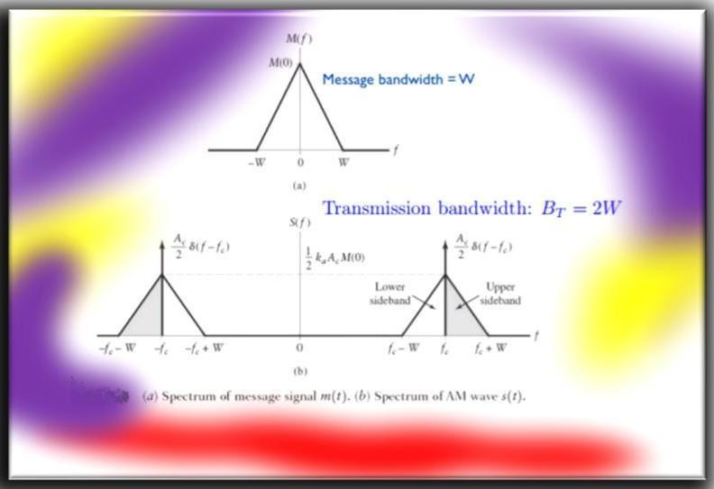
TRANSMISSION BANDWIDTH:

FIG 2.6 Spectrum of FM Bandwidth
  - FM TRANSMITTER
    - Indirect method (phase shift) of modulation
The part of the Armstrong FM transmitter (Armstrong phase modulator) which is expressed in dotted lines describes the principle of operation of an Armstrong phase modulator. It should be noted, first that the output signal from the carrier oscillator is supplied to circuits that perform the task of modulating the carrier signal. The oscillator does not change frequency, as is the case of direct FM. These points out the major advantage of phase modulation (PM), or indirect FM, over
direct FM. That is the phase modulator is crystal controlled for frequency.

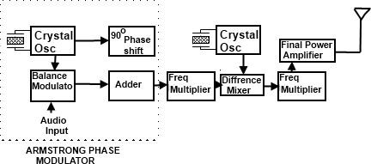
FIG 2.7 Armstrong Modulator

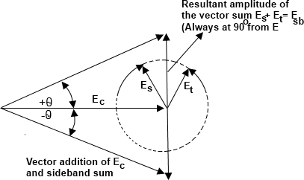
The crystal-controlled carrier oscillator signal is directed to two circuits in parallel. This signal (usually a sine wave) is established as the reference past carrier signal and is assigned a value 0°.The balanced modulator is an amplitude modulator used to form an envelope of double side- bands and to suppress the carrier signal (DSSC). This requires two input signals, the carrier signal and the modulating message signal. The output of the modulator is connected to the adder circuit; here the 90° phase-delayed carriers signal will be added back to replace the suppressed carrier. The act of delaying the carrier phase by 90° does not change the carrier frequency or its wave- shape. This signal identified as the 90° carrier signal.

FIG 2.8 Phasor diagram of Armstrong Modulator
The carrier frequency change at the adder output is a function of the output phase shift and is
found by. fc = ∆θf_{s} (in hertz)
When θ is the phase change in radians and f_{s} is the lowest audio modulating frequency. In most FM radio bands, the lowest audio frequency is 50Hz. Therefore, the carrier frequency change at the adder output is 0.6125 x 50Hz = ± 30Hz since 10% AM represents the upper limit of carrier voltage change, then ± 30Hz is the maximum deviation from the modulator for PM.
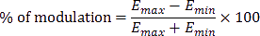
The 90° phase shift network does not change the signal frequency because the components and resulting phase change are constant with time. However, the phase of the adder output voltage is in a continual state of change brought about by the cyclical variations of the message signal, and during the time of a phase change, there will also be a frequency change.

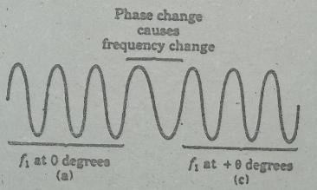
In figure. (c). during time (a), the signal has a frequency f₁, and is at the zero reference phase. During time (c), the signal has a frequency f₁ but has changed phase to θ. During time (b) when the phase is in the process of changing, from 0 to θ. the frequency is less than f₁.

Using Reactance modulator direct method
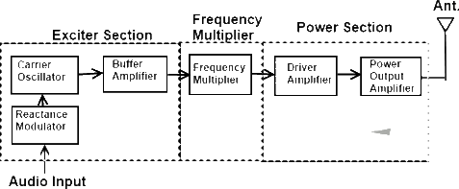

FIG 2.9 Reactance Modulator The FM transmitter has three basic sections.
- The exciter section contains the carrier oscillator, reactance modulator and the buffer amplifier.
- The frequency multiplier section, which features several frequency multipliers.
- The poweroutput ection, which includes a low-
level power amplifier, the final power amplifier, and the impedance matching network to properly load the power section with the antenna impedance.
The essential function of each circuit in the FM transmitter may be described as follows.

The Exciter
- The function of the carrier oscillator is to generate a stable sine wave signal at the rest frequency, when no modulation is applied. It must be able to linearly change frequency when fully modulated, with no measurable change in amplitude.
- The buffer amplifier acts as a constant high-impedance load on the oscillator to help stabilize the oscillator frequency. The buffer amplifier may have a small gain.
- The modulator acts to change the carrier oscillator frequency by application of the message signal. The positive peak of the message signal generally lowers the oscillator's frequency to a point below the rest frequency, and the negative message peak raises the oscillator frequency to a value above the rest frequency. The greater
the peak-to-peak message signal, the larger the oscillator deviation.
- Frequency multipliers are tuned-input, tuned-output RF amplifiers in which the output resonant circuit is tuned to a multiple of the input frequency. Common frequency multipliers are 2x, 3x and 4x multiplication. A 5x Frequency multiplier is sometimes seen, but its extreme low efficiency forbids widespread usage. Note that multiplication is by whole numbers only. There can not a 1.5x multiplier, for instance.
- The final power section develops the carrier power, to be transmitted and often has a low-power amplifier driven the final power amplifier. The impedance matching network is the same as for the AM transmitter and matches the antenna impedance to the correct load on the final over amplifier.
- Frequency Multiplier
A special form of class C amplifier is the frequency. multiplier. Any class C amplifier is capable of performing frequency multiplidàtion if the tuned circuit in the collector resonates at some

integer multiple of the input frequency.
For example a frequency doubler can be constructed by simply connecting a parallel tuned circuit in the collector of a class C amplifier that resonates at twice the input frequency. When the collector current pulse occurs, it excites or rings the tuned circuit at twice the input frequency. A current pulse flows for every other cycle of the input.
A Tripler circuit is constructed in the same way except that the tuned circuit resonates at 3 times the input - frequency. In this way, the tuned circuit receives one input pulse for every three cycles of oscillation it produces Multipliers can be constructed to increase the input

frequency by any integer factor up to approximately 10. As' the multiplication factor gets higher, the power output of the multiplier decreases. For most practical applications, the best result is obtained with multipliers of 2 and 3.
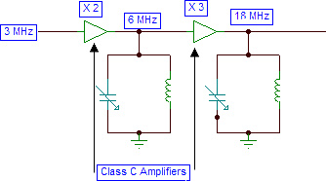
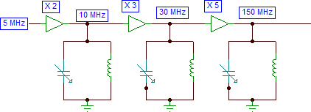
Another way to look the operation of class C multipliers is .to .remember that the non-sinusoidal current pulse is rich in harmonics. Each time the pulse occurs, the second, third, fourth, fifth, and higher harmonics are generated. The purpose of the tuned circuit in the collector is to act as a filter to select the desired harmonics.
FIG 2.10 Block Diagram of Frequency Multiplier - 1
FIG 2.10 Block Diagram of Frequency Multiplier - 2

In many applications a multiplication factor greater than that achievable with a single multiplier stage is required. In such cases two or more multipliers are cascaded to produce an overall multiplication of 6. In the second example, three multipliers provide an overall multiplication of
- The total multiplication factor is simply the product of individual stage multiplication factors.

Reactance Modulator
The reactance modulator takes its name from the fact that the impedance of the circuit acts as a reactance (capacitive or inductive) that is connected in parallel with the resonant circuit of the Oscillator. The varicap can only appear as a capacitance that becomes part of the frequency determining branch of the oscillator circuit. However, other discrete devices can appear as a capacitor or as an inductor to the oscillator, depending on how the circuit is arranged. A colpitts

oscillator uses a capacitive voltage divider as the phase-reversing feedback path and would most likely tapped coil as the phase-reversing element in the feedback loop and most commonly uses a modulator that appears inductive.

COMPARISION OF VARIOUS MODULATIONS:
    - Comparisons of Various Modulations:
- Comparisons of Narrowband and Wideband FM:
  - APPLICATION & ITS USES:
    - Magnetic Tape Storage.

Amplitude modulation | Frequency modulation | Phase modulation
1. Amplitude of the carrier  wave is varied in accordance with the message signal. | 1. Frequency of the carrier  wave is varied in accordance with the message signal. | 1. Phase of the carrier wave  is varied in accordance with the message signal.
2.Much affected by noise. | 2.More immune to the noise. | 2. Noise voltage is constant.
3.System fidelity is poor. | 3.Improved system fidelity. | Improved system fidelity.
4.Linear modulation | 4.Non Linear modulation | 4.Non Linear modulation

Narrowband FM | Wideband FM
1. Modulation index > 1. | 1. Modulation index < 1.
2.Bandwidth B = 2∆𝑓 𝐻𝑧. | 2.Bandwidth B = 2𝑓𝑚 𝐻𝑧.
3. Occupies more bandwidth. | 3. Occupies less bandwidth.
4.Used in entertainment  broadcastings | 4.Used in FM Mobile  communication services.

      - Sound
      - Noise Fm Reduction
      - Frequency Modulation (FM) stereo decoders, FM Demodulation networks for FM operation.
      - Frequency synthesis that provides multiple of a reference signal frequency.
      - Used in motor speed controls, tracking filters.

REFERENCES:
- P. Lathi, Communication Systems, John Wiley and Sons, 2005.
- Simon Haykins - ―Communication Systems‖ John Wilsey 2005.
- J.G Prokias, M.Salelhi,‖Fundamental Of Communication Systems‖ Pearson Education 2006.
- Muralibabu – ―Communication Theory‖.

GLOSSARY TERMS:
- Frequency modulation (FM), with its digital correspondence frequency-shift keying (FSK).
- Phase modulation (PM), with its digital correspondence phase-shift keying (PSK).
- In PM, the total phase of the modulated carrier changes due to the changes in the instantaneous phase of the carrier keeping the frequency of the carrier signal constant.
- A device called a phase-locked loop (PLL) can be used to demodulate an FM signal with better performance in a noisy environment than a frequency discriminator.
- As in other modulation systems, the value of the modulation index indicates by how much the modulated variable varies around its unmodulated level.
- Amplitude Limiters, are used to keep the output constant despite changes in the input signal to remove distortion.
TUTORIAL PROBLEMS:
1. If the modulating frequency is 1 kHZ and the maximum deviation is 10 KHZ, what is the required for an FM signal?
Solution:
fm = 1khz, ∆f = 10khz
Bandwidth = 2(𝑚𝑓 + 1)fm
∆𝑓

𝑚𝑓 =

𝑓𝑚
= 10

B = 22KHZ.
2. Cosider an angle modulated wave (pm) 𝑣 = 10 sin(𝜔𝑐𝑡 + 5 sin 𝑤𝑚𝑡), Let fm = 2khz calculate the modulation index and find the bandwidth.

Solution:
The equation is of the form, = 10 sin(𝜔𝑐𝑡 + 5 sin 𝑤𝑚𝑡), A = 10v, fm = 2 kHz, m = 5 Bandwidth =2(𝑚 + 1)𝑓𝑚 = 24 𝑘𝑕𝑧.

WORKED OUT PROBLEMS:

1. Find the deviation ratio if the maximum frequency deviation is 60 kHz and the fm = 10khz.
∆𝐟

𝐃𝐞𝐯𝐢𝐚𝐭𝐢𝐨𝐧 𝐫𝐚𝐭𝐢𝐨 = (
𝐟𝐦
) ; 𝐀𝐧𝐬 ∶ 𝟔

2. Angle modulated signal is given by 𝒙(𝒕) = 𝟓 𝐜𝐨𝐬[𝟐𝝅𝟏𝟎^{𝟔}𝒕 + 𝟎. 𝟐 𝐜𝐨𝐬 𝟐𝟎𝟎 𝝅𝒕] Find whether xa(t) is PM or FM?
Ans : xa(t) can be either FM or PM.

UNIT – III RANDOM PROCESS
  - PREREQUISTING ABOUT RANDOM PROCESS:

In probability theory, a stochastic process, or sometimes random process is a collection of random variables, representing the evolution of some system of random values over time. This is the probabilistic counterpart to a deterministic process. A random process, or stochastic process, X(t), is an ensemble of number of sample functions {X1(t),X2(t), . . . ,X_(t)} together with a probability rule which assigns a probability to any meaningful event associated with the
observation of these functions. Suppose the sample function Xi(t) corresponds to the sample point si in the sample space S and occurs with probability Pi.
- may be finite or infinite.
- Sample functions may be defined at discrete or continuous time instants.
Random process associated with the Poisson model, and more generally, renewal theory include
  - The sequence of inter arrival times.
  - The sequence of arrival times.
  - The counting process.
CONTENT:
    - RANDOM VARIABLES
    - CENTRAL LIMIT THEOREM
    - STATIONARY PEROCESS
    - CORRELATION

COVARIANCE FUNCTION
    - ERGODIC PROCESS

GAUSSIAN PROCES
    - FLITERING THROUGH RANDOM PROCESS

RANDOM VARIABLES:
A random variable, usually written X, is a variable whose possible values are numerical outcomes of a random phenomenon. Random variable consists of two types they are discrete and continuous type variable this defines discrete- or continuous-time random processes. Sample function values may take on discrete or continuous a value is defines discrete- or continuous Sample function

values may take on discrete or continuous values. This defines discrete- or continuous-parameter random process.

RANDOM PROCESSES VS. RANDOM VARIABLES:
- For a random variable, the outcome of a random experiment is mapped onto variable, e.g., a number.
- For a random processes, the outcome of a random experiment is mapped onto a waveform that is a function of time.Suppose that we observe a random process X(t) at some time t1 to generate the servation X(t1) and that the number of possible waveforms is finite. If Xi(t1) is observed with probability Pi, the collection of numbers {Xi(t1)}, i =1, 2, . . . , n forms a random variable, denoted by X(t1), having the probabilitydistribution Pi, i = 1, 2, . . . , n. E[ ・ ] = ensemble
average operator.
- DISCRETE RANDOM VARIABLES:
A discrete random variable is one which may take on only a countable number of distinct values such as 0,1,2,3,4,........ Discrete random variables are usually (but not necessarily) counts. If a random variable can take only a finite number of distinct values, then it must be discrete. Examples of discrete random variables include the number of children in a family, the Friday night attendance at a cinema, the number of patients in a doctor's surgery, the number of defective light bulbs in a box of ten.
- PROBABILITY DISTRIBUTION:
The probability distribution of a discrete random variable is a list of probabilities associated with each of its possible values. It is also sometimes called the probability function or the probability mass function. Suppose a random variable X may take k different values, with the probability that X = x_{i} defined to be P(X = x_{i}) = p_{i}. The probabilities p_{i} must satisfy the following:
1: 0 < p_{i} < 1 for each i 2: p₁ + p₂ + ... + p_{k} = 1.
All random variables (discrete and continuous) have a cumulative distribution function. It is a function giving the probability that the random variable X is less than or equal to x, for every value x. For a discrete random variable, the cumulative distribution function is found by summing up the probabilities.

CENTRAL LIMIT THEOREM:
In probability theory, the central limit theorem (CLT) states that, given certain conditions, the arithmetic mean of a sufficiently large number of iterates of independent random variables, each

SCE 56 DEPT OF ECE

with a well-defined expected value and well-defined variance, will be approximately normally distributed.
The Central Limit Theorem describes the characteristics of the "population of the means" which has been created from the means of an infinite number of random population samples of size (N), all of them drawn from a given "parent population". The Central Limit Theorem predicts that regardless of the distribution of the parent population:
- The mean of the population of means is always equal to the mean of the parent population from which the population samples were drawn.
- The standard deviation of the population of means is always equal to the standard deviation of the parent population divided by the square root of the sample size (N).
- The distribution of means will increasingly approximate a normal distribution as the size N of samples increases.
A consequence of Central Limit Theorem is that if we average measurements of a particular quantity, the distribution of our average tends toward a normal one. In addition, if a measured variable is actually a combination of several other uncorrelated variables, all of them "contaminated" with a random error of any distribution, our measurements tend to be contaminated with a random error that is normally distributed as the number of these variables increases.Thus, the Central Limit Theorem explains the ubiquity of the famous bell-shaped "Normal distribution" (or "Gaussian distribution") in the measurements domain.
Examples:
  - Uniform distribution
  - Triangular distribution
  - 1/X distribution

  - Parabolic distribution
  - CLT Summary
  - more statistical fine-print
The uniform distribution on the left is obviously non-Normal. Call that the parent distribution.

SCE 57 DEPT OF ECE

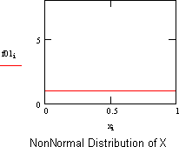
FIG 3.1 Non uniform distributions
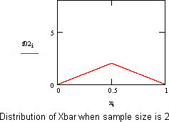
To compute an average, Xbar, two samples are drawn, at random, from the parent distribution and averaged. Then another sample of two is drawn and another value of Xbar computed. This process is repeated, over and over, and averages of two are computed. The distribution of
averages of two is shown on the left.
FIG 3.2 Distributions of Xbar
Repeatedly taking three from the parent distribution, and computing the averages, produce the probability density on the left.

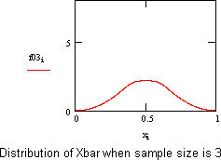
FIG 3.3 Distributions of Xbar

STATIONARY PROCESS:
In mathematics and statistics, a stationary process is a stochastic process whose joint probability distribution does not change when shifted in time. Consequently, parameters such as

the mean and variance, if they are present, also do not change over time and do not follow any trends.
Stationary is used as a tool in time series analysis, where the raw data is often transformed to become stationary; for example, economic data are often seasonal and/or dependent on a non- stationary price level. An important type of non-stationary process that does not include a trend- like behaviour is the cyclostationary process.
Note that a "stationary process" is not the same thing as a "process with a stationary distribution". Indeed there are further possibilities for confusion with the use of "stationary" in the context of stochastic processes; for example a "time-homogeneous" Markov chain is sometimes said to have "stationary transition probabilities". Besides, all stationary Markov random processes
are time-homogeneous.
- Definition:
Formally, let be a stochastic
the cumulative
distribution
process and let
function of the joint
represent
distribution of at
times
. Then,
is said to be stationary if, for all , for all , and for
all
,
Since
✓
does not affect
,
is not a function of time.
Wide Sense Stationary:
Weaker form of stationary commonly employed in signal processing is known as weak-sense stationary, wide-sense stationary (WSS), covariance stationary, or second-order stationary. WSS random processes only require that 1st moment and covariance do not vary with respect to time.
Any strictly stationary process which has a mean and a covariance is also WSS.
So, a continuous-time random process x(t) which is WSS has the following restrictions on its mean function.
and auto covariance function.

CORRELATION:
In statistics, dependence is any statistical relationship between two random variables or two sets of data. Correlation refers to any of a broad class of statistical relationships involving dependence. Familiar examples of dependent phenomena include the correlation between the physical statures of parents and their offspring, and the correlation between the demand for a

SCE 59 DEPT OF ECE

product and its price. Correlations are useful because they can indicate a predictive relationship that can be exploited in practice. For example, an electrical utility may produce less power on a mild day based on the correlation between electricity demand and weather. In this example there is a causal relationship, because extreme weather causes people to use more electricity for heating or cooling; however, statistical dependence is not sufficient to demonstrate the presence of such a causal relationship.
Formally, dependence refers to any situation in which random variables do not satisfy a mathematical condition of probabilistic independence. In loose usage, correlation can refer to any departure of two or more random variables from independence, but technically it refers to any of several more specialized types of relationship between mean values. There are several correlation
coefficients, often denoted ρ or r, measuring the degree of correlation. The most common of these is the Pearson correlation coefficient, which is sensitive only to a linear relationship between two variables. Other correlation coefficients have been developed to be more robust than the Pearson correlation that is, more sensitive to nonlinear relationships. Mutual information can also be applied to measure dependence between two variables.
- Pearson's correlation coefficient:
He most familiar measure of dependence between two quantities is the Pearson product-moment correlation coefficient, or "Pearson's correlation coefficient", commonly called simply "the correlation coefficient". It is obtained by dividing the covariance of the two variables by the product of their standard deviations. Karl Pearson developed the coefficient from a similar but slightly different idea by Francis Galton.
The population correlation coefficient ρ_{X,Y} between two random variables X and Y with expected
values μ_{X} and μ_{Y} and standard deviations 𝜎_{X} and 𝜎_{Y} is defined as:

where E is the expected value operator, cov means covariance, and, corr a widely used alternative notation for the correlation coefficient.
The Pearson correlation is defined only if both of the standard deviations are finite and nonzero. It is a corollary of the Cauchy–Schwarz inequality that the correlation cannot exceed 1 in absolute value. The correlation coefficient is symmetric: corr(X,Y) = corr(Y,X).
The Pearson correlation is +1 in the case of a perfect direct (increasing) linear relationship (correlation), −1 in the case of a perfect decreasing (inverse) linear relationship (autocorrelation),
and some value between −1 and 1 in all other cases, indicating the degree of linear SCE 60 DEPT OF ECE

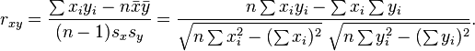
dependence between the variables. As it approaches zero there is less of a relationship (closer to uncorrelated). The closer the coefficient is to either −1 or 1, the stronger the correlation between the variables.
If the variables are independent, Pearson's correlation coefficient is 0, but the converse is not true because the correlation coefficient detects only linear dependencies between two variables. For example, suppose the random variable X is symmetrically distributed about zero, and Y = X². Then Y is completely determined by X, so that X and Y are perfectly dependent, but their correlation is zero; they are uncorrelated. However, in the special case when X and Y are jointly normal, uncorrelatedness is equivalent to independence.
If we have a series of n measurements of X and Y written as x_{i} and y_{i} where i = 1, 2, ..., n, then
the sample correlation coefficient can be used to estimate the population Pearson correlation r between X and Y.
where x and y are the sample means of X and Y, and s_{x} and s_{y} are the sample standard deviations of X and Y.
This can also be written as:
If x and y are results of measurements that contain measurement error, the realistic limits on the correlation coefficient are not −1 to +1 but a smaller range.
3.5 COVARIANCE FUNCTIONS:
In probability theory and statistics, covariance is a measure of how much two variables change together, and the covariance function, or kernel, describes the spatial covariance of a random
variable process or field. For a random field or stochastic process Z(x) on a domain D, a covariance function C(x, y) gives the covariance of the values of the random field at the two locations x and y:
The same C(x, y) is called the auto covariance function in two instances: in time series (to denote exactly the same concept except that x and y refer to locations in time rather than in space), and in multivariate random fields (to refer to the covariance of a variable with itself, as opposed to the cross covariance between two different variables at different locations, Cov(Z(x₁), Y(x₂))).

Mean & Variance of covariance functions:
For locations x₁, x₂, …, x_{N} ∈ D the variance of every linear combination
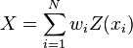
can be computed as
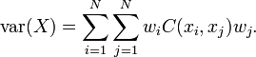
A function is a valid covariance function if and only if this variance is non-negative for all

(RXX)T = ( ) ∫ x(t) ∗ x(t − T)dt
possible choices of N and weights w₁, …, w_{N}. A function with this property is called positive definite.
3.6 ERGODIC PROCESS:
In the event that the distributions and statistics are not available we can avail ourselves of the time averages from the particular sample function. The mean of the sample function Xλo(t)
is referred to as the sample mean of the process X(t) and is defined as
(μ(X)T) = (1) ∫T/2 Xλo(t)dt
T
−T/2
This quantity is actually a random-variable by itself because its value depends on the parameter
sample function over it was calculated. the sample variance of the random process is defined as
(𝜎²(X)T) = ( ) ∫
1
T/2
2
T
||Xλo(t)| − (μx)T| dt
−T/2
The time-averaged sample ACF is obtained via the relation is
1
T/2
T −T/2
These quantities are in general not the same as the ensemble averages described before. A random process X(t) is said to be ergodic in the mean, i.e., first-order ergodic if the mean of sample average asymptotically approaches the ensemble mean
lim_{T→∞} E{(μX)T} = μx(t)
lim var{(μX)T} = 0
T→∞
In a similar sense a random process X(t) is said to be ergodic in the ACF, i.e, second-order ergodic if
lim E{(RXX(τ))} = RXX(τ)
T→∞

lim var{(RXX(τ))} = 0
T→∞
The concept of ergodicity is also significant from a measurement perspective because in Practical situations we do not have access to all the sample realizations of a random process. We therefore have to be content in these situations with the time-averages that we obtain from a single realization. Ergodic processes are signals for which measurements based on a single sample function are sufficient to determine the ensemble statistics. Random signal for which this property does not hold are referred to as non-ergodic processes. As before the Gaussian random signal is an exception where strict sense ergodicity implies wide sense ergodicity.

GUASSIAN PROCESSS:
A random process X(t) is a Gaussian process if for all n and all (t1 ,t2 ,…,tn ), the random
variables have a jointly Gaussian density function. For Gaussian processes, knowledge of the mean and autocorrelation; i.e., mX (t) and Rx (t1 ,t2 ) gives a complete statistical description of the process. If the Gaussian process X(t) is passed through an LTI system, then the output process Y(t) will also be a Gaussian process. For Gaussian processes, WSS and strict stationary are
equivalent.
A Gaussian process is a stochastic process X_{t}, t ∈ T, for
which
More normally
any finite linear
combination of samples has a joint
Gaussian
distribution.
linear functional applied to the sample functionX_{t} will give a
accurately, any
distributed result.
Notation-wise, one can write X ~ GP(m,K), meaning the random function X is distributed as a GP with mean function m and covariance function K.^{[1]} When the input vector t is two- or multi- dimensional a Gaussian process might be also known as a Gaussian random field.
A sufficient condition for the ergodicity of the stationary zero-mean Gaussian process X(t) is that

Jointly Gaussian processes:
∞
∫−∞
RX(τ)dτ < ∞.

The random processes X(t) and Y(t) are jointly Gaussian if for all n, m and all (t1 ,t2 ,…,tn ), and (τ1 , τ2 ,…, τm ), the random vector (X(t1 ),X(t2 ),…,X(tn ), Y(τ1 ),Y( τ2 ),…, Y(τm )) is distributed according to an n+M dimensional jointly Gaussian distribution.
For jointly Gaussian processes, uncorrelatedness and independence are equivalent.

LINEAR FILTERING OF RANDOM PROCESSES:
- A random process X(t) is applied as input to a linear time-invariant filter of impulse response h(t),
- It produces a random process Y (t) at the filter output as

X(t) →→→→→h(t)→→→ Y(t)
- Difficult to describe the probability distribution of the output random process Y (t), even when the probability distribution of the input random process X(t) is completely specified for
−∞ ≤ t ≤ +∞.
- Estimate characteristics like mean and autocorrelation of the output and try to analyse its behaviour.
- Mean The input to the above system X(t) is assumed stationary. The mean of the output random process Y (t) can be calculated

mY (t) = E[Y (t)] = E[ ∞
∫
−∞
h(τ )X(t − τ ) dτ]

= ∫∞ h(τ )E[X(t − τ )] dτ
−∞
−∞
= mXH(0)
where H(0) is the zero frequency response of the system.
- Autocorrelation:
The autocorrelation function of the output random process Y (t). By definition, we have
RY (t, u) = E[Y (t)Y (u)]
where t and u denote the time instants at which the process is observed. We may therefore use the convolution integral to write
= mX ∫∞ h(τ ) dτ
RY (t, u) = E [∫∞ h(τ1)X(t − τ1) dτ1] ∫∞ h(τ2)X(t − τ2) dτ2 ]
−∞
∞
= ∫∞ h(τ1) dτ1 ∫∞ h(τ2)E [X(t − τ1)X(t − τ2)] dτ2
−∞
−∞
When the input X(t) is a wide-stationary random process, autocorrelation function of X(t) is only a
function of the difference between the observation times t − τ1 and u − τ2.

Putting τ = t − u, we get
RY (τ ) = ∞
∫
−∞

∞
∫−∞

h(τ1)h(τ2)RX(τ − τ1 + τ2) dτ1 dτ2 RY (0) = E[Y²(t)]

The mean square value of the output random process Y (t) is obtained by putting τ = 0 in the
above equation.

E[ Y²(t)] = ∞
∫
−∞
∞
∫−∞
h(τ1)h(τ2)RX(τ2 − τ1) dτ1 dτ2

The mean square value of the output of a stable linear time-invariant filter in response to a wide- sense stationary random process is equal to the integral over all frequencies.

of the power spectral density of the input random process multiplied by the squared magnitude of the transfer function of the filter.

APPLICATION AND ITS USES:
- A Gaussian process can be used as a prior probability distribution over functions in Bayesian inference.
- Wiener process (aka Brownian motion) is the integral of a white noise Gaussian process. It is not stationary, but it has stationary increments.

REFERENCES:
1. Copyrights Zhu, Weihon School of Information Science and Engineering, Shandong University ―Principles of the Communications‖
- Simon Haykins - ―Communication Systems‖ John Wilsey 2005.
- J.G Prokias, M.Salelhi,‖Fundamental Of Communication Systems‖ Pearson Education 2006.
- Muralibabu – ―Communication Theory‖.
GLOSSARY TERMS:
- A Random experiment is called a random experiment if its outcomes cannot be predicted.
- Sample space, the set of all possible outcomes of a random experiment.
- SSS, A Random process is strict sense stationary if its satisfies are in variant to a shift of origin.
- Ergodic Process, if time averages are the same for all sample functions and equal to the corresponding ensemble averages.
- Noise, as an unwanted interference of energy with the wanted signals.

6. The power spectral density of white noise is constant.

UNIT – IV

NOISE CHARACTERISATION

PREREQUISTING ABOUT NOISE:

Noise is an inevitable consequence of the working of minerals and is an important health and safety consideration for those working on the site. Whether it becomes "environmental noise" depends on whether it disrupts or disturbs people outside the site boundary.

CONTENT:
    - NOISE IN COMMUNCATION SYSTEM

CLASSIFICATION OF NOISE
- NOISE FIGURE & TEMPERATURE
- NOISE IN CASCADE SYSTEMS
- REPRESENTATION OF NARROW BAND NOISE
- NOISE PERFORMANCE
- PREEMPHESIS & DE EMPHESIS
- CAPTURE AND THERSHOLD EFFECT
  - INTRODUCTION:
Noise is often described as the limiting factor in communication systems: indeed if there as no noise there would be virtually no problem in communications.
Noise is a general term which is used to describe an unwanted signal which affects a wanted signal. These unwanted signals arise from a variety of sources which may be considered in one of two main categories:-
    - Interference, usually from a human source (manmade)
b) Naturally occurring random noise.
Interference arises for example, from other communication systems (cross talk), 50 Hz supplies (hum) and harmonics, switched mode power supplies, thyristor circuits, ignition (car spark plugs) motors … etc. Interference can in principle be reduced or completely eliminated by careful engineering (i.e. good design, suppression, shielding etc). Interference is essentially deterministic (i.e. random, predictable), however observe.
When the interference is removed, there remains naturally occurring noise which is essentially random (non-deterministic),. Naturally occurring noise is inherently present in electronic communication systems from either ‗external‘ sources or ‗internal‘ sources.

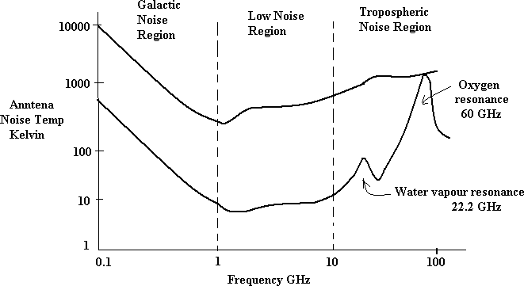
Naturally occurring external noise sources include atmosphere disturbance (e.g. electric storms, lighting, ionospheric effect etc), so called ‗Sky Noise‘ or Cosmic noise which includes noise from galaxy, solar noise and ‗hot spot‘ due to oxygen and water vapour resonance in the earth‘s atmosphere. These sources can seriously affect all forms of radio transmission and the design of a radio system (i.e. radio, TV, satellite) must take these into account.The diagram below shows noise temperature (equivalent to noise power, we shall discuss later) as a function of frequency for sky noise.

The upper curve represents an antenna at low elevation (~ 5º above horizon), the lower curve represents an antenna pointing at the zenith (i.e. 90º elevation).

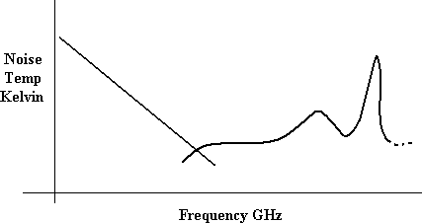
Contributions to the above diagram are from galactic noise and atmospheric noise as shown below.Note that sky noise is least over the band – 1 GHz to 10 GHz. This is referred to as a low noise ‗window‘ or region and is the main reason why satellite links operate at frequencies in this

band (e.g. 4 GHz, 6GHz, 8GHz). Since signals received from satellites are so small it is important to keep the background noise to a minimum.

Naturally occurring internal noise or circuit noise is due to active and passive electronic devices (e.g. resistors, transistors ...etc) found in communication systems. There are various mechanism which produce noise in devices; some of which will be discussed in the following sections.
- THERMAL NOISE (JOHNSON NOISE):
This type of noise is generated by all resistances (e.g. a resistor, semiconductor, the resistance of a resonant circuit, i.e. the real part of the impedance, cable etc).
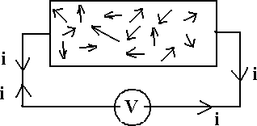
Free electrons are in contact random motion for any temperature above absolute zero (0 degree K,
~ -273 degree C). As the temperature increases, the random motion increases, hence thermal noise, and since moving electron constitute a current, although there is no net current flow, the
motion can be measured as a mean square noise value across the resistance.
FIGURE 4.1 Circuit Diagram of Thermal Noise Voltage
Experimental results (by Johnson) and theoretical studies (by Nyquist) give the mean square noise
_ 2
voltage as V = 4 k TBR (volt ² )
Where k = Boltzmann‘s constant = 1.38 x 10⁻²³ Joules per K T = absolute temperature
B = bandwidth noise measured in (Hz) R = resistance (ohms)
The law relating noise power, N, to the temperature and bandwidth is N = k TB watts
These equations will be discussed further in later section.
The equations above held for frequencies up to > 10¹³ Hz (10,000 GHz) and for at least all practical temperatures, i.e. for all practical communication systems they may be assumed to be

valid.Thermal noise is often referred to as ‗white noise‘ because it has a uniform ‗spectral density‘.
Note – noise power spectral density is the noise power measured in a 1 Hz bandwidth i.e. watts per Hz. A uniform spectral density means that if we measured the thermal noise in any 1 Hz bandwidth from ~ 0Hz → 1 MHz → 1GHz …….. 10,000 GHz etc we would measure the same amount of noise.

From the equation N=kTB, noise power spectral density is
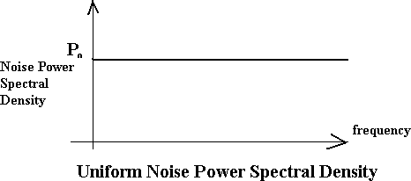
I.e. Graphically figure 4.2 is shown as,
po = kT watts per Hz.

- SHOT NOISE:
Shot noise was originally used to describe noise due to random fluctuations in electron emission from cathodes in vacuum tubes (called shot noise by analogy with lead shot). Shot noise also occurs in semiconductors due to the liberation of charge carriers, which have discrete amount of charge, in to potential barrier region such as occur in pn junctions. The discrete amounts of charge
give rise to a current which is effectively a series of current pulses.
For pn junctions the mean square shot noise current is

Where
n
DC
I ² = 2(I
- 2 Io
)qe B
(amps)²

I DC is the direct current as the pn junction (amps)
I 0 is the reverse saturation current (amps)
q is the electron charge = 1.6 x 10⁻¹⁹ coulombs
e

B is the effective noise bandwidth (Hz)
Shot noise is found to have a uniform spectral density as for thermal noise.

  - LOW FREQUENCY OR FLICKER NOISE:
Active devices, integrated circuit, diodes, transistors etc also exhibits a low frequency noise, which is frequency dependent (i.e. non uniform) known as flicker noise or ‗one – over – f‘ noise.

The mean square value is found to be proportional to ⎛⎜
⎝
n
⎟ where f is the frequency and n= 1.
1
f
⎞
⎠

Thus the noise at higher frequencies is less than at lower frequencies. Flicker noise is due to impurities in the material which in turn cause charge carrier fluctuations.
1
f
  - EXCESS RESISTOR NOISE:
Thermal noise in resistors does not vary with frequency, as previously noted, by many resistors
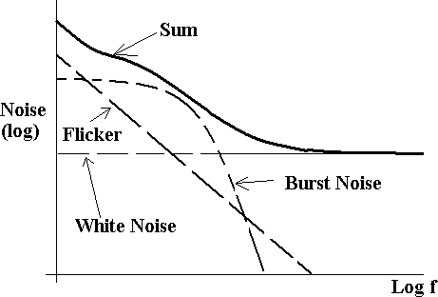
also generates as additional frequency dependent noise referred to as excess noise. This noise also exhibits a (1/f) characteristic, similar to flicker noise.
Carbon resistor generally generates most excess noise whereas were wound resistors usually generates negligible amount of excess noise. However the inductance of wire wound resistor limits their frequency and metal film resistor are usually the best choices for high frequency communication circuit where low noise and constant resistance are required.
- BURST NOISE OR POPCORN NOISE:
Some semiconductors also produce burst or popcorn noise with a spectral density which is
proportional to ⎜ ⎟ .
⎛
⎞2
⎝ ⎠
- GENERAL COMMENTS:
The diagram below illustrates the variation of noise with frequency.

For frequencies below a few KHz (low frequency systems), flicker and popcorn noise are the most significant, but these may be ignored at higher frequencies where ‗white‘ noise predominates.

Thermal noise is always presents in electronic systems. Shot noise is more or less significant depending upon the specific devices used for example as FET with an insulated gate avoids junction shot noise. As noted in the preceding discussion, all transistors generate other types of
‗non-white‘ noise which may or may not be significant depending on the specific device and application. Of all these types of noise source, white noise is generally assumed to be the most significant and system analysis is based on the assumption of thermal noise. This assumption is reasonably valid for radio systems which operates at frequencies where non-white noise is greatly reduced and which have low noise ‗front ends‘ which, as shall be discussed, contribute most of the internal (circuit) noise in a receiver system. At radio frequencies the sky noise contribution is significant and is also (usually) taken into account.
Obviously, analysis and calculations only gives an indication of system performance. Measurements of the noise or signal-to-noise ratio in a system include all the noise, from whatever source, present at the time of measurement and within the constraints of the measurements or system bandwidth.
Before discussing some of these aspects further an overview of noise evaluation as applicable to communication systems will first be presented.
- NOISE EVALUATION:
  - OVERVIEW:
It has been stated that noise is an unwanted signal that accompanies a wanted signal, and, as discussed, the most common form is random (non-deterministic) thermal noise.
The essence of calculations and measurements is to determine the signal power to Noise power ratio, i.e. the (S/N) ratio or (S/N) expression in dB.
i.e. Let S= signal power (mW)

N = noise power (mW)

⎛ S ⎞ S
=
⎜ N ⎟ N
⎝ ⎠ratio

⎛ S ⎞
⎜ N ⎟
=10 log
⎛ S ⎞
₁₀⎜ N ⎟

⎝ ⎠_{dB} ⎝ ⎠
⎠
Alsorecall that

- =10log
⎛ S (mW ) ⎞

dBm
10 ⎜
⎝
⎠
1mW ⎟

and N
=10log
⎛ N (mW ) ⎞

dBm
10 ⎜
⎝
1mW ⎟

i.e. ⎛ S ⎞
⎜ ⎟
N
=10 log10
S −10log₁₀ N

⎝ ⎠_{dB}

⎛ S ⎞
⎜ N ⎟
= SdBm
- NdBm

⎝ ⎠_{dB}
Powers are usually measured in dBm (or dBw) in communications systems. The equation

⎛ S ⎞
⎜ N ⎟

= SdBm

- NdBm

is often the most useful.

⎝

The
⎠dB
⎛ S ⎞
⎜ N ⎟

at various stages in a communication system gives an indication of system quality and

⎝ ⎠
performance in terms of error rate in digital data communication systems and ‗fidelity‘ in case of
analogue communication systems. (Obviously, the larger the ⎛ S ⎞ , the better the system will be).
⎜ ⎟
N
⎝ ⎠
Noise, which accompanies the signal is usually considered to be additive (in terms of powers) and its often described as Additive White Gaussian Noise, AWGN, noise. Noise and signals may also

be multiplicative and in some systems at some levels of
⎛ S ⎞ , this may be more significant then
N
⎜ ⎟

⎝ ⎠
AWGN.In order to evaluate noise various mathematical models and techniques have to be used, particularly concepts from statistics and probability theory, the major starting point being that random noise is assumed to have a Gaussian or Normal distribution.
We may relate the concept of white noise with a Gaussian distribution as follows:

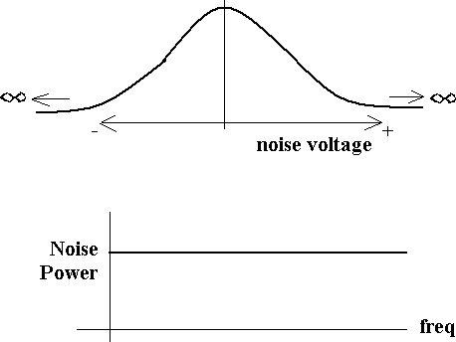

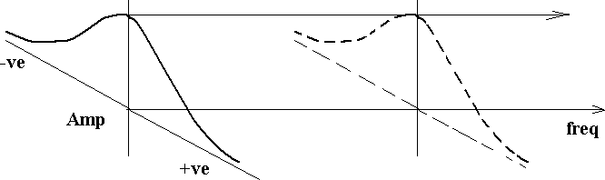
FIGURE 4.4 Characteristics of Thermal Noise

FIGURE 4.3 Probability of noise voltage vs voltage
Gaussian distribution – ‗graph‘ shows Probability of noise voltage vs voltage – i.e. most probable noise voltage is 0 volts (zero mean). There is a small probability of very large +ve or –ve noise voltages.
White noise – uniform noise power from ‗DC‘ to very high frequencies.
Although not strictly consistence, we may relate these two characteristics of thermal noise as follows:
The probability of amplitude of noise at any frequency or in any band of frequencies (e.g. 1 Hz, 10Hz… 100 KHz .etc) is a Gaussian distribution.Noise may be quantified in terms of noise power spectral density, p₀ watts per Hz, from which Noise power N may be expressed as
N= p₀ B_{n} watts
Where B_{n} is the equivalent noise bandwidth, the equation assumes p₀ is constant across the band (i.e. White Noise).

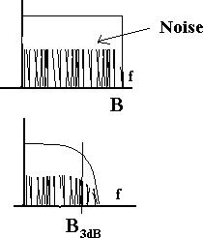
Note - B_{n} is not the 3dB bandwidth, it is the bandwidth which when multiplied by p₀ Gives the actual output noise power N. This is illustrated further below.

FIGURE 4.5 Basic Ideal Low Pass Filter
Ideal low pass filter
Bandwidth B Hz = B_{n} N= p₀ B_{n} watts
Practical LPF
3 dB bandwidth shown, but noise does not suddenly cease at B_{3dB} Therefore, B_{n} > B_{3dB}, B_{n} depends on actual filter.
N= p₀ B_{n}
In general the equivalent noise bandwidth is > B_{3dB}.

Alternatively, noise may be quantified in terms of ‗mean square noise‘ i.e. V ² , which is
effectively a power. From this a ‗Root mean square (RMS)‘ value for the noise voltage may be determined.
____
V 2

i.e. RMS =
In order to ease analysis, models based on the above quantities are used. For example, if we imagine noise in a very narrow bandwidth, δf , as δf → df , the noise approaches a sine wave (with frequency ‗centred‘ in df).Since an RMS noise voltage can be determined, a ‗peak‘ value of the noise may be invented since for a sine wave

RMS =
2
Peak

Note – the peak value is entirely fictious since in theory the noise with a Gaussian distribution could have a peak value of + ∞ or - ∞ volts.
Hence we may relate
Mean square → RMS → (RMS) → Peak noise voltage (invented for convenience)
2
Problems arising from noise are manifested at the receiving end of a system and hence most of the analysis relates to the receiver / demodulator with transmission path loss and external noise sources (e.g. sky noise) if appropriate, taken into account.
The transmitter is generally assumed to transmit a signal with zero noise (i.e (S/N) at the Tx → ∞
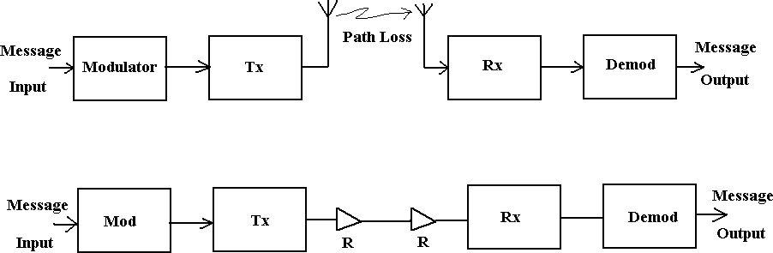
General communication system block diagrams to illustrate these points are shown below.

FIGURE 4.6 Block Diagrams of Communication System
Transmission Line
R = repeater (Analogue) or Regenerators (digital)
These systems may facilitate analogue or digital data transfer. The diagram below characterizes these typical systems in terms of the main parameters.

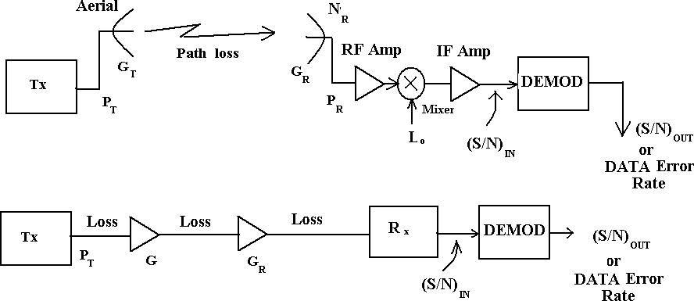
FIGURE 4.7 Block Diagrams of Communication System P_{T} represents the output power at the transmitter.
G_{T} represents the Tx aerial gain.
Path loss represents the signal attenuation due to inverse square law and absorption e.g. in atmosphere.
G represents repeater gains.
P_{R} represents receiver inout signal power
N_{R} represents the received external noise (e.g. sky noise) G_{R} represents the receiving aerial gain.
⎛ S ⎞
⎜ N ⎟
⎝
⎠IN
represents the ⎛ S ⎞ at the input to the demodulator
⎜ N ⎟
⎝ ⎠
⎛ S ⎞
⎜ N ⎟
⎝
⎠OUT
represents the quality of the output signal for analogue systems
  - DATA ERROR RATE represents the quality of the output (probability of error) for digital data system.
  - ANALYSIS OF NOISE IN COMMUNICATION SYSTEMS:

Thermal Noise (Johnson noise)
It has been discussed that the thermal noise in a resistance R has a mean square value given by

V ² = 4 k TBR (volt ² )
Where k = Boltzmann‘s constant = 1.38 x 10⁻²³ Joules per K T = absolute temperature
B = bandwidth noise measured in (Hz)

R = resistance (ohms)
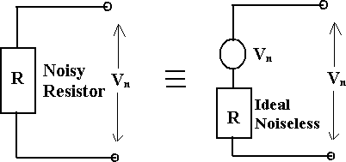
This is found to hold for large bandwidth (>10¹³ Hz) and large range in temperature. This thermal noise may be represented by an equivalent circuit as shown below.

FIGURE 4.7 Equivalent Circuit of Thermal Noise Voltage
i.e. equivalent to the ideal noise free resistor (with same resistance R) in series with a voltage source with voltage V_{n}.
Since

V ² = 4 k TBR (volt ² ) (mean square value , power)

then V_{RMS} = = 2 kTBR =Vn in above
i.e. V_{n} is the RMS noise voltage.
The above equation indicates that the noise power is proportional to bandwidth. For a given resistance R, at a fixed temperature T (Kelvin)
We have V ² =(4 k TR) B , where (4 k TR) is a constant – units watts per Hz.

For a given system, with
(4 k TR)
constant, then if we double the bandwidth from B Hz to 2B Hz,

the noise power will double (i.e increased by 3 dB). If the bandwidth were increased by a factor of 10, the noise power is increased by a factor of 10.For this reason it is important that the system bandwidth is only just ‗wide‘ enough to allow the signal to pass to limit the noise bandwidth to a minimum.
____
V 2
- I.e. Signal Spectrum Signal Power = S
- System BW = B Hz
N= Constant B (watts) = KB

- System BW
N= Constant 2B (watts) = K2B
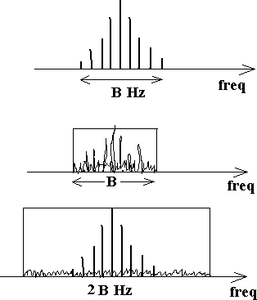

FIGURE 4.8 Spectrum Diagrams of Communication System
For A,
N KB
S = S
,
For B,
N K 2B
S =
S
i.e. S for B only ½ that for A.
N
  - Noise Voltage Spectral Density
Since date sheets specify the noise voltage spectral density with unit‘s volts per root Hz).
(volts per
This is from
Vn = (2 kTR)
i.e. Vn is proportional to
. The quantity in bracket, i.e.
( 2 kTR ) has units of volts per
. If the bandwidth B is doubled the noise voltage will

increased by . If bandwidth is increased by 10, the noise voltage will increased by .
Hz
B
B
Hz
2
10

Resistance in Series
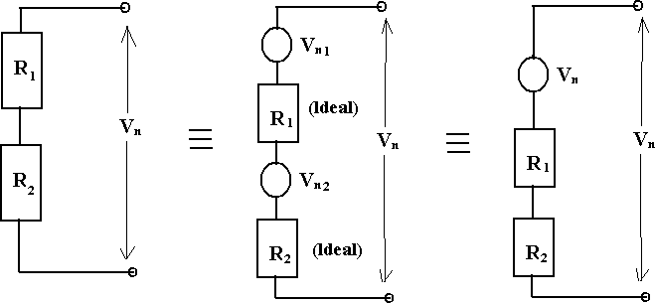

FIGURE 4.9 Circuit Diagram of Resistance in Series Assume that R₁ at temperature T₁ and R₂ at temperature T_{2,} then

V ² = V n12
- V n2 2
(we add noise power not noise voltage)

n

Vn1
² = 4 k T
B R1
Vn2
² = 4 k T
B R2

1
2

∴ V ² = 4 k B (T R +T R )
Mean square noise

n 1 1 2 2

If T₁= T₂ = T then
V ² = 4 kT B (R + R )

n 1 2
i.e. The resistor in series at same temperature behave as a single resistor (R₁ + R₂ ) .
- Resistance in Parallel

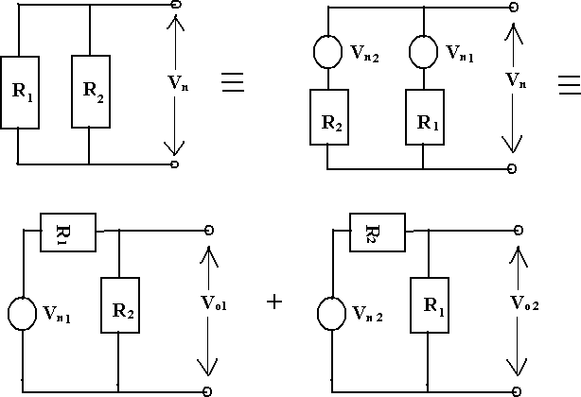

FIGURE 4.10 Circuit Diagram of Resistance in Parallel
Since an ideal voltage source has zero impedance, we can find noise as an output V_{o1}, due to V_{n1} , an output voltage V₀₂ due to V_{n2}.

Vo1
=Vn1
1
R
R2
- R2
Vo 2
=Vn 2
1
R
R1
- R2

V 2 = V o12 + V o2 2
n

Assuming
R1 at temperature T1
and
R2 at temperature T2

Hence,
1
2
Vn1

² = 4 k T
B R1

⎛
and

R ⎞2
Vn2
² = 4 k T
B R2

V ² = 4 k T B R ⎜ ² ⎟
1

o1
⎝
R
2 ⎠

and
1 1 + R

⎛ R ⎞2
V ² = 4 k T B R ⎜ ¹ ⎟
o2
2 2
⎝ 1 2 ⎠
R + R
⎧
⎪e.g.
⎪
V = V
1 ,
R
- R
V =(
2
o1 n1
V )
2
⎛
⎜
2
R
⎞2 ⎫
o1 n1 R
⎟ ⎪
⎪
1 2
⎝ 1 2 ⎠
R + R
⎪
⎪
⎪
⎨
⎪
⎪
⎪
⎪⎩
V = RMS, ∴(V
⎪
n1
n1
)
2
= Meansqaure = V
2
n1
⎛
V 2 = V2 ⎜ 2 ⎟ 2
R ⎞
o1 n1
⎝ R
1 2
+ R ⎠
⎬
⎪
⎪
⎪
⎪⎭
Thus V ² = V
2
n
o1
+
V
2
o2
=
4kB
R + R
[
R T R +
2
R T R ]
2
(
×⎜
⎛ R1 R2 ⎞
1 2
)
2 2 1 1 1 2
2
⎝
R R
1
⎟
2 ⎠
V =
2

4kBR R (T R +T R )
1 2 1 1 2 2
n
(R + R )
2
1 2

Since T₁
usually equals T₂
(say T)

4kBR R T (R +R )

V 2 = 1 2 1 2
(R1 + R2 )
n
2
or
⎛ R R ⎞

V ² = 4kTB⎜ ¹ ² ⎟
n

⎝ R1
+ R2 ⎠

⎛ R1R2 ⎞

i.e. the two noisy resistors in parallel behave as a resistance
⎜
R + R
⎟ which is the equivalent

resistance of the parallel combination.
⎝ 1 2 ⎠

  - MATCHED COMMUNICATION SYSTEMS:
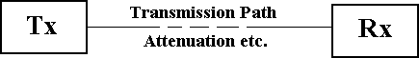
In communication systems we are usually concerned with the noise (i.e. S/N) at the receiver end of the system.

FIGURE 4.11 Circuit Diagram of Transmission Path The transmission path may be for example:-
a) A transmission line (e.g. coax cable).

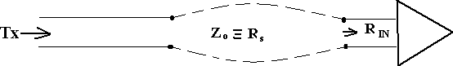

FIGURE 4.12 Circuit Diagram of Coxial Cable
Z_{o} is the characteristics impedance of the transmission line, i.e. the source resistance Rs. This is connected to the receiver with an input impedance R_{IN} .
b) A radio path (e.g. satellite, TV, radio – using aerial)

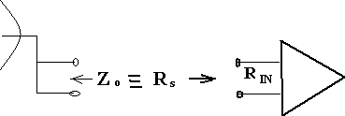
FIGURE 4.13 Circuit Diagram of Radio Path.
Again Z_{o}=Rs the source resistance, connected to the receiver with input resistance Rin.
Typically Z_{o} is 600 ohm for audio/ telephone systems Or Z_{o} is 50 ohm (for radio/TV systems)
75 ohm (radio frequency systems).
An equivalent circuit, when the line is connected to the receiver is shown below. (Note we omit the noise due to Rin – this is considered in the analysis of the receiver section).

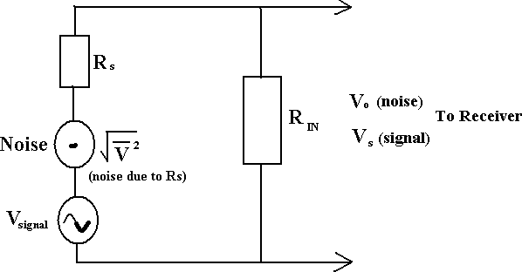

FIGURE 4.14 Equivalent Circuit of Noise Voltage
v2

The RMS voltage output, V_{o} (noise) is
V (noise) =
⎛ RIN ⎞
o
⎜
⎝ RIN + RS ⎠
⎟
Similarly, the signal voltage output due to V_{signal} at input is
Vs( ) = (V
signal
signal
)⎛
⎜
R
RIN
⎝ IN s ⎠
⎟
- R
⎞
For maximum power transfer, the input RIN is matched to the source RS , i.e. RIN = RS = R (say)
Then
V (noise) =
o
⎛ R ⎞ =
⎜ ⎟
(RMS Value)
And signal, V
S ( signal )
⎝ 2R ⎠ 2
= Vsignal
2
Continuing the analysis for noise only, the mean square noise is (RMS)².

⎛ ⎞2

( )2 =⎜
v2 ⎟
= v2

Vo (noise)
⎜ ⎟
⎜ 2 ⎟ 4
⎝ ⎠



But v²
is noise due to Rs =R, i.e. V ²
= 4 k TBR (volt ² ) .

Hence (Vo
v2
v2
(noise))2 = 4kTBR= kTBR
4

Since average power =
(Vrms )

2
2

Then
V 2
N = R = kTBn

i.e. Noise Power = kTBn
watts

For a matched system, N represents the average noise power transferred from the source to the load. This may be written as

p = N
0 B
= kT watts per Hz

n
where p₀ is the noise power spectral density (watts per Hz)
Bn is the noise equivalent bandwidth (Hz) k is the Boltzmann‘s constant
T is the absolute temperature K.
Note: that p₀ is independent of frequency, i.e. white noise.
These equations indicate the need to keep the system bandwidth to a minimum, i.e. to that required to pass only the band of wanted signals, in order to minimize noise power, N.
For example, a resistance at a temperature of 290 K (17 deg C), p₀ = kT is 4 x 10 watts per Hz.
For a noise bandwidth Bn = 1 KHz, N is 4 x 10⁻¹⁸ watts (-174 dBW).If the system bandwidth is increased to 2 KHz, N will decrease by a factor of 2 (i.e. 8 x 10⁻¹⁸ watts or -171 dBW) which will degrade the (S/N) by 3 dB.Care must also be exercised when noise or (S/N ) measurements are
made, for example with a power meter or spectrum analyser, to be clear which bandwidth the
-21
noise is measured in, i.e. system or test equipment. For example, assume a system bandwidth is 1 MHz and the measurement instrument bandwidth is 250 KHz.
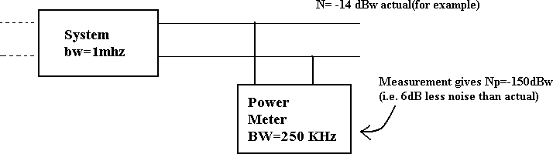

FIGURE 4.15 Block Diagram of Measurement Instrumentation

In the above example, the noise measured is band limited by the test equipment rather than the system, making the system appears less noisy than it actually is. Clearly if the relative bandwidths are known (they should be) the measured noise power may be corrected to give the actual noise power in the system bandwidth.
If the system bandwidth was 250 KHz and the test equipment was 1 MHz then the measured result now would be – 150 dBW (i.e. the same as the actual noise) because the noise power monitored by the test equipment has already been band limited to 250 KHz.
  - SIGNAL – TO – NOISE :
The signal to noise ratio is given by
S = Signal Power N Noise Power
The signal to noise in dB is expressed by
⎛ S ⎞
⎜ ⎟
⎝ ⎠
N
dB
=10 log
⎛ S ⎞
10
⎜ ⎟
⎝ ⎠
N
or
⎛ S ⎞
⎜ ⎟
⎝ ⎠
N
dB
=10 log
10
S −10 log N
10
since 10 log10 S = S dBm if S in mW
and 10 log₁₀ N = N dBm
then
⎛ S ⎞
⎜ ⎟
⎝ ⎠
N
dB dBm dBm
=S
- N
for S and N measured in mW
- NOISE FACTOR – NOISE FIGURE:

Consider the network shown below, in which
⎛ S ⎞
⎜ N ⎟

represents the
⎛ S ⎞
⎜ N ⎟
at the input and⎛ S ⎞
N
⎜ ⎟

represents the ⎛ S ⎞
⎜ ⎟
N

at the output.
⎝ ⎠_{IN} ⎝ ⎠
⎝ ⎠OUT

⎝ ⎠
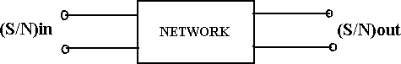

FIGURE 4.16 Block Diagram of S/N Ratio

In general
⎛ S ⎞
⎜ N ⎟

≥ , i.e. the network ‗adds‘ noise (thermal noise tc from the network devices) so

⎝ ⎠_{IN}
that the output (S/N) is generally worst than the input.
The amount of noise added by the network is embodied in the Noise Factor F, which is defined by Noise factor F =
( )
(S N )
IN
S
N
OUT
F equals to 1 for noiseless network and in general F > 1.
The noise figure in the noise factor quoted in dB
i.e. Noise Figure F dB = 10 log₁₀ F F ≥ 0 dB
The noise figure / factor is the measure of how much a network degrades the (S/N)_{IN}, the lower the value of F, the better the network.
The network may be active elements, e.g. amplifiers, active mixers etc, i.e. elements with gain > 1 or passive elements, e.g. passive mixers, feeders cables, attenuators i.e. elements with gain <1.
- NOISE FIGURE – NOISE FACTOR FOR ACTIVE ELEMENTS :
For active elements with power gain G>1, we have
FIGURE 4.17 Circuit Diagram of Noise Factor -1
F =
= SIN
NOUT
NIN SOUT

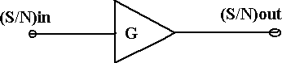
But
( )
(S N )
IN
S
N
OUT
SOUT
= G SIN

Therefore F =
SIN
NOUT

NIN G SIN
F = NOUT
G N IN

If the
NOUT
was due only to G times
N IN
the F would be 1 i.e. the active element would be noise

free. Since in general F v> 1 , then
NOUT is increased by noise due to the active element i.e.

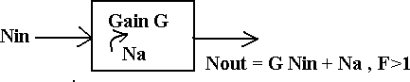

FIGURE 4.17 Circuit Diagram of Noise Factor -2
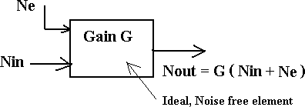
Na represents ‗added‘ noise measured at the output. This added noise may be referred to the input as extra noise, i.e. as equivalent diagram is

FIGURE 4.17 Circuit Diagram of Noise Factor -3
Ne is extra noise due to active elements referred to the input; the element is thus effectively noiseless.
Hence F =
NOUT
G N IN
= F =
G(NIN + Ne )
G NIN
Rearranging gives,
Ne =(F −1) NIN
- NOISE TEMPERATURE:
N IN is the ‗external‘ noise from the source i.e. N IN = k TS Bn
TS is the equivalent noise temperature of the source (usually 290K).

We may also write
Ne = k Te Bn , where
Te is the equivalent noise temperature of the element

i.e. with noise factor F and with source temperature TS .
i.e. k Te Bn = (F-1) k TS Bn

or Te = (F-1) TS
The noise factor F is usually measured under matched conditions with noise source at ambient

temperature TS , i.e. TS
~ 290K is usually assumed, this is sometimes written as

Te =(F290 −1)290

This allows us to calculate the equivalent noise temperature of an element with noise factor F, measured at 290 K.
For example, if we have an amplifier with noise figure F_{dB} = 6 dB (Noise factor F=4) and

equivalent Noise temperature Te

Comments:-
= 865 K.

  - We have introduced the idea of referring the noise to the input of an element, this noise is not actually present at the input, it is done for convenience in the analysis.
  - The noise power and equivalent noise temperature are related, N=kTB, the temperature T is not necessarily the physical temperature, it is equivalent to the temperature of a resistance R (the system impedance) which gives the same noise power N when measured in the same bandwidth Bn.

  - Noise figure (or noise factor F) and equivalent noise temperature Te
indicate how much noise an element is producing.
are related and both

Since,
Te = (F-1) TS

Then for F=1, Te = 0, i.e. ideal noise free active element.
- NOISE FIGURE – NOISE FACTOR FOR PASSIVE ELEMENTS :
The theoretical argument for passive networks (e.g. feeders, passive mixers, attenuators) that is

networks with a gain < 1 is fairly abstract, and in essence shows that the noise at the input,
N IN is

attenuated by network, but the added noise Na contributes to the noise at the output such that
NOUT = N IN .

Thus, since F =
SIN
NOUT

and

N = N .

NIN
SOUT
OUT IN

F = SIN = 1
G SIN G
If we let L denote the insertion loss (ratio) of the network i.e. insertion loss L_{dB} = 10 log L

Then L =
1 and hence for passive network
G

F = L
Also, since Te = (F-1) TS
Then for passive network

Where Te
Te = (L-1) TS
is the equivalent noise temperature of a passive device referred to its input.

- REVIEW OF NOISE FACTOR – NOISE FIGURE –TEMPERATURE:

F, dB and Te Te = (F-1)290
are related by F_{dB} = 10 log_{dB} F

Some corresponding values are tabulated below:

Typical values of noise temperature, noise figure and gain for various amplifiers and attenuators are given below:

F | F_{dB} (dB) | Te (degree K)
1 | 0 | 0
2 | 3 | 290
4 | 6 | 870
8 | 9 | 2030
16 | 12 | 4350

Device | Frequency | Te (K) | F_{dB} (dB) | Gain (dB)
Maser Amplifier | 9 GHz | 4 | 0.06 | 20
Ga As Fet amp | 9 GHz | 330 | 303 | 6
Ga As Fet amp | 1 GHz | 110 | 1.4 | 12
Silicon Transistor | 400 MHz | 420 | 3.9 | 13
L C Amp | 10 MHz | 1160 | 7.0 | 50
Type N cable | 1 GHz |  | 2.0 | 2.0

- CASCADED NETWORK:
A receiver systems usually consists of a number of passive or active elements connected in series, each element is defined separately in terms of the gain (greater than 1 or less than 1 as the case may be), noise figure or noise temperature and bandwidth (usually the 3 dB bandwidth). These elements are assumed to be matched.
A typical receiver block diagram is shown below, with example

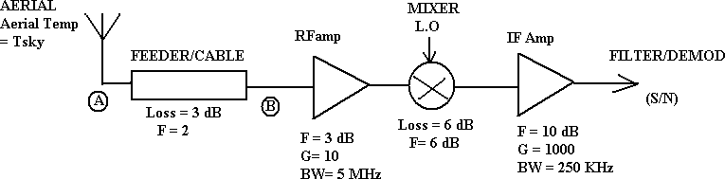

FIGURE 4.18 Circuit Diagram of Cascade System -1
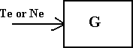
In order to determine the (S/N) at the input, the overall receiver noise figure or noise temperature must be determined. In order to do this all the noise must be referred to the same point in the receiver, for example to A, the feeder input or B, the input to the first amplifier.
The equations so far discussed refer the noise to the input of that specific element i.e.
Te or Ne is the noise referred to the input.
To refer the noise to the output we must multiply the input noise by the gain G. For example, for a lossy feeder, loss L, we had
Ne = (L-1) N IN , noise referred to input
Or
Te = (L-1) TS - referred to the input.
Noise referred to output is gain x noise referred to input, hence
N referred to output = G N = 1 (L-1) N
e
e
L
IN
1 N

= (1- L ) IN
Similarly, the equivalent noise temperature referred to the output is
- 1 T

_{e} referred to output = (1- L ) S
These points will be clarified later; first the system noise figure will be considered.
- SYSTEM NOISE FIGURE:
Assume that a system comprises the elements shown below, each element defined and specified separately.

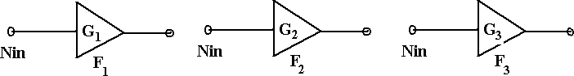

FIGURE 4.18 Circuit Diagram of Cascade System -2
The gains may be greater or less than 1, symbols F denote noise factor (not noise figure, i.e. not in dB). Assume that these are now cascaded and connected to an aerial at the input, with

NIN = Nae
from the aerial.

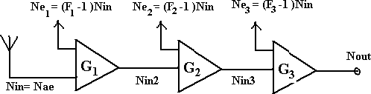

FIGURE 4.18 Circuit Diagram of Cascade System -3
Note: - N IN for each stage is equivalent to a source at a temperature of 290 K since this is how each element is specified. That is, for each device/ element is specified
NOUT = G3 (NIN 3 + Ne3 )
= G3 (NIN 3 + (F3 −1)NIN )
Since NIN 3 = G2 (NIN 2 + Ne2 )= G2 (NIN 2 + (F2 −1)NIN )
and similarly N_{IN} ₂ =G₁ (N_{ae} +(F₁ −1)N_{IN} )
Now ,
then
NOUT = G3 [G2 [G1 Nae + G1 (F1 −1)NIN ]+ G2 (F2 −1)NIN ]+ G3 (F3 −1)NIN
The overall system Noise Factor is

Fsys
= NOUT
GN
= NOUT
G G G N

IN 1 2 3 ae

= 1+ (F
− 1) NIN
+ (F2 − 1) NIN
+ (F3 − 1) NIN

ae G1
N
1
Nae
G1G2
Nae

If we assume
N ae
is ≈
N IN , i.e. we would measure and specify
Fsys under similar conditions as

F1 , F2
etc (i.e. at 290 K), then for n elements in cascade.

F = F
+ (F2 − 1) + (F3 − 1) +

(F4 − 1) + +

(Fn − 1)

sys 1 G
G G G G G
G G G

1 1 2
1 2 3
1 2 n−1

The equation is called FRIIS Formula.
This equation indicates that the system noise factor depends largely on the noise factor of the first stage if the gain of the first stage is reasonably large. This explains the desire for ―low noise front ends‖ or low noise most head preamplifiers for domestic TV reception. There is a danger however; if the gain of the first stage is too large, large and unwanted signals are applied to the mixer which may produce intermodulation distortion. Some receivers apply signals from the aerial directly to the mixer to avoid this problem. Generally a first stage amplifier is designed to have a good noise factor and some gain to give an acceptable overall noise figure.

e sys
- SYSTEM NOISE TEMPERATURE:
Since T = (L-1) T , i.e. F= 1 +
S
T
T
e
e
s
Then F
sys
= 1+ Te sys
T
⎧whereT_{e} _{sys} is theequivalentNoisetemperature of thesystem
s
⎨ andT is thenoisetemperature of thesource
⎩
s
and
⎛
Te 2
⎞
⎛
⎜1+ ^{e} ^{sys} ⎟ =⎜1+ ^{e1} ⎟ +
T
⎞ ⎛
T
⎞
⎜1+ −1⎟
⎝ Ts ⎠
+...etc
⎝
Ts
⎠ ⎝ Ts ⎠
G1
i.e. fromF = F +
(F −1
2
)
sys 1
G
- e. tc
1
which gives
T =T
- Te 2 + Te3
+
Te 4
+.......... .......... ......
^{e1} G G G G G G

1 1 2 1 2 3

Te sys
is the receiver system equivalent noise temperature. Again, this shows that the system noise

temperature depends on the first stage to a large extent if the gain of the first stage is reasonably

large.The equations for Te sys
and
F sys refer the noise to the input of the first stage. This can best

be classified by examining the equation for Te sys in conjunction with the diagram below.

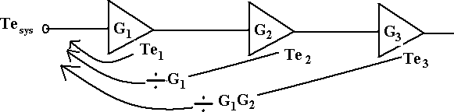

Te1
FIGURE 4.18 Circuit Diagram of Cascade System - 4 is already referred to input of 1st stage.

T is referred to input of the 2nd stage – to refer this to the input of the 1st stage we must divide
e 2
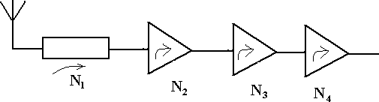
Te 2 by G₁.
Te 3 is referred to input of third stage, ( ÷ G₁G₂) to refer to input of 1 stage, etc.
It is often more convenient to work with noise temperature rather than noise factor. Given a noise factor we find Te from Te = (F-1)290.
st
Note: also that the gains (G₁G₂ G₃ etc) may be gains > 1 or gains <1, i.e. losses L where L = 1 .
G
See examples and tutorials for further classifications.

- REVIEW AND APPLICATION:
It is important to realize that the previous sections present a technique to enable a receiver performance to be calculated. The essence of the approach is to refer all the noise contributed at various stages in the receiver to the input and thus contrive to make all the stages ideal, noise free.
i.e. in practice or reality : -

FIGURE 4.18 Circuit Diagram of Cascade System - 5

The noise gets worse as we proceed from the aerial to the output. The technique outlined.
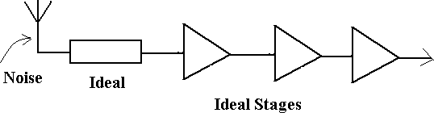

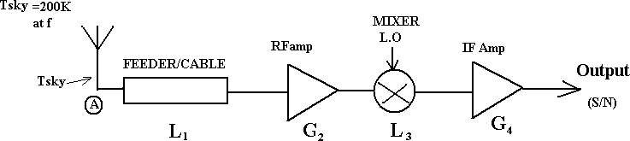
FIGURE 4.18 Circuit Diagram of Cascade System - 6

All noise referred to input and all stages assumed noise free.
To complete the analysis consider the system below
FIGURE 4.18 Circuit Diagram of Cascade System - 7 The overall noise temp = Tsky + T sys (referred to A)
Noise referred to A = kTB
= k ( T sky + T sys )B watts
Where , k = 1.38 x 10⁻²³ J/K
B is the bandwidth as measured at the output, in this case from the IF amp.
If we let this noise by N_{R}, i.e. N_{R} = k ( T sky + T sys )B then the noise at the output would be

⎛ 1 ⎞ ⎛ 1 ⎞

NOUT = NR ⎜ L
⎟(G2 )⎜
L
⎟(G4 )

⎝ 1 ⎠ ⎝ 3 ⎠
i.e. the noise referred to input times the gain of each stage. Now consider

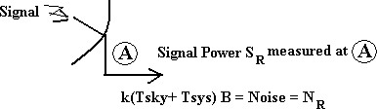

⎛ SR ⎞

FIGURE 4.18 Circuit Diagram of Cascade System - 8
⎛ S ⎞

⎜ ⎟ is not the actual (real),
N
⎜ N ⎟ ratio that would be measured at A because N_{R} is all referred

⎝ R ⎠ ⎝ ⎠
back from later stages.
⎡
⎢ Actual⎜
⎛ S ⎞
⎢⎣
⎟ ≈
S
R
⎝ N ⎠ k T
sky Ae
B
⎤
⎥
⎦
where B is theaerialbandwidth.
Ae
Signal power at the output would be
S = S
OUT R
⎛ 1 ⎞(G )⎛ 1 ⎞(G )
⎜ ⎟ ⎜ ⎟
⎝ 1 ⎠ ⎝ 3 ⎠
L
2
L
4
and ⎛ S ⎞
⎜ N ⎟
⎝
⎠OUT
= SOUT
N
= SR
OUT
N
R
Hence, by receiving all the noise to the input, and finding N_{R,} we can find
SR
NR
which is the same
as ⎛ S ⎞
⎜ N ⎟
⎝
⎠OUT
- i.e. we do not need to know all the system gain.

Consider now the diagram below

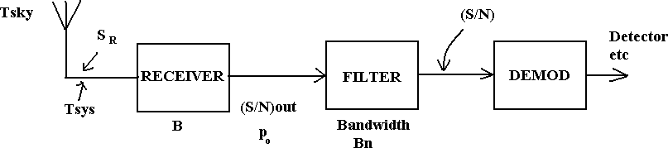

A filter in same form often follows the receiver and we often need to know po , the noise power spectral density.

i.e. recall that N=
po B = kTB.
po = kT

We may find
po from
po = k( T sky

- T sys )

- ALGEBRAIC REPRESENTATION OF NOISE:

General
In order for the effects of noise to be considered in systems, for example the analysis of

N = ⎜ ^{n} ⎟ = p Bn
2
probability of error as a function of Signal to noise for an FSK modulated data systems, or the performance of analogue FM system in the presence of noise, it is necessary to develop a model which will allow noise to be considered algebraically.
Noise may be quantified in terms of noise power spectral density po watts per Hz such that the average noise power in a noise bandwidth Bn Hz is
N= po Bn watts
Thus the actual noise power in a system depends on the system bandwidth and since we are often
interested in the ⎛ S ⎞ at the input to a demodulator, Bn is the smallest noise equivalent bandwidth
⎝ ⎠
before the demodulator.
⎜ N ⎟
Since average power is proportional to (V
rms
)2 we may relate N to a ―peak‖ noise voltage so that
⎛ V
⎞2
o
⎝ ⎠

i.e. Vn =
2 po Bn
≡ ‘peak‘ value of noise

In practice noise is a random signal with (in theory) a Gaussian distribution and hence peak values

up to
± ∞ or as otherwise limited by the system dynamic range are possible. Hence this ―peak‖

value for noise is a fictitious value which will give rise to the same average noise as the actual noise.

  - PHASOR REPRESENTATION OF SIGNAL AND NOISE:
shown below:
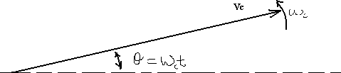

FIGURE 4.19 PHASOR Diagram -1

The phasor represents a signal with peak value Vc, rotating with angular frequencies Wc rads per sec and with an angle θ = ω_{c}t to some reference axis at time t=0.
If we now consider a carrier with a noise voltage with ―peak‖ value superimposed we may represents this as:
FIGURE 4.19 PHASOR Diagram -2
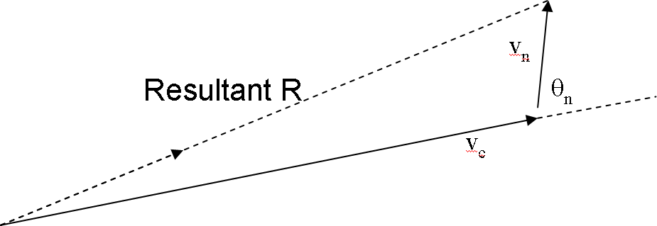
In this case Vn is the peak value of the noise and is the phase of the noise relative to the carrier. Both Vn and θ n are random variables, the above phasor diagram represents a snapshot at some instant in time.
The resultant or received signal R, is the sum of carrier plus noise. If we consider several snapshots overlaid as shown below we can see the effects of noise accompanying the signal and how this affects the received signal R.

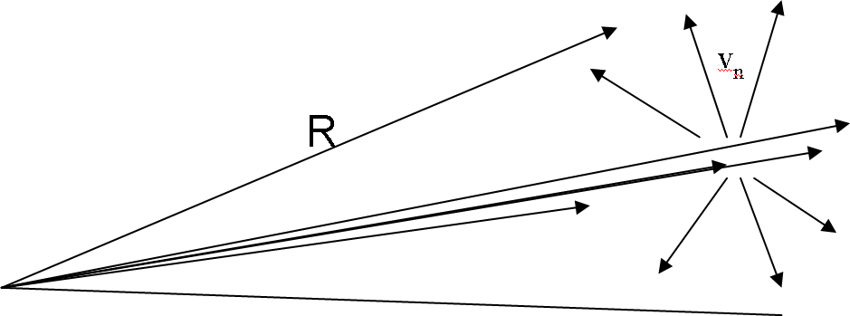

FIGURE 4.19 PHASOR Diagram -3
Thus the received signal has amplitude and frequency changes (which in practice occur randomly) due to noise.We may draw, for a single instant, the phasor with noise resolved into 2 components, which are:
- x(t) in phase with the carriers
x(t) =Vn Cosφ_{n}
- y(t) in quadrature with the carrier
y(t) =Vn Sinφn

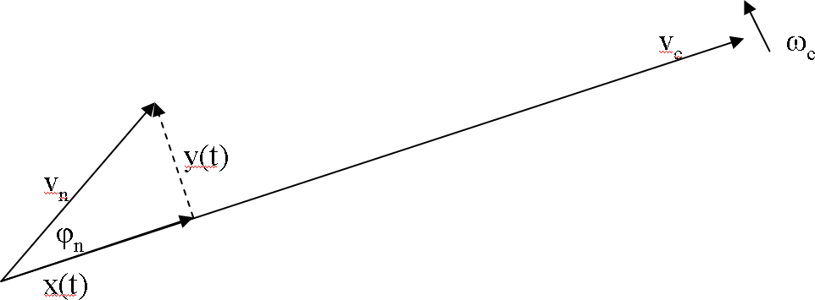
FIGURE 4.19 PHASOR Diagram -4
The reason why this is done is that x(t) represents amplitude changes in Vc (amplitude changes affect the performance of AM systems) and y(t) represents phase (i.e. frequency) changes (phase / frequency changes affect the performance of FM/PM systems)
We note that the resultant from x(t) and y(t) i.e.

Vn =
y(t)² + x(t)²
=
V Cos φ +V Sin φ
2
2
2
2
n
n n
n
= Vn

(Since Cos ²θ + Sin²θ = 1)

We can regard x(t) as a phasor which is in phase with
i.e. x(t)Cos ωc t
and by similar reasoning, y(t) in quadrature
i.e. y(t)Sin ωc t Hence we may write
Vn (t )= x(t) Cosωct + y(t) Sinωct
Vc Cosωct , i.e a phasor rotating at ωc .

Or – alternative approach
Vn (t )= Vn Cos(ωct − φn )
Vn (t )= Vn Cosφn Cosωct + Vn Sinφn Sinωct Vn (t )= x(t) Cosωct + y(t) Sinωct
This equation is algebraic representation of noise and since
x(t) =Vn Cosφ_{n} =
the peak value of x(t) is
Cosφ_{n}
(i.e. when Cosφn = 1)
Similarly the peak value of y(t) is also
(i.e. when Sinφ_{n} = 0 )
The mean square value in general is ⎜
⎝
⎛ V
peak ⎟ = (V
⎠
⎞2
rms
)2

⎛ ⎞2
2 po Bn
2 po Bn
2
2 po Bn
2

and thus the mean square of x(t), i.e
=
x(t)² ⎜
⎝
⎜
⎟ = po Bn
⎠
⎟

⎛ ⎞2
2 po Bn
2

also the mean square value of y(t), i.e
=

The total noise in the bandwidth, Bn is

2

y(t)² ⎜
⎝
⎜
⎟ = po Bn
⎠
⎟

⎛ V ⎞
x(t)²
y(t)²

N = ⎜ ^{v} ⎟ = p B = +

⎝ ⎠ o n 2 2
2

i.e. NOT
2 po Bn
x(t)² + y(t)²
as might be expected.

The reason for this is due to the
Cosφ_{n} and
Sinφ_{n} relationship in the representation e.g. when say

―x(t)‖ contributes
po Bn , the ―y(t)‖ contribution is zero, i.e. sum is always equal to
po Bn .

The algebraic representation of noise discussed above is quite adequate for the analysis of many systems, particularly the performance of ASK, FSK and PSK modulated systems.
When considering AM and FM systems, assuming a large (S/N) ratio, i.e Vc>> Vn, the following may be used.
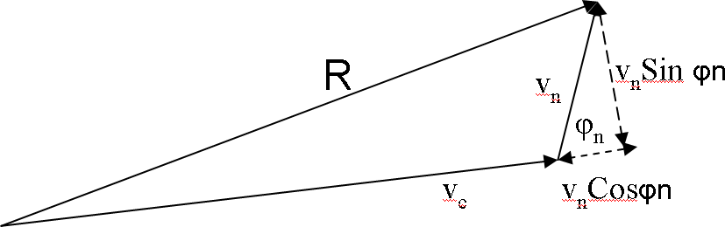
Considering the general phasor representation below:-

FIGURE 4.19 PHASOR Diagram -5
For AM systems, the signal is of the form (Vc + m(t))Cosωct where m(t) is the message or modulating signal and the resultant for (S/N) >> 1 is
AM received = (Vc + m(t))Cosωc t + x(t) Cosωct
Since AM is sensitive to amplitude changes, changes in the Resultant length are predominantly due to x(t).

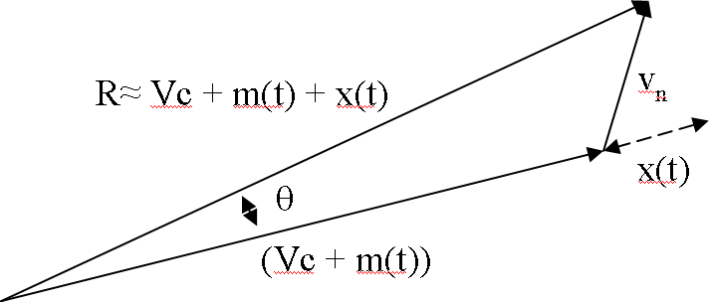
FIGURE 4.19 PHASOR Diagram -6

For FM systems the signal is of the form Vc Cos(ωc ± Δω)t . Noise will produce both amplitude changes (i.e. in Vc) and frequency variations – the amplitude variations are removed by a limiter in the FM receiver. Hence,
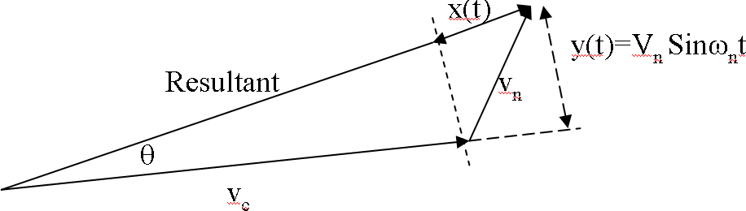
FIGURE 4.19 PHASOR Diagram -7
The angle θ represents frequency / phase variations in the received signal due to noise. From the
diagram.
θ = tan
−1
⎛
⎜
Vn Sinω_{n}t
⎞
⎝ Vc + VnCosω_{n}t ⎠
⎟
⎛ V
ω t
⎞
= tan
⎜
−1 ⎜
n
V
Sin
n
⎜
⎟
c ⎟
⎜1+ ^{n} Cosω t ⎟
V
⎟
⎝
V
c
n
⎠
Since V >>V (assumed) then
V
n
c n
V
Cos
ω t << 1
n
c
So θ = tan
−1 n
⎛ V
⎜
⎝ V
Sinω
t
⎞
⎟
{which is also obvious from diagram}
c
n
⎠
Since tanθ = θ for small θ and θ is small since Vc >>Vn

Then
θ ≈ Vn Sinω t Vc

The above discussion for AM and FM serve to show bow the ‗model‘ may be used to describe the effects of noise.Applications of this model to ASK, FSK and PSK demodulation, and AM and FM demodulation are discussed elsewhere.
n
- ADDITIVE WHITE GAUSSIAN NOISE:
Noise in Communication Systems is often assumed to be Additive White Gaussian Noise (AWGN).

FIGURE 4.20 Block Diagram of White Noise
The signal (information bearing) is at its weakest (most vulnerable) at the receiver input. Noise at the other points (e.g. Receiver) can also be referred to the input.The noise is uncorrelated with the signal, i.e. independent of the signal and we may state, for average powers
Output Power = Signal Power + Noise Power
= (S+N)
- White
As we have stated noise is assumed to have a uniform noise power spectral density, given that the noise is not band limited by some filter bandwidth.
We have denoted noise power spectral density by po ( f ).
White noise = po ( f ) = Constant Also Noise power = po Bn

Additive
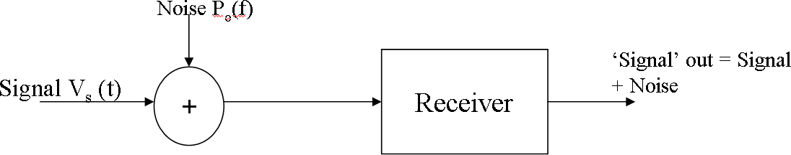
Noise is usually additive in that it adds to the information bearing signal. A model of the received signal with additive noise is shown below.

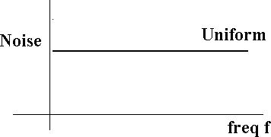
FIGURE 4.21 Spectral Density Diagram of White Noise

GAUSSIAN
We generally assume that noise voltage amplitudes have a Gaussian or Normal distribution.

CLASSIFICATION OF NOISE:
Noise is random, undesirable electrical energy that enters the communications system via the communicating medium and interferes with the transmitted message. However, some noise is also produced in the receiver.
(OR)
With reference to an electrical system, noise may be defined as any unwanted form of energy which tends to interfere with proper reception and reproduction of wanted signal.
Noise may be put into following two categories.
1. External noises, i.e. noise whose sources are external.
External noise may be classified into the following three types:
- Atmospheric noises
- Extraterrestrial noises
- Man-made noises or industrial noises.
- Internal noise in communication, i.e. noises which get, generated within the receiver or communication system. Internal noise may be put into the following four categories.
  - Thermal noise or white noise or Johnson noise
  - Shot noise.
  - Transit time noise
  - Miscellaneous internal noise.
External noise cannot be reduced except by changing the location of the receiver or the entire system. Internal noise on the other hand can be easily evaluated mathematically and can be reduced to a great extent by proper design. As already said, because of the fact that internal noise can be reduced to a great extent, study of noise characteristics is a very important part of the communication engineering.

Explanation of External Noise
      - Atmospheric Noise:
Atmospheric noise or static is caused by lighting discharges in thunderstorms and other natural electrical disturbances occurring in the atmosphere. These electrical impulses are random in

SCE 102 DEPT OF ECE

nature. Hence the energy is spread over the complete frequency spectrum used for radio communication.
Atmospheric noise accordingly consists of spurious radio signals with components spread over a wide frequency range. These spurious radio waves constituting the noise get propagated over the earth in the same fashion as the desired radio waves of the same frequency. Accordingly at a given receiving point, the receiving antenna picks up not only the signal but also the static from all the thunderstorms, local or remote.

Extraterrestrial noise:
      - Solar noise
      - Cosmic noise
- Solar noise:
This is the electrical noise emanating from the sun. Under quite conditions, there is a steady radiation of noise from the sun. This results because sun is a large body at a very high temperature (exceeding 6000°c on the surface), and radiates electrical energy in the form of noise over a very wide frequency spectrum including the spectrum used for radio communication. The intensity produced by the sun varies with time. In fact, the sun has a repeating 11-year noise cycle. During the peak of the cycle, the sun produces some amount of noise that causes tremendous radio signal interference, making many frequencies unusable for communications. During other years. The noise is at a minimum level.
- Cosmic noise:
Distant stars are also suns and have high temperatures. These stars, therefore, radiate noise in the
same way as our sun. The noise received from these distant stars is thermal noise (or black body noise) and is distributing almost uniformly over the entire sky. We also receive noise from the
center of our own galaxy (The Milky Way) from other distant galaxies and from other virtual point sources such as quasars and pulsars.

Man-Made Noise (Industrial Noise):
By man-made noise or industrial- noise is meant the electrical noise produced by such sources as automobiles and aircraft ignition, electrical motors and switch gears, leakage from high voltage lines, fluorescent lights, and numerous other heavy electrical machines. Such noises are produced by the arc discharge taking place during operation of these machines. Such man-made noise is most intensive in industrial and densely populated areas. Man-made noise in such areas far exceeds all other sources of noise in the frequency range extending from about 1 MHz to 600
MHz.
SCE 103 DEPT OF ECE

Explanation of Internal Noise in communication:
      - Thermal Noise:
Conductors contain a large number of 'free" electrons and "ions" strongly bound by molecular forces. The ions vibrate randomly about their normal (average) positions, however, this vibration being a function of the temperature. Continuous collisions between the electrons and the vibrating ions take place. Thus there is a continuous transfer of energy between the ions and electrons. This is the source of resistance in a conductor. The movement of free electrons constitutes a current which is purely random in nature and over a long time averages zero. There is a random motion of the electrons which give rise to noise voltage called thermal noise.Thus noise generated in any resistance due to random motion of electrons is called thermal noise or white or Johnson noise.
The analysis of thermal noise is based on the Kinetic theory. It shows that the temperature of particles is a way of expressing its internal kinetic energy. Thus "Temperature" of a body can be said to be equivalent to the statistical rms value of the velocity of motion of the particles in the body. At -273°C (or zero degree Kelvin) the kinetic energy of the particles of a body becomes zero .Thus we can relate the noise power generated by a resistor to be proportional to its absolute temperature. Noise power is also proportional to the bandwidth over which it is measured. From the above discussion we can write down.
P_{n} 𝖺 TB
P_{n} = KTB (1)
Where Pn = Maximum noise power output of a resistor. K = Boltzmann‘s constant = 1.38 x10-23 joules I Kelvin. T = Absolute temperature.
B = Bandwidth over which noise is measured.

SCE 104 DEPT OF ECE

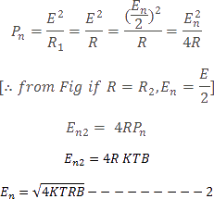
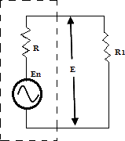

- Transit Time Noise:
Another kind of noise that occurs in transistors is called transit time noise.
Transit time is the duration of time that it takes for a current carrier such as a hole or current to move from the input to the output.
The devices themselves are very tiny, so the distances involved are minimal. Yet the time it takes
for the current carriers to move even a short distance is finite. At low frequencies this time is negligible. But when the frequency of operation is high and the signal being processed is the
magnitude as the transit time, then problem can occur. The transit time shows up as a kind of random noise within the device, and this is directly proportional to the frequency of operation.

Miscellaneous Internal Noises Flicker Noise:
Flicker noise or modulation noise is the one appearing in transistors operating at low audio frequencies. Flicker noise is proportional to the emitter current and junction temperature. However, this noise is inversely proportional to the frequency. Hence it may be neglected at frequencies above about 500 Hz and it, Therefore, possess no serious problem.

Transistor Thermal Noise:
Within the transistor, thermal noise is caused by the emitter, base and collector internal resistances. Out of these three regions, the base region contributes maximum thermal noise.
SCE 105 DEPT OF ECE

Partition Noise:
Partition noise occurs whenever current has to divide between two or more paths, and results from the random fluctuations in the division. It would be expected, therefore, that a diode would be less noisy than a transistor (all other factors being equal) If the third electrode draws current (i.e.., the base current). It is for this reason that the inputs of microwave receivers are often taken directly to diode mixers.

Shot Noise:
The most common type of noise is referred to as shot noise which is produced by the random arrival of 'electrons or holes at the output element, at the plate in a tube, or at the collector or drain in a transistor. Shot noise is also produced by the random movement of electrons or holes across a
PN junction. Even through current flow is established by external bias voltages, there will still be some random movement of electrons or holes due to discontinuities in the device. An example of such a discontinuity is the contact between the copper lead and the semiconductor materials. The interface between the two creates a discontinuity that causes random movement of the current carriers.
- Signal to Noise Ratio:
Noise is usually expressed as a power because the received signal is also expressed in terms of power. By Knowing the signal to noise powers the signal to noise ratio can be computed. Rather than express the signal to noise ratio as simply a number, you will usually see it expressed in
terms of decibels.
A receiver has an input signal power of l.2µW. The noise power is 0.80µW. The signal to noise

ratio is

Signal to Noise Ratio = 10 Log (1.2/0.8)
= 10 log 1.5
= 10 (0.176)
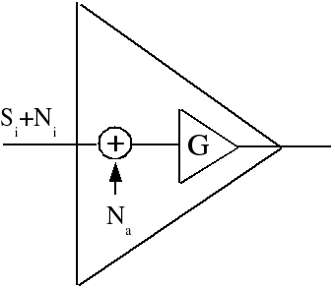= 1.76 Db

FIG 4.22 Block diagram S/N Ratio.

Noise Figure:
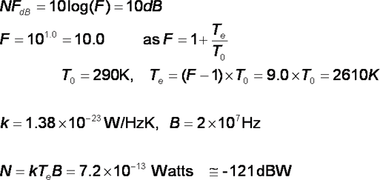
Noise Figure is designed as the ratio of the signal-to-noise power at the input to the signal to noise power at the output.The device under consideration can be the entire receiver or a single amplifier stage. The noise figure also called the noise factor can be computed with the expression , F = Signal to Noise power Input/Signal to noise power output .You can express the noise figure as a number, more often you will see it expressed in decibels.

4.3 NOISE IN CASCADE SYSTEMS:
Cascade noise figure calculation is carried out by dealing with gain and noise figure as a ratio rather than decibels, and then converting back to decibels at the end. As the following equation shows, cascaded noise figure is affected most profoundly by the noise figure of components closest to the input of the system as long as some positive gain exists in the cascade. If only loss exists in the cascade, then the cascaded noise figure equals the magnitude of the total loss. The
following equation is used to calculate cascaded noise figure as a ratio based on ratio values for
gain and noise figure (do not use decibel values).

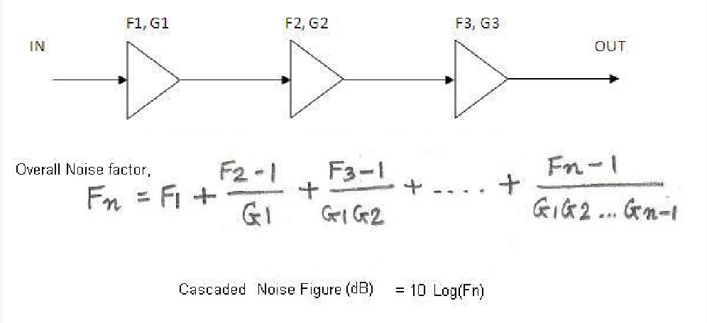
FIG 4.23 Block diagram of cascaded systems
  - NARROW BAND NOISE:
    - Definition: A random process X(t) is bandpass or narrowband random process if its power spectral density SX(f) is nonzero only in a small neighborhood of some high frequency fc Deterministic signals: defined by its Fourier transform Random processes: defined by its power spectral density.
Notes:
- Since X(t) is band pass, it has zero mean: E[(X(t)] = 0.
- fc needs not be the center of the signal bandwidth, or in the signal bandwidth at all.
4.4.2 Narrowband Noise Representation:
In most communication systems, we are often dealing with band-pass filtering of signals.
Wideband noise will be shaped into bandlimited noise. If the bandwidth of the bandlimited noise is relatively small compared to the carrier frequency, we refer to this as narrowband
noise. We can derive the power spectral density Gn(f) and the auto-correlation function Rnn(τ) of the narrowband noise and use them to analyse the performance of linear systems. In practice, we often deal with mixing (multiplication), which is a non-linear operation, and the system analysis becomes difficult. In such a case, it is useful to express the narrowband noise as n(t) = x(t) cos 2πfct - y(t) sin 2πfct.
where fc is the carrier frequency within the band occupied by the noise. x(t) and y(t) are known as the quadrature components of the noise n(t). The Hibert transform of n(t) is n^ (t) = H[n(t)] = x(t) sin 2πfct + y(t) cos 2πfct.
      - Generation of quadrature components of n(t). x(t) and y(t) have the following properties:

- E[x(t) y(t)] = 0. x(t) and y(t) are uncorrelated with each other.
- x(t) and y(t) have the same means and variances as n(t).
- If n(t) is Gaussian, then x(t) and y(t) are also Gaussian.
- x(t) and y(t) have identical power spectral densities, related to the power spectral density of n(t) by Gx(f) = Gy(f) = Gn(f- fc) + Gn(f+ fc) (28.5)
for fc - 0.5B < | f | < fc + 0.5B and B is the bandwidth of n(t).

Inphase and Quadrature Components:
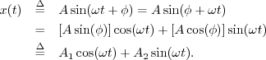
In-Phase & Quadrature Sinusoidal Components
From the trig identity, we have
From this we may conclude that every sinusoid can be expressed as the sum of a sine function
phase zero) and a cosine function (phase ^{𝜋}). If the sine part is called the ``in-phase'' component,
2
the cosine part can be called the ``phase-quadrature'' component. In general, ``phase quadrature''
means ``90 degrees out of phase,'' i.e., a relative phase shift of ± 𝜋. It is also the case that every
2
sum of an in-phase and quadrature component can be expressed as a single sinusoid at some amplitude and phase. The proof is obtained by working the previous derivation backwards.Figure
illustrates in-phase and quadrature components overlaid. Note that they only differ by a relative

degree phase shift.

Noise in AM receivers using Envelope detection:
In standard AM wave both sidebands and the carrier are transmitted. The AM wave may be written as s(t) = Ac[ 1+ kam(t) ] cos2𝜋𝑓𝑐𝑡

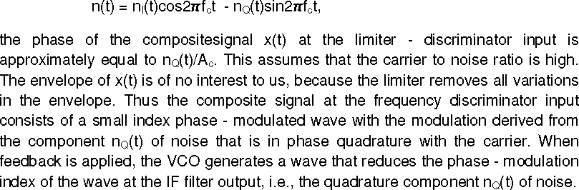

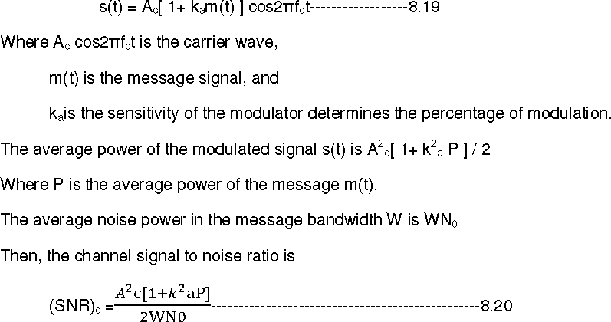

The received signal x(t) at the envelope detector input consists of the modulated message signal s(t) and narrow band noise n(t). then,

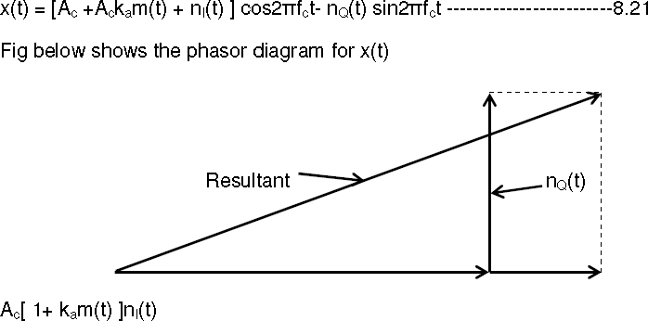
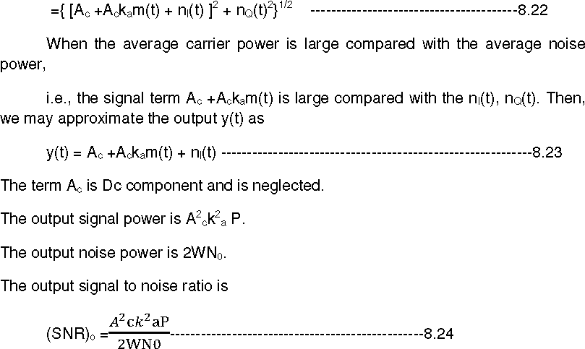

From this Phasor diagram for AM wave plus narrow-band noise for the case of high carrier –to- noise for the case of high carrier-to-noise ratio
From this phasor diagram the receiver output can be obtained as y(t) = envelope of x(t).
The average noise power is derived from both in-phase component and quadrature component,

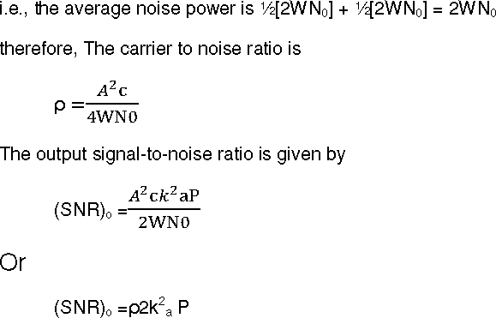
Signal to Noise Ratio:

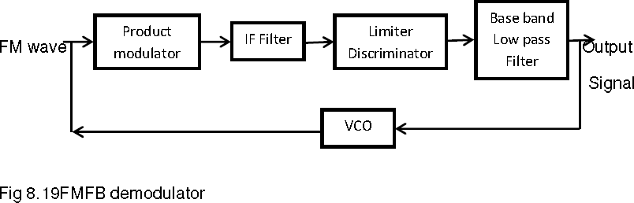
  - FM CAPTURE EFFECT:
4.5 FM NOISE REDUCTION:
A phenomenon, associated with FM reception, in which only the stronger of two signals at or near the same frequency will be demodulated
    - The complete suppression of the weaker signal occurs at the receiver limiter, where it is treated as noise and rejected.
    - When both signals are nearly equal in strength, or are fading independently, the receiver may switch from one to the other.

In the frequency modulation, the signal can be affected by another frequency modulated signal whose frequency content is close to the carrier frequency of the desired FM wave. The receiver may lock such an interference signal and suppress the desired FM wave when interference signal is stronger than the desired signal. When the strength of the desired signal and interference signal are nearly equal, the receiver fluctuates back and forth between them, i.e., receiver locks interference signal for some times and desired signal for some time and this goes on randomly.
    - This phenomenon is known as the capture effect.

PRE-EMPHASIS & DE-EMPHASIS:
Pre-emphasis refers to boosting the relative amplitudes of the modulating voltage for higher audio frequencies from 2 to approximately 15 KHz.
- DE-EMPHASIS:
De-emphasis means attenuating those frequencies by the amount by which they are boosted. However pre-emphasis is done at the transmitter and the de-emphasis is done in the receiver. The purpose is to improve the signal-to-noise ratio for FM reception. A time constant of 75µs is specified in the RC or L/Z network for pre-emphasis and de-emphasis.
4.7.1 Pre-Emphasis Circuit:
At the transmitter, the modulating signal is passed through a simple network which amplifies the high frequency, components more than the low-frequency components. The simplest form of such a circuit is a simple high pass filter of the type shown in fig (a). Specification dictate a time constant of 75 microseconds (µs) where t = RC. Any combination of resistor and capacitor (or resistor and inductor) giving this time constant will be satisfactory. Such a circuit has a cutoff frequency fco of 2122 Hz. This means that frequencies higher than 2122 Hz will he linearly
enhanced. The output amplitude increases with frequency at a rate of 6 dB per octave. The pre-

emphasis curve is shown in Fig (b). This pre-emphasis circuit increases the energy content of the higher-frequency signals so that they will tend to become stronger than the high frequency noise components. This improves the signal to noise ratio and increases intelligibility and fidelity.

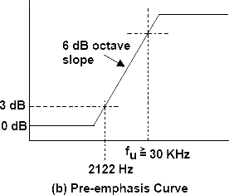
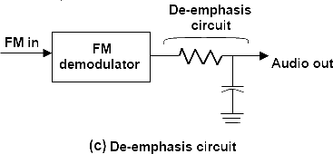
4.7.2 De-Emphasis Circuit:
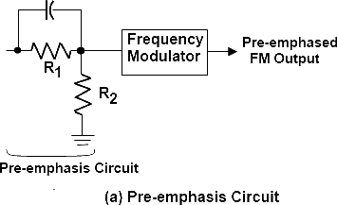

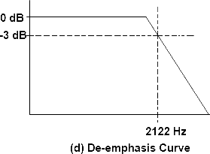

FM THRESHOLD EFFECT:
In an FM receiver, the effect produced when the desired-signal gain begins to limit the desired signal, and thus noise limiting (suppression).(188) Note: FM threshold effect occurs at (and above) the point at which the FM signal-to-noise improvement is measured. The output signal to noise ratio of FM receiver is valid only if the carrier to noise ratio is measured at the discriminator input is high compared to unity. It is observed that as the input noise is increased so that the carrier to noise ratio decreased, the FM receiver breaks. At first individual clicks are heard in the receiver output and as the carrier to noise ratio decreases still further, the clicks rapidly merge in to a crackling or sputtering sound. Near the break point eqn8.50 begins to fail predicting values of output SNR larger than the actual ones. This phenomenon is known as the threshold effect.The threshold effect is defined as the minimum carrier to noise ratio that gives the output SNR not less than the value predicted by the usual signal to noise formula assuming a small noise power. For a qualitative discussion of the FM threshold effect, Consider, when there is no signal present, so that the carrier is unmodulated. Then the composite signal at the frequency discriminator input is
x(t) = [Ac +nI(t)] cos2𝜋fct – nQ(t) sin 2𝜋fct (1)
Where nI(t) and nQ(t) are inphase and quadrature component of the narrow band noise n(t) with respect to carrier wave Accos2𝜋fct. The phasor diagram of fig8.17 below shows the phase relations b/n the various components of x(t) in eqn (1).This effect is shown in fig below, this calculation is based on the following two assumptions:
- The output signal is taken as the receiver output measured in the absence of noise. The average output signal poweris calculated for a sinusoidal modulation that produces a frequency deviation ΔIequal to 1/2 of the IF filter bandwidth B, The carrier is thus enabled to swing back and forth across the entire IF band.

- The average output noise power is calculated when there is no signal present, i.e.,the carrier is unmodulated, with no restriction placed on the value of the carrier to noise ratio.

Assumptions:
  - Single-tone modulation, ie: m(t) = Am cos(2∆ fmt)
  - The message bandwidth W = fm;
  - For the AM system, µ = 1;
  - For the FM system, β = 5 (which is what is used in commercial FM transmission, with ∆f = 75 kHz, and W = 15 kHz).

APPLICATION & ITS USES:
    - Tape Noise reduction.
- PINK Noise or 1/f noise.
- Noise masking and baby sleep.
REFERENCES:
  - Simon Haykins - ―Communication Systems‖ John Wilsey 2005.
  - J.G Prokias, M.Salelhi,‖Fundamental Of Communication Systems‖ Pearson Education 2006.
  - Muralibabu – ―Communication Theory‖.
GLOSSARY TERMS:
    - Correlated noise, is a form of internal noise which is correlated to the signal and is absent in the absence of signal.
    - Noise, unwanted introduction of energy which interferes with the proper reception and reproduction of transmitted signals.

- Coherent detection, carrier wave at the transmitted side is phase locked within the carrier wave at the receiver side.
- Non Coherent detection, carrier wave at the transmitted side need not phase locked within the carrier wave at the receiver side.
- Demodulation, which is used to recover the original message signals.
- Mixer, non linear device which combines RF frequency and local oscillator frequency.

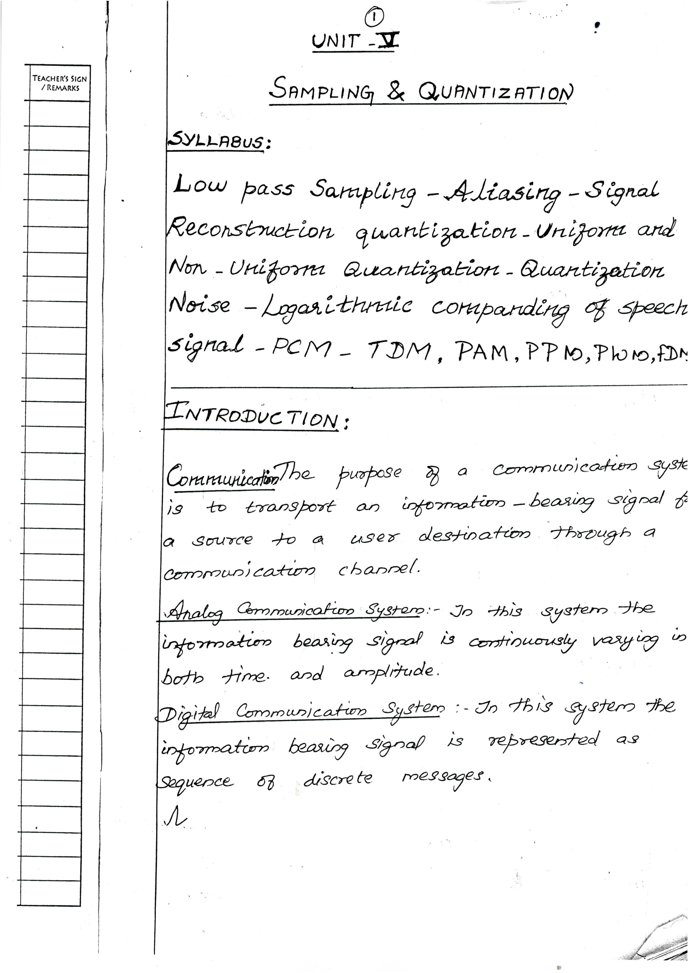Downloaded From : www.EasyEngineering.net

Downloaded From : www.EasyEngineering.net

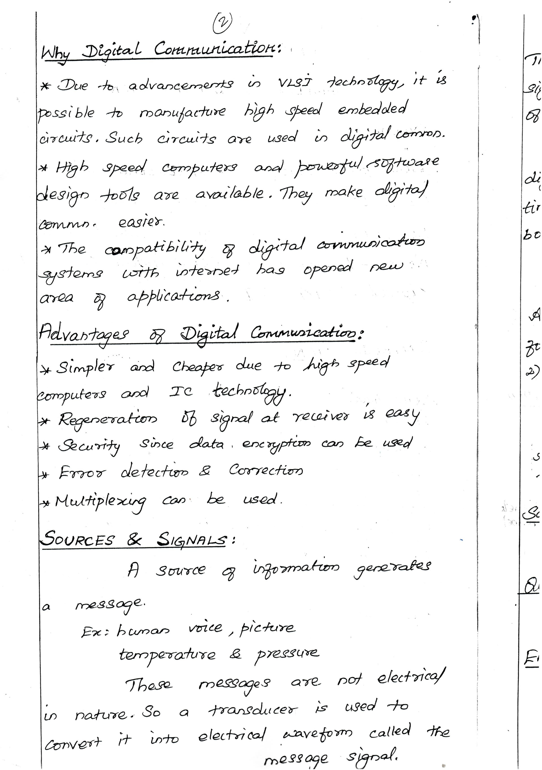Downloaded From : www.EasyEngineering.net

Downloaded From : www.EasyEngineering.net

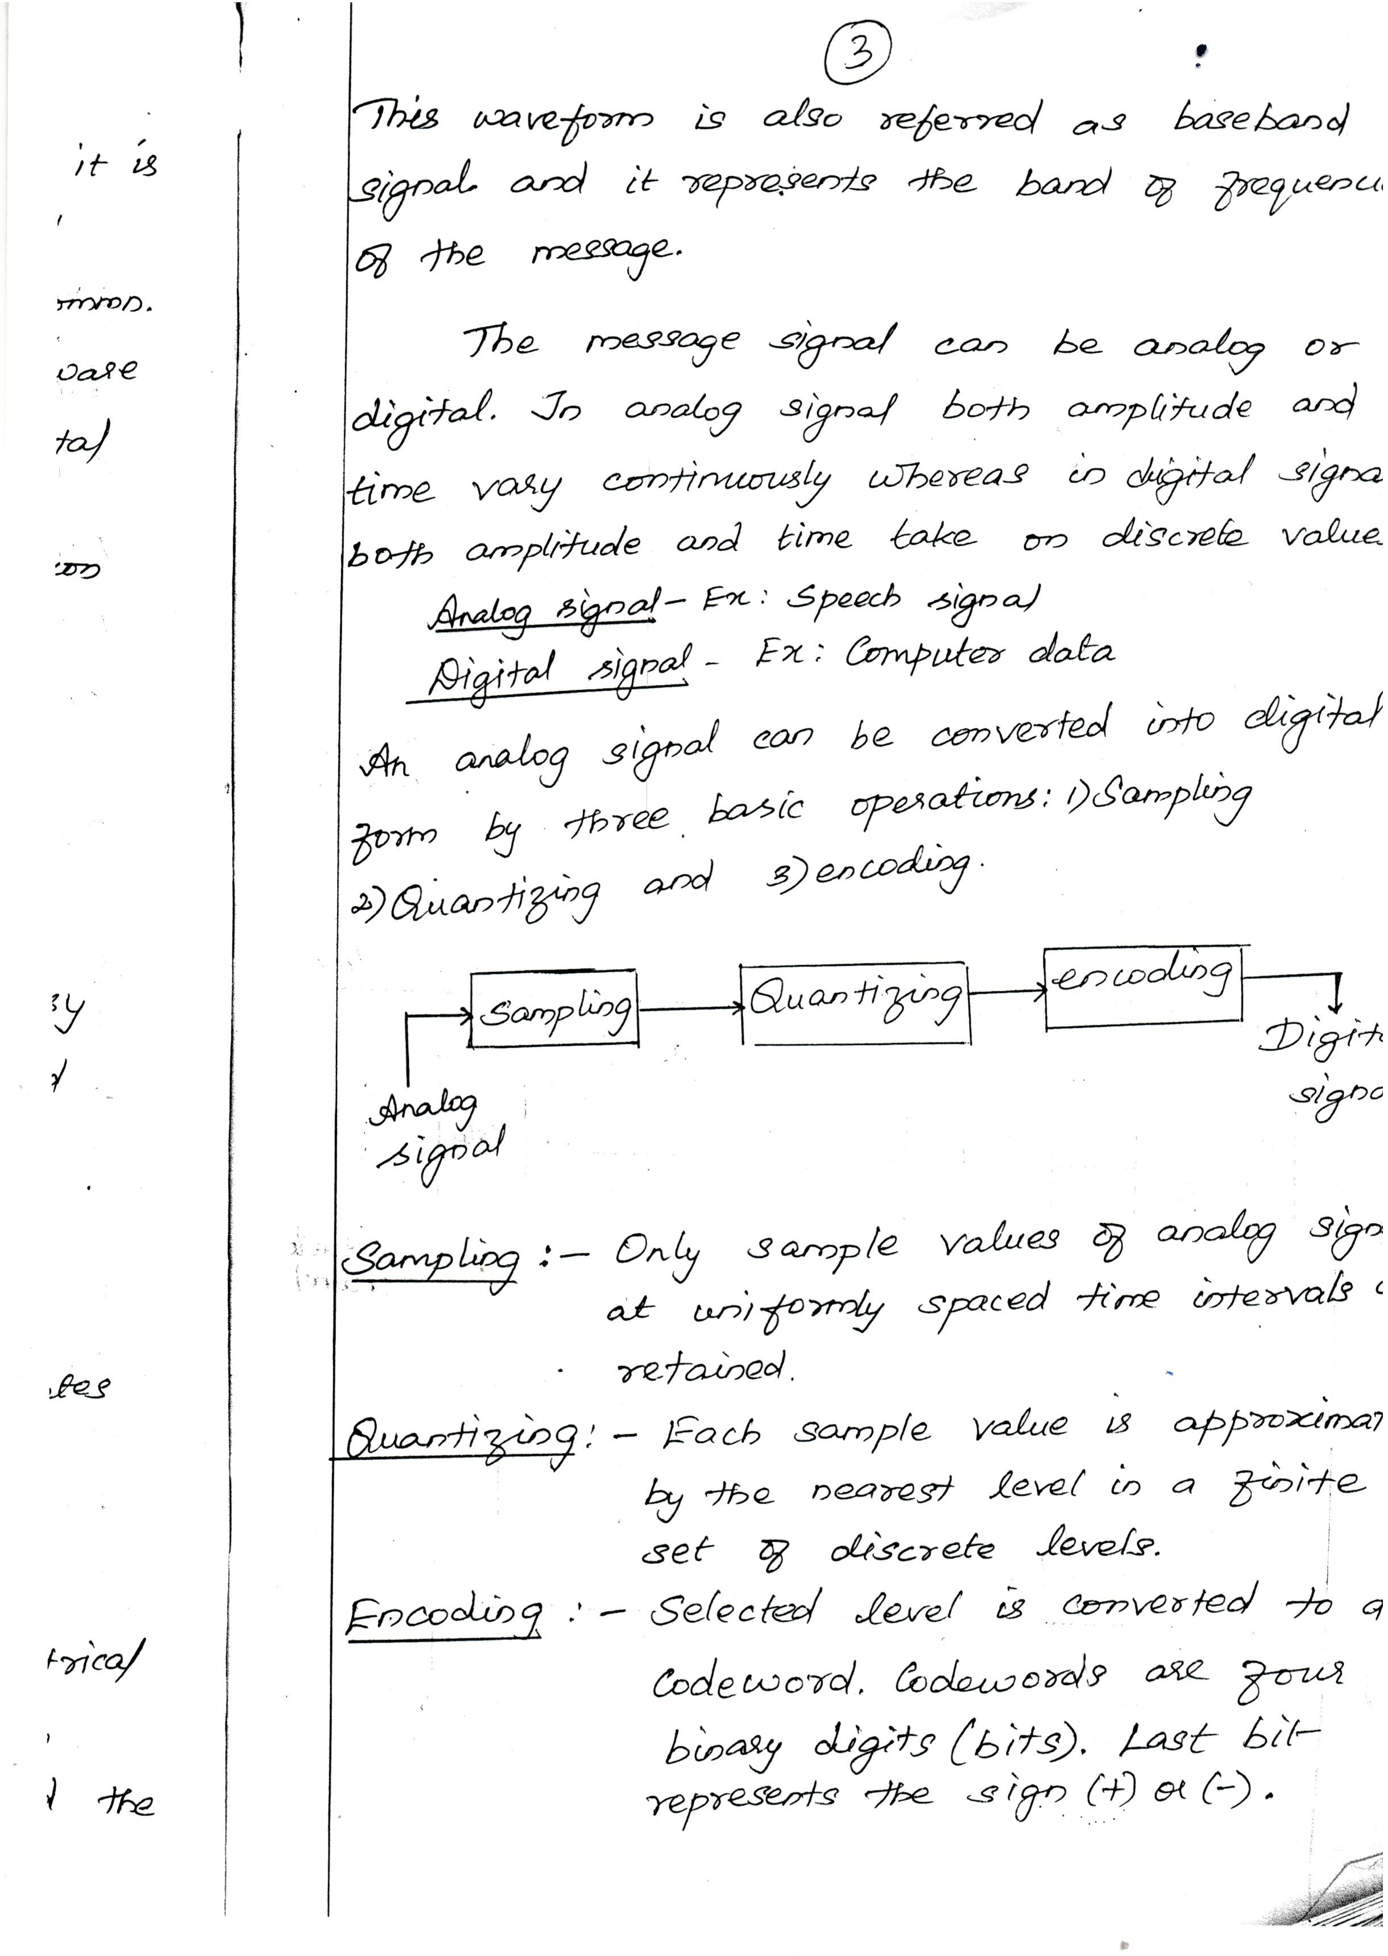Downloaded From : www.EasyEngineering.net

Downloaded From : www.EasyEngineering.net

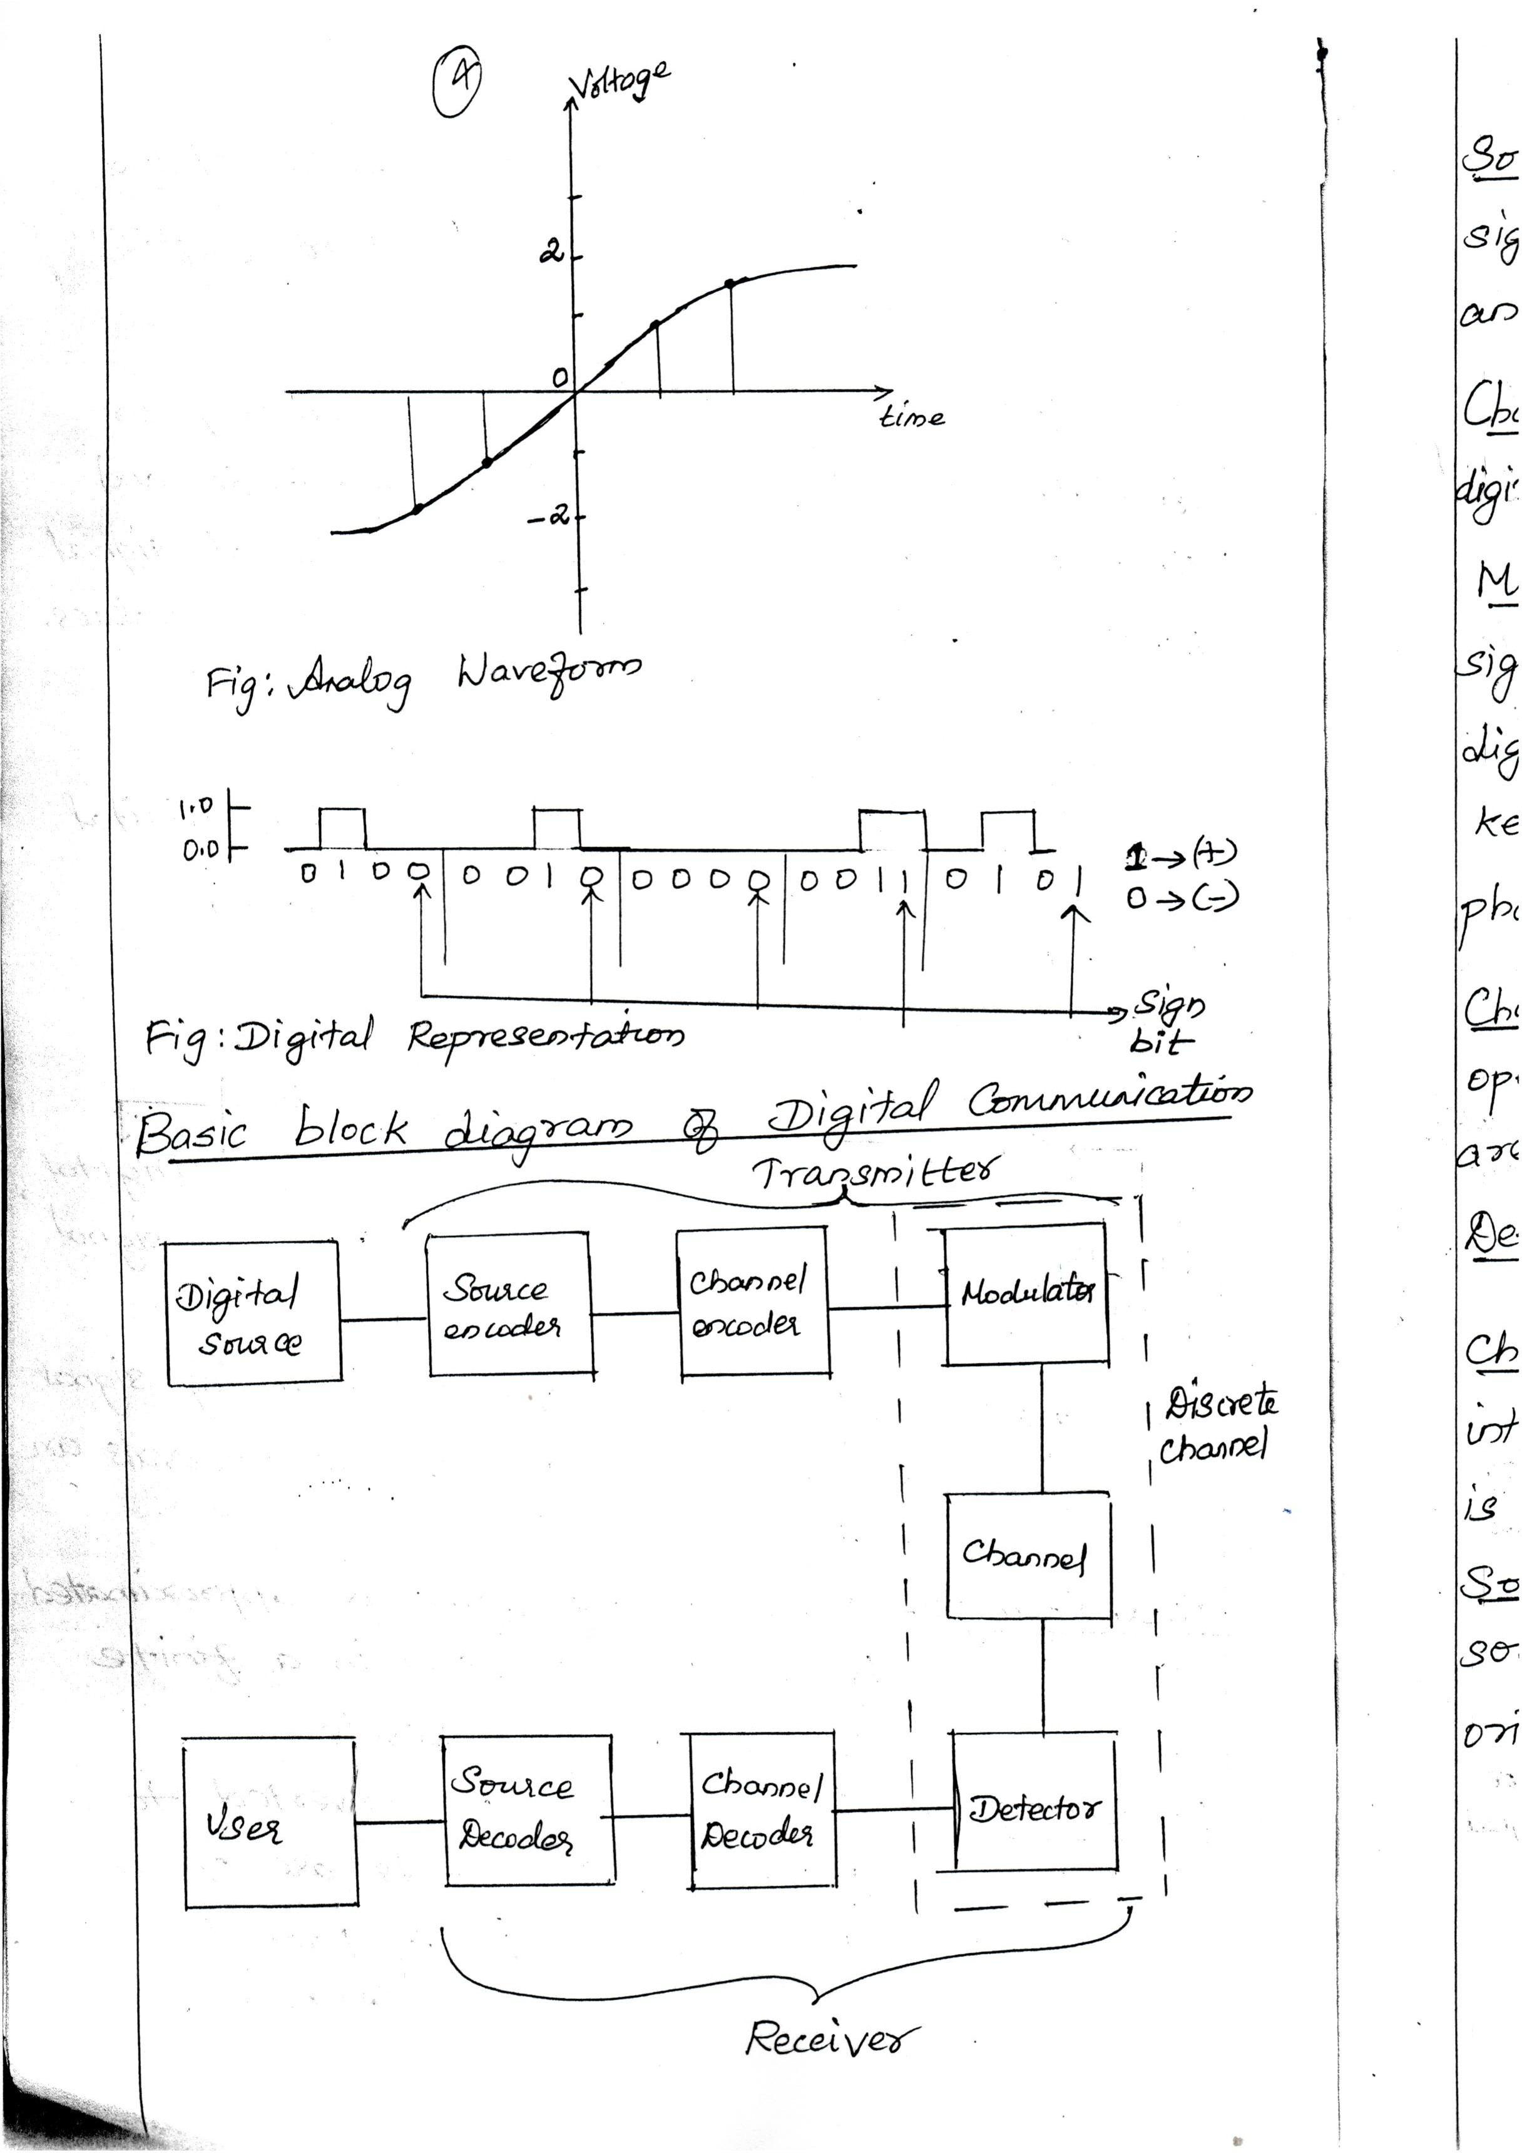Downloaded From : www.EasyEngineering.net

Downloaded From : www.EasyEngineering.net

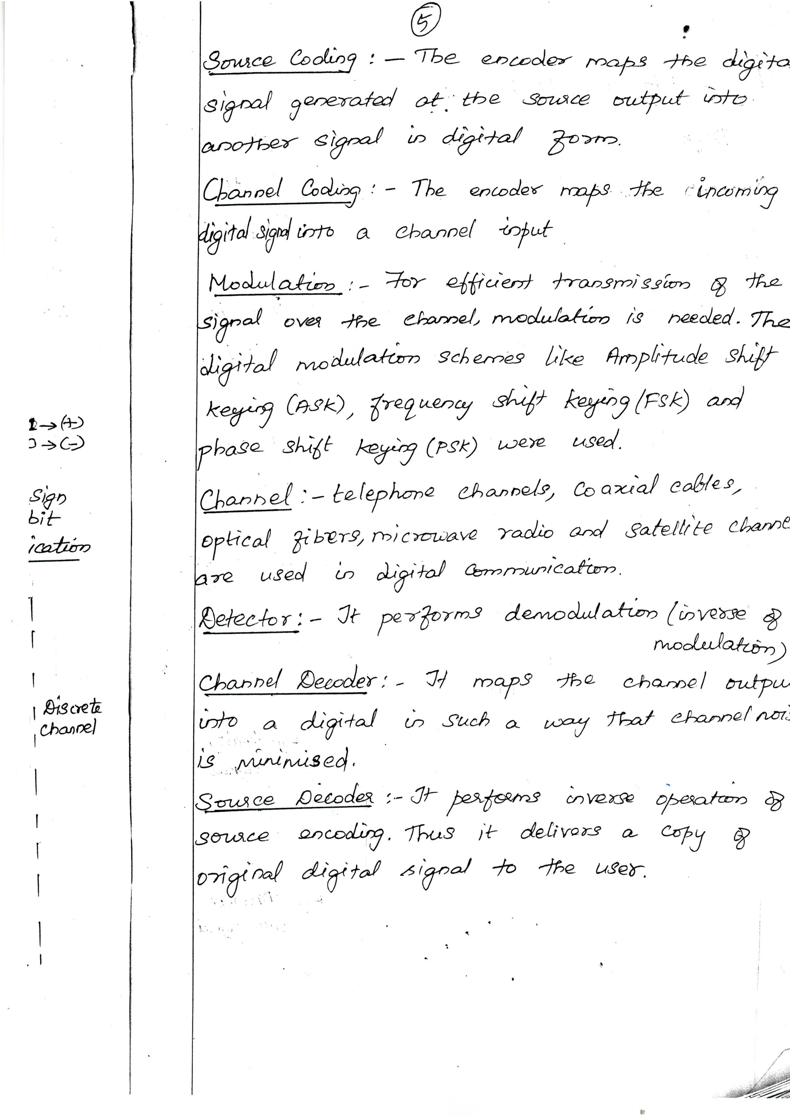Downloaded From : www.EasyEngineering.net

Downloaded From : www.EasyEngineering.net

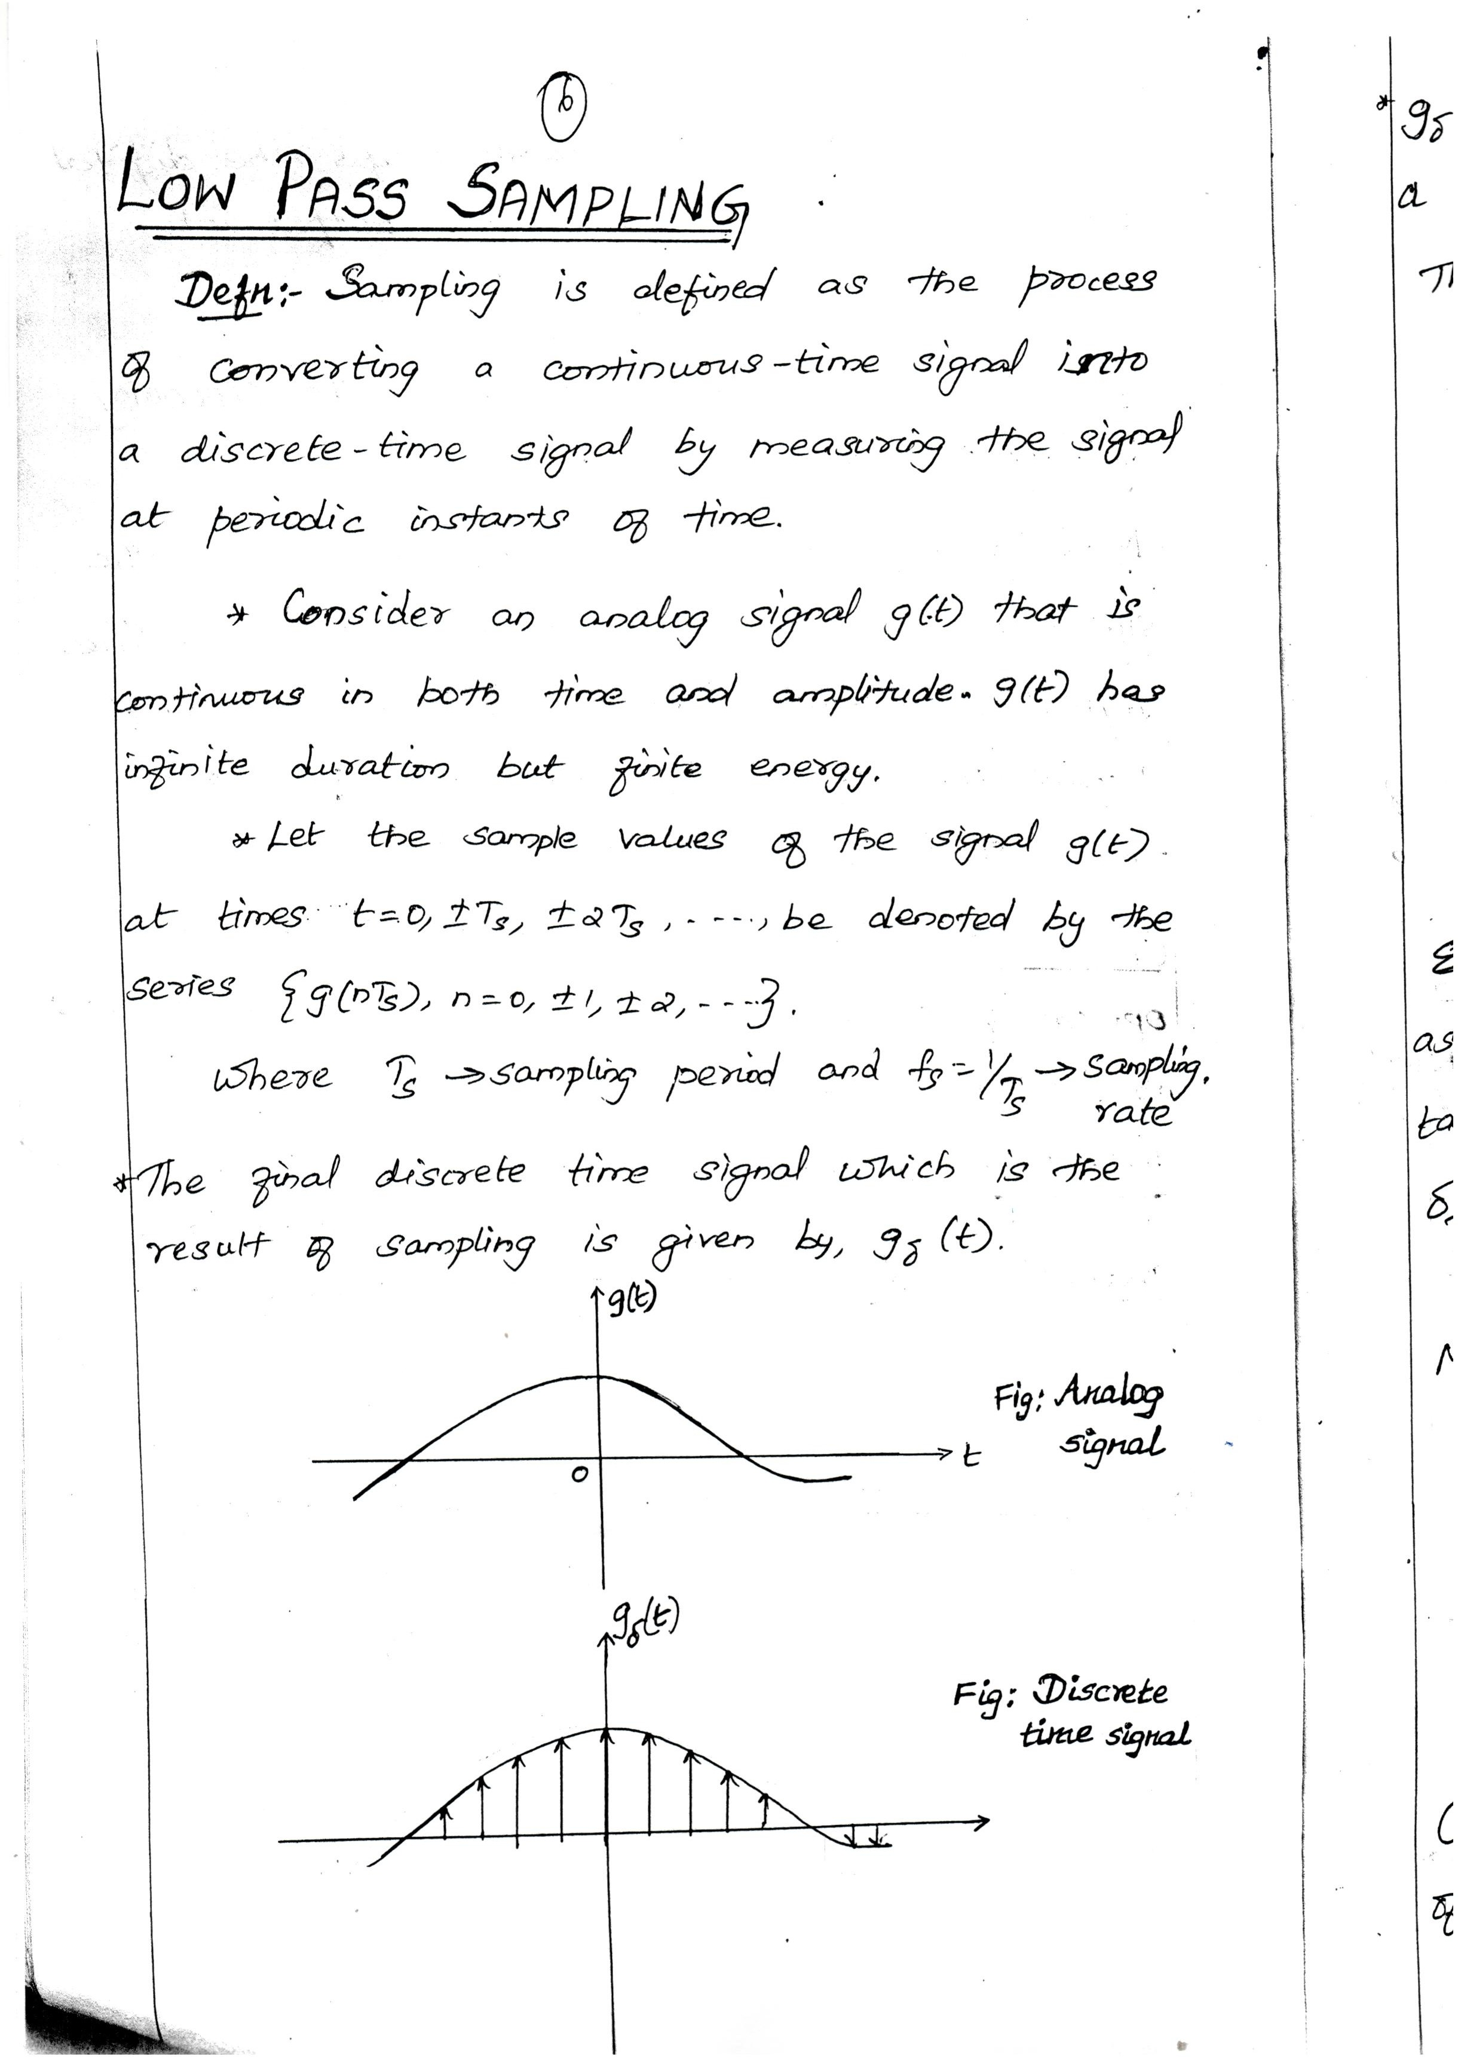Downloaded From : www.EasyEngineering.net

Downloaded From : www.EasyEngineering.net

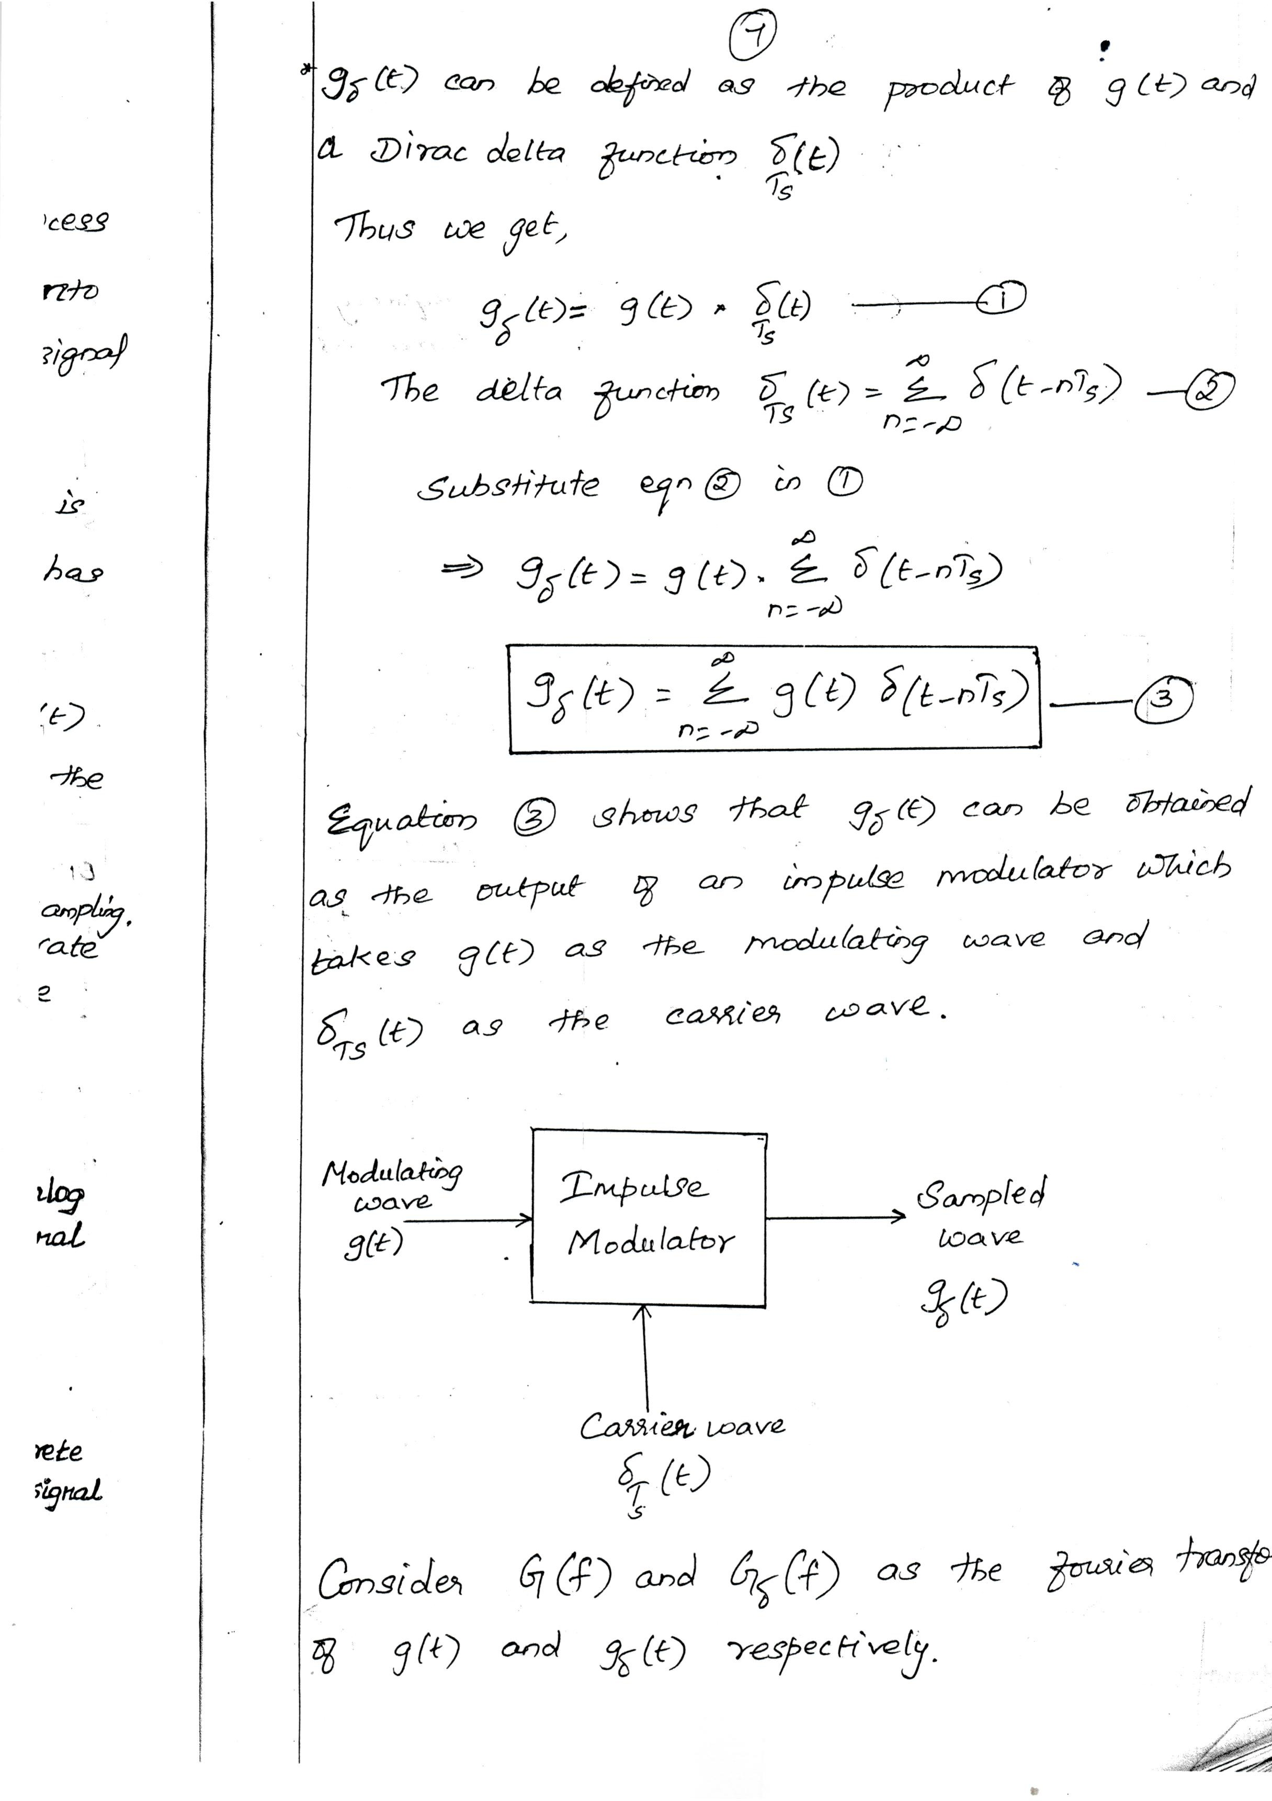Downloaded From : www.EasyEngineering.net

Downloaded From : www.EasyEngineering.net

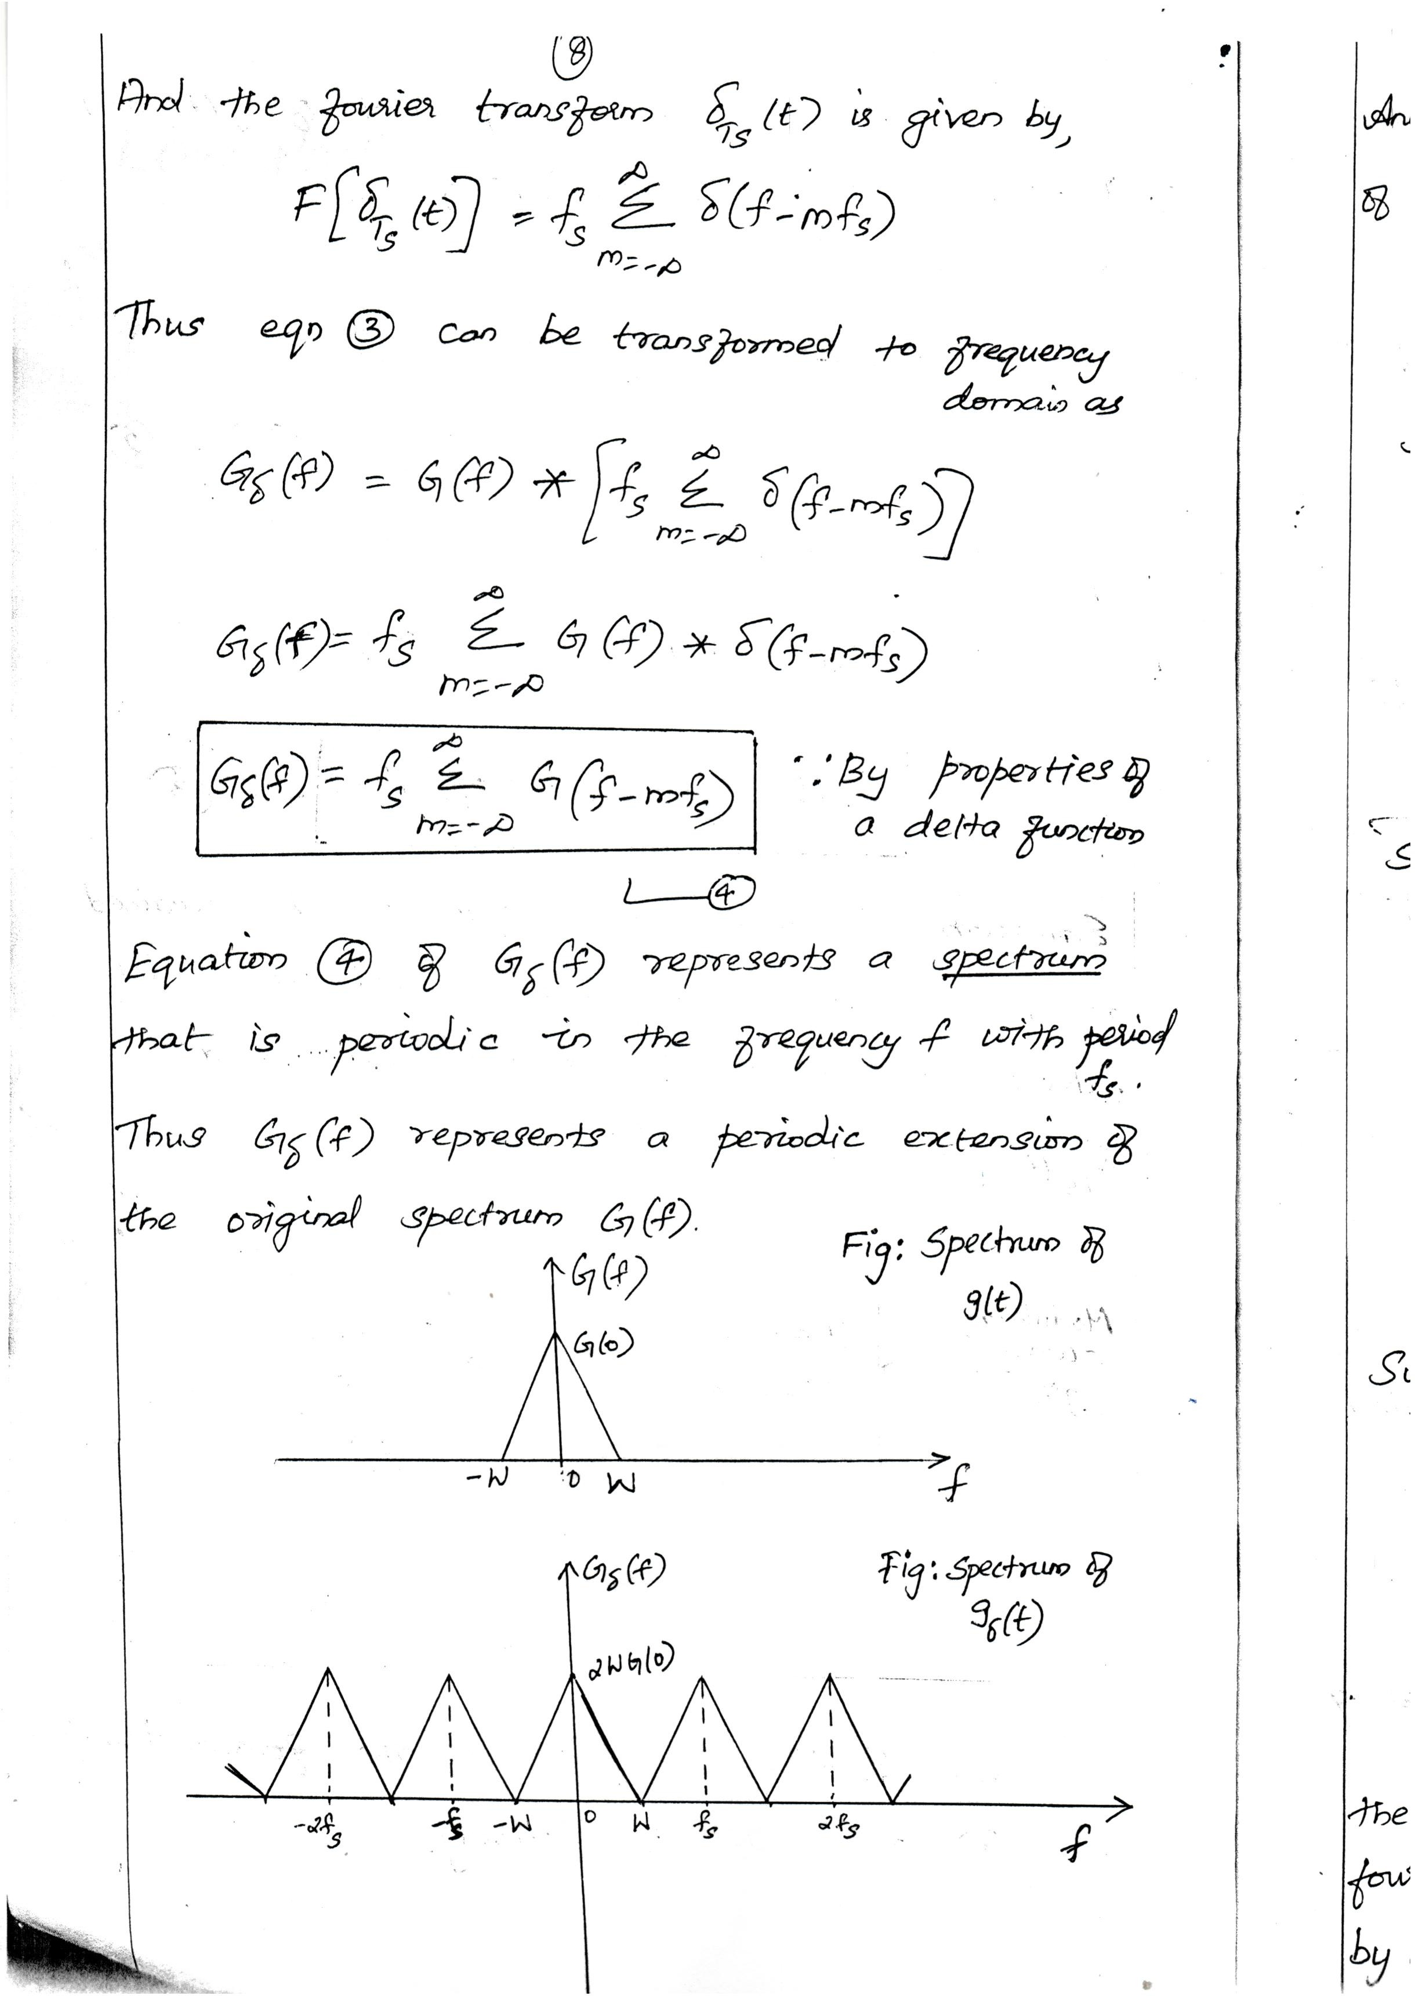Downloaded From : www.EasyEngineering.net

Downloaded From : www.EasyEngineering.net

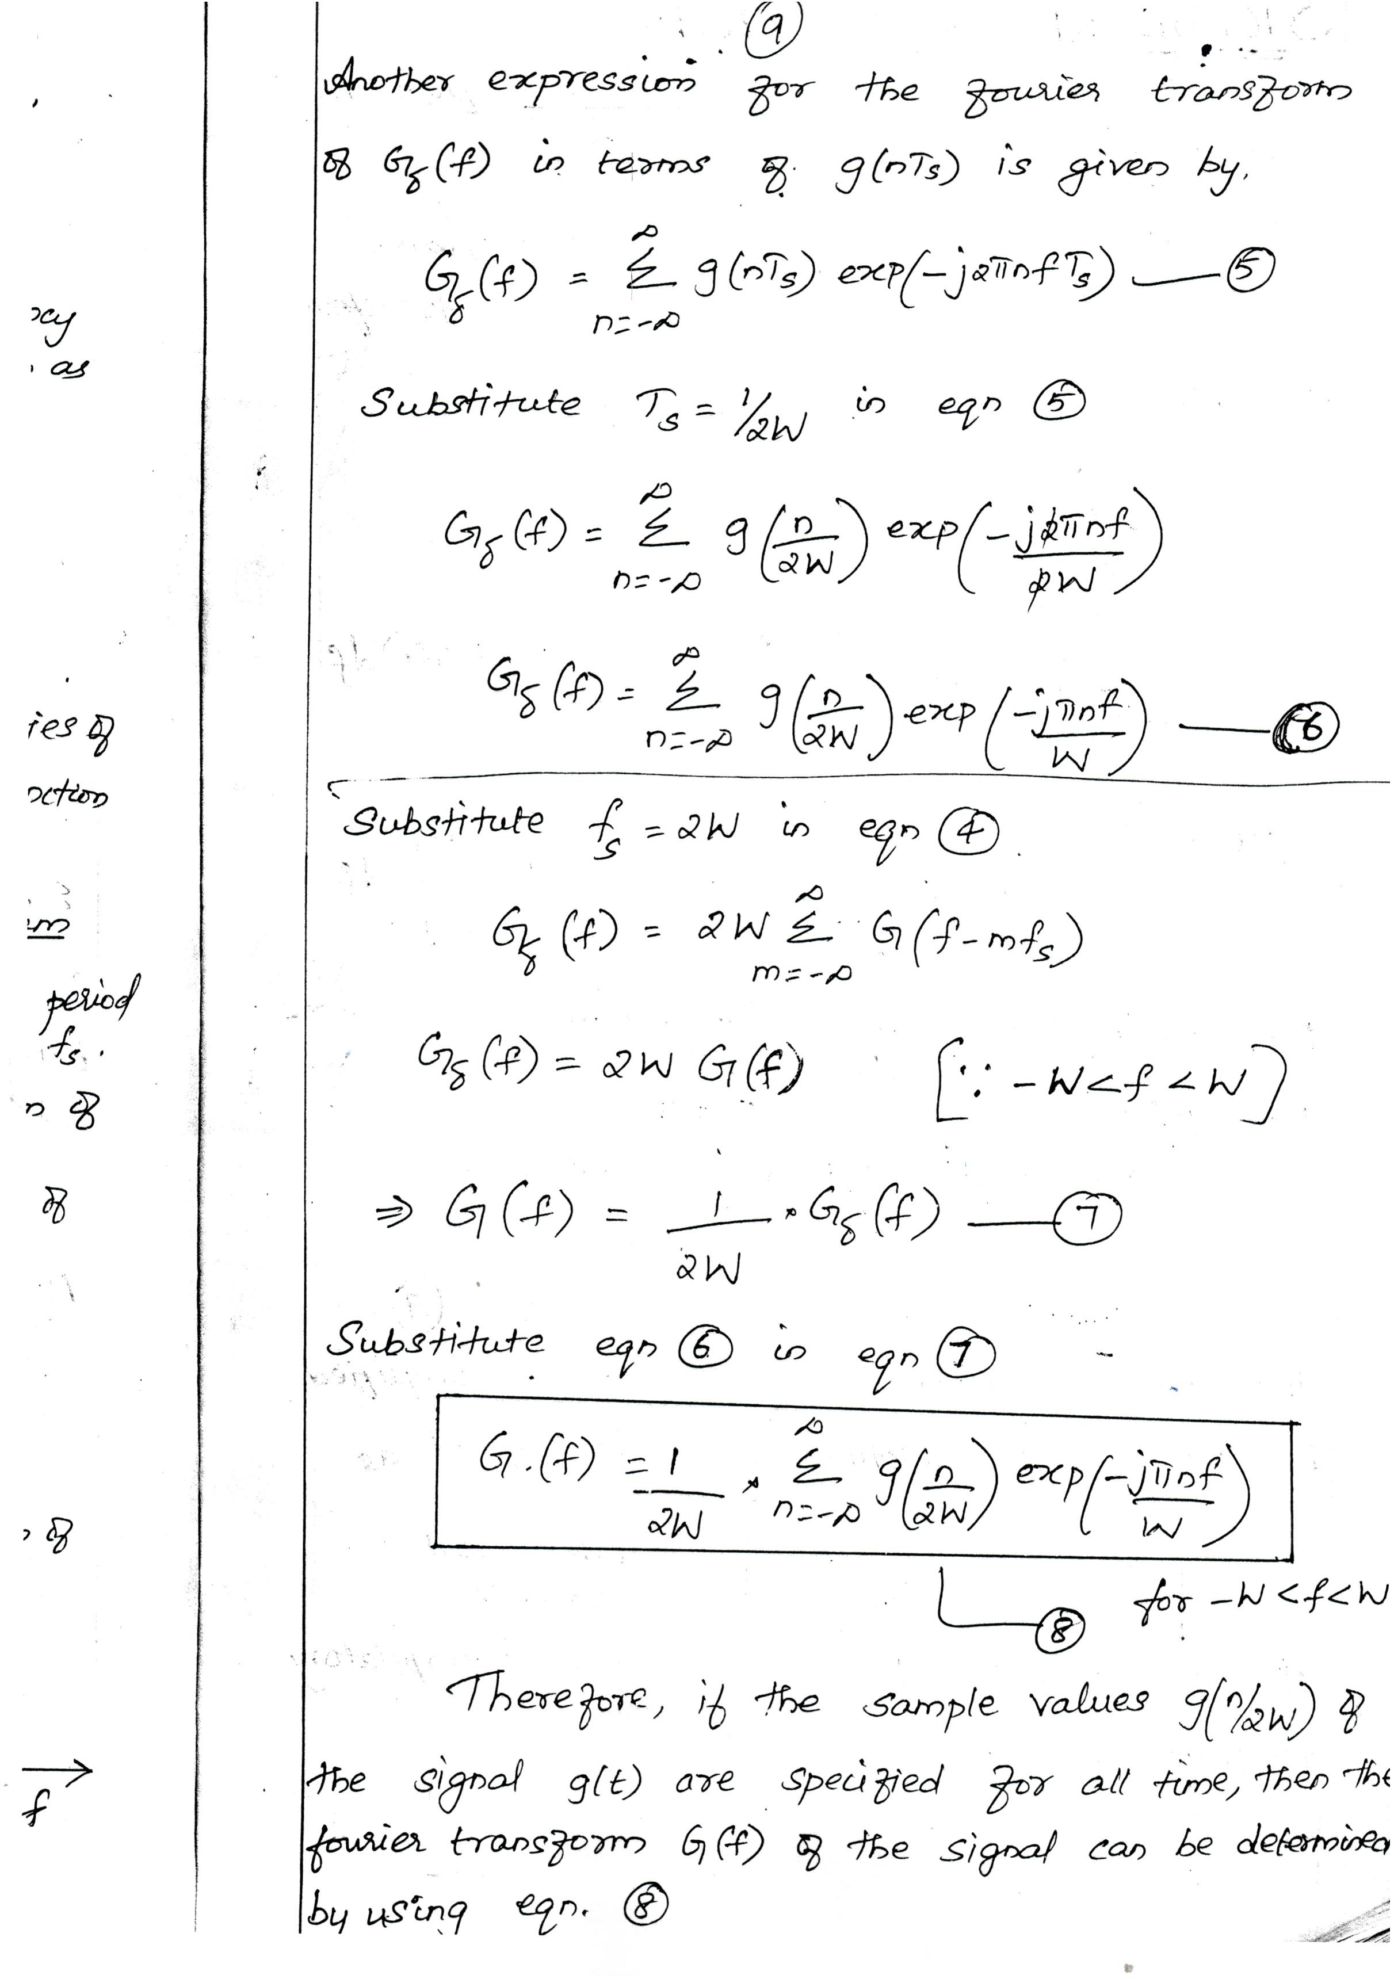Downloaded From : www.EasyEngineering.net

Downloaded From : www.EasyEngineering.net

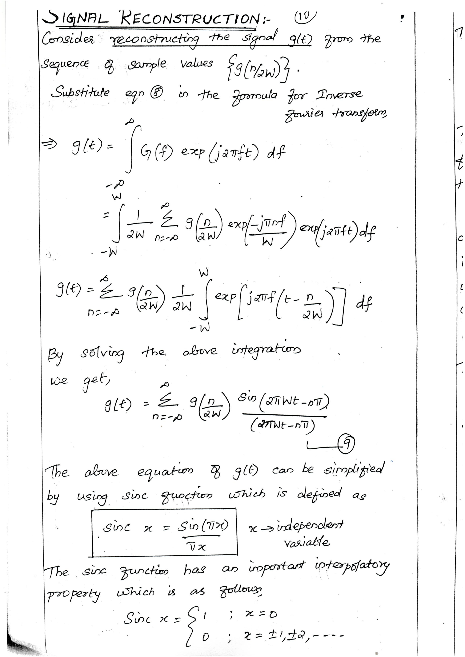Downloaded From : www.EasyEngineering.net

Downloaded From : www.EasyEngineering.net

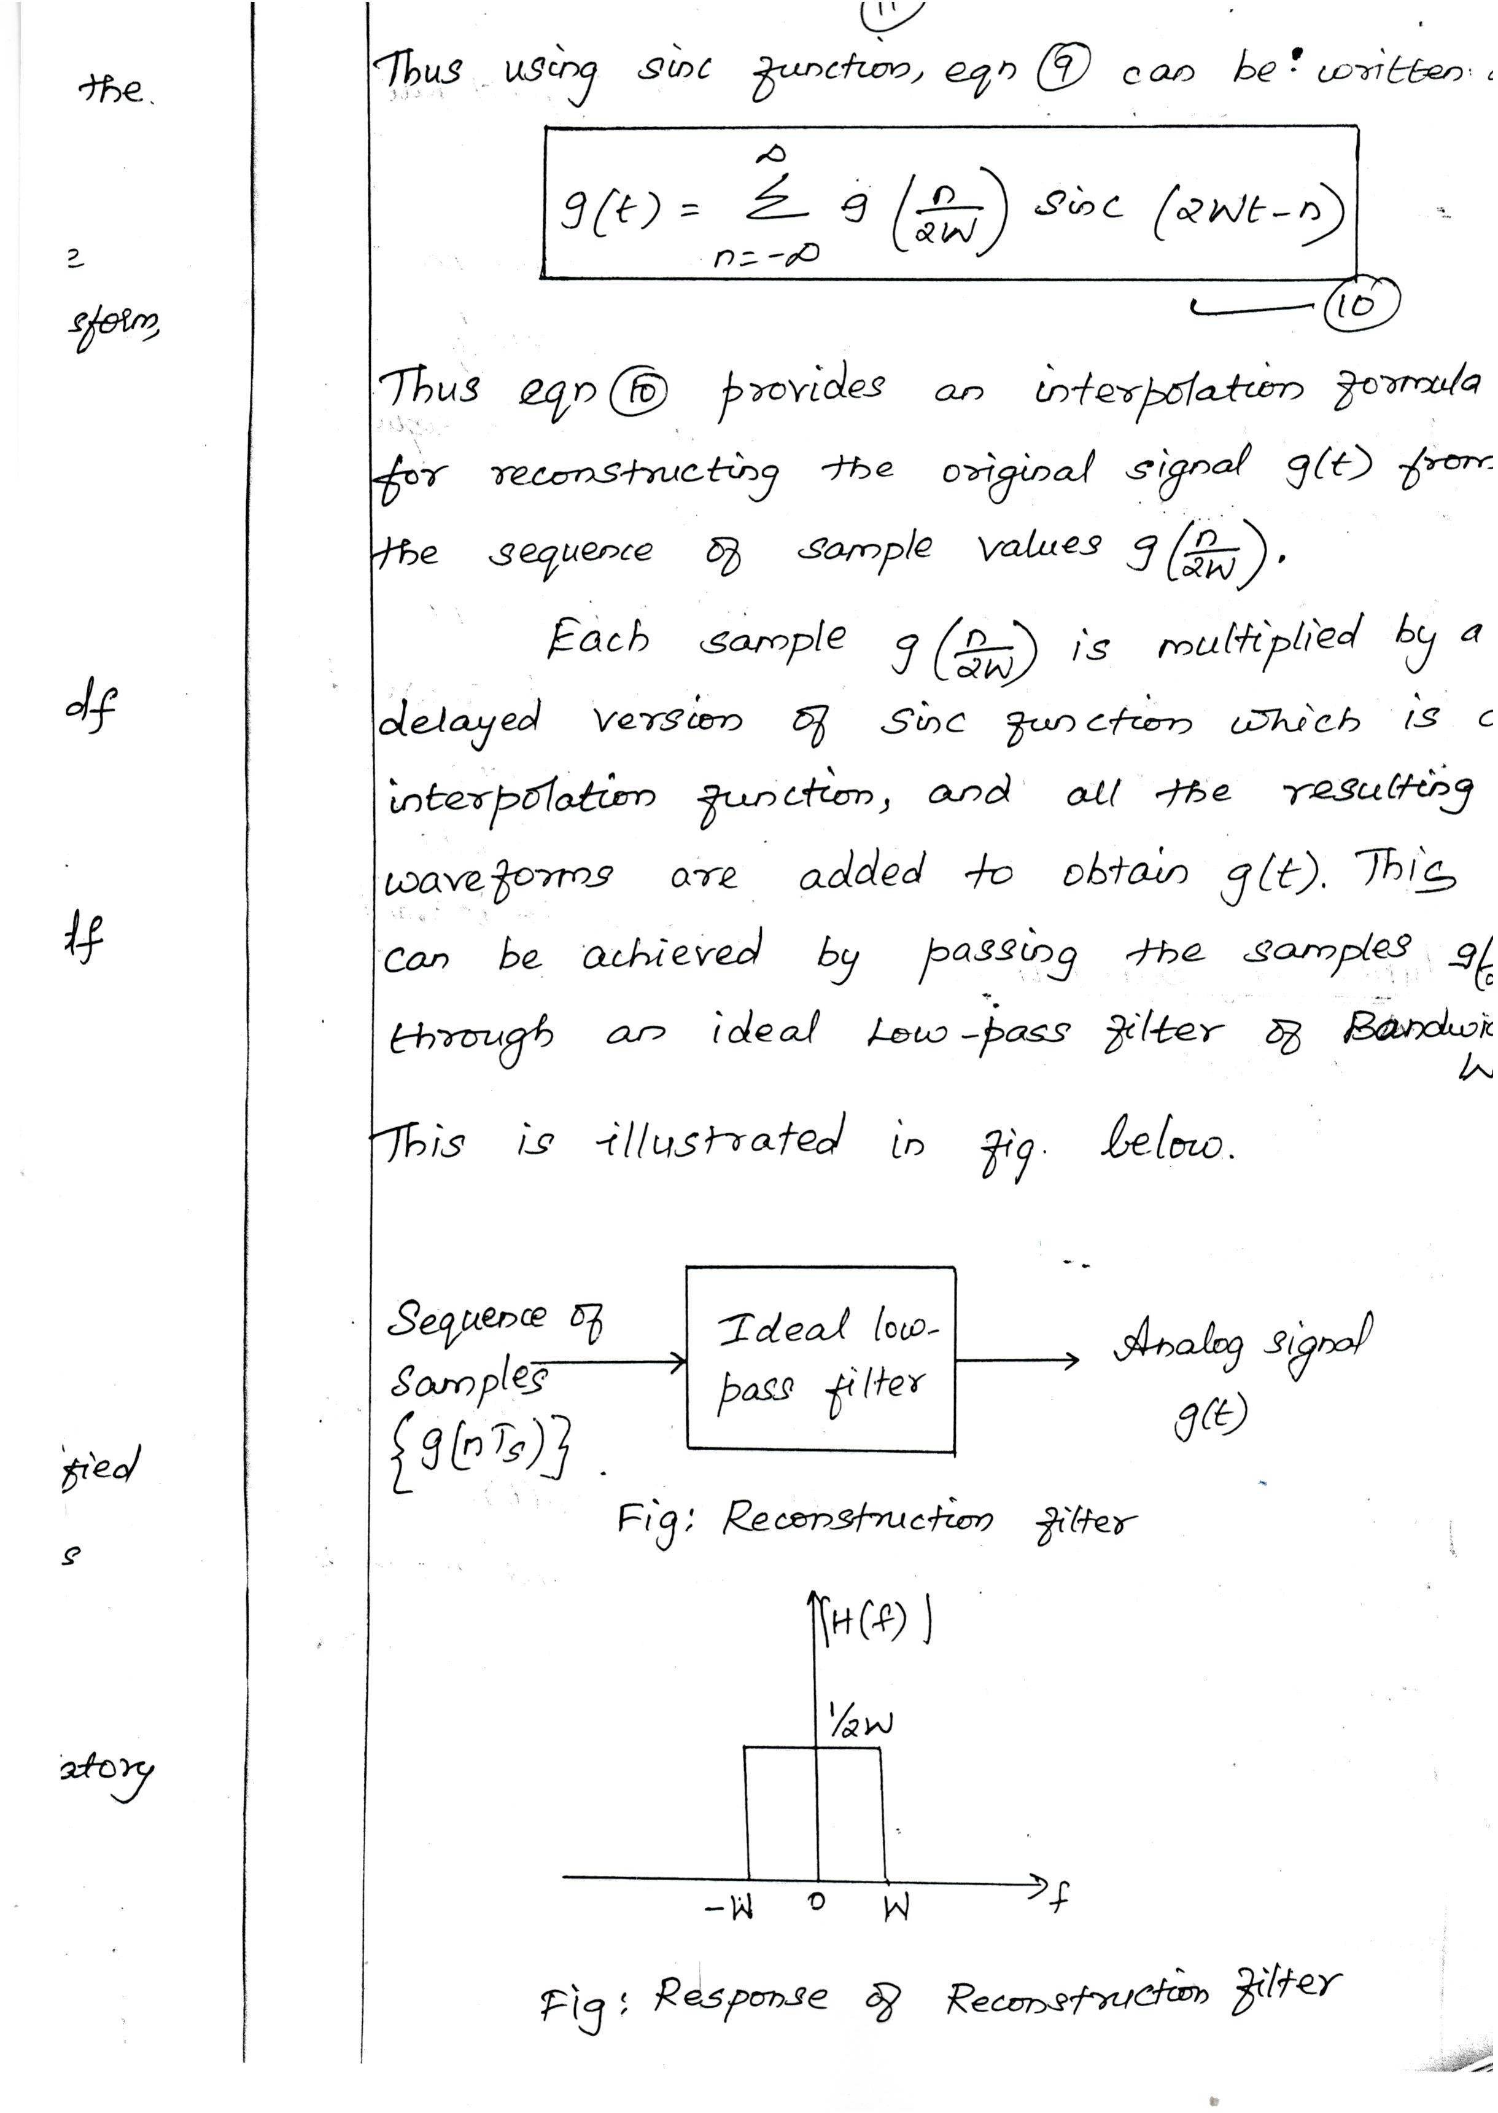Downloaded From : www.EasyEngineering.net

Downloaded From : www.EasyEngineering.net

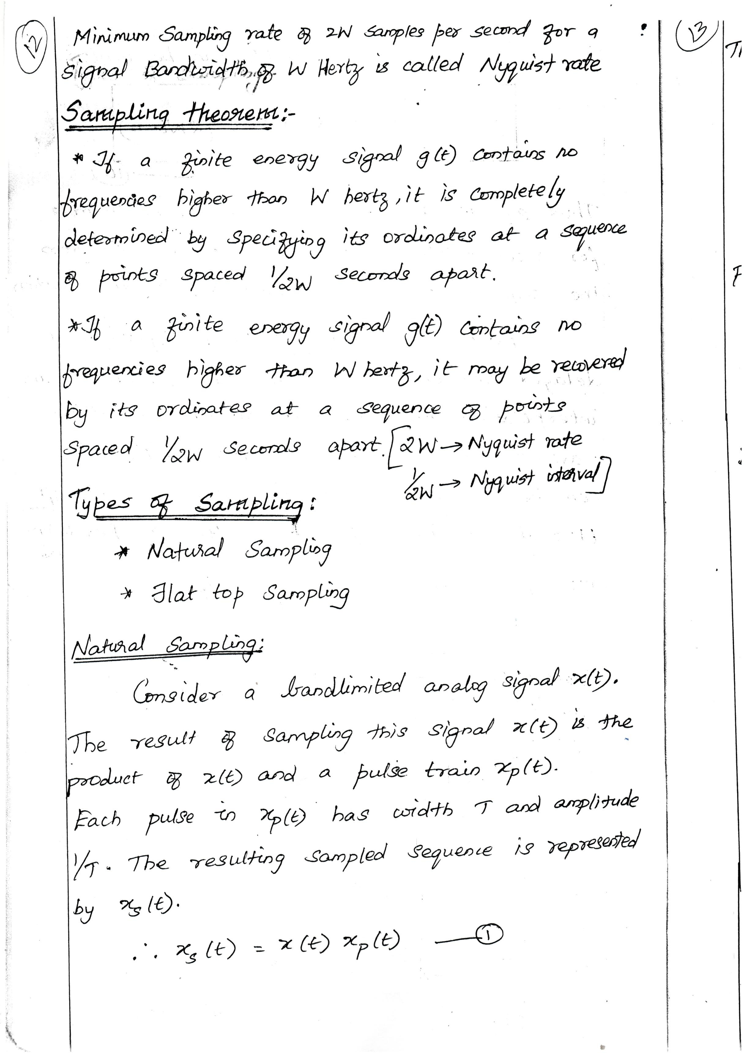Downloaded From : www.EasyEngineering.net

Downloaded From : www.EasyEngineering.net

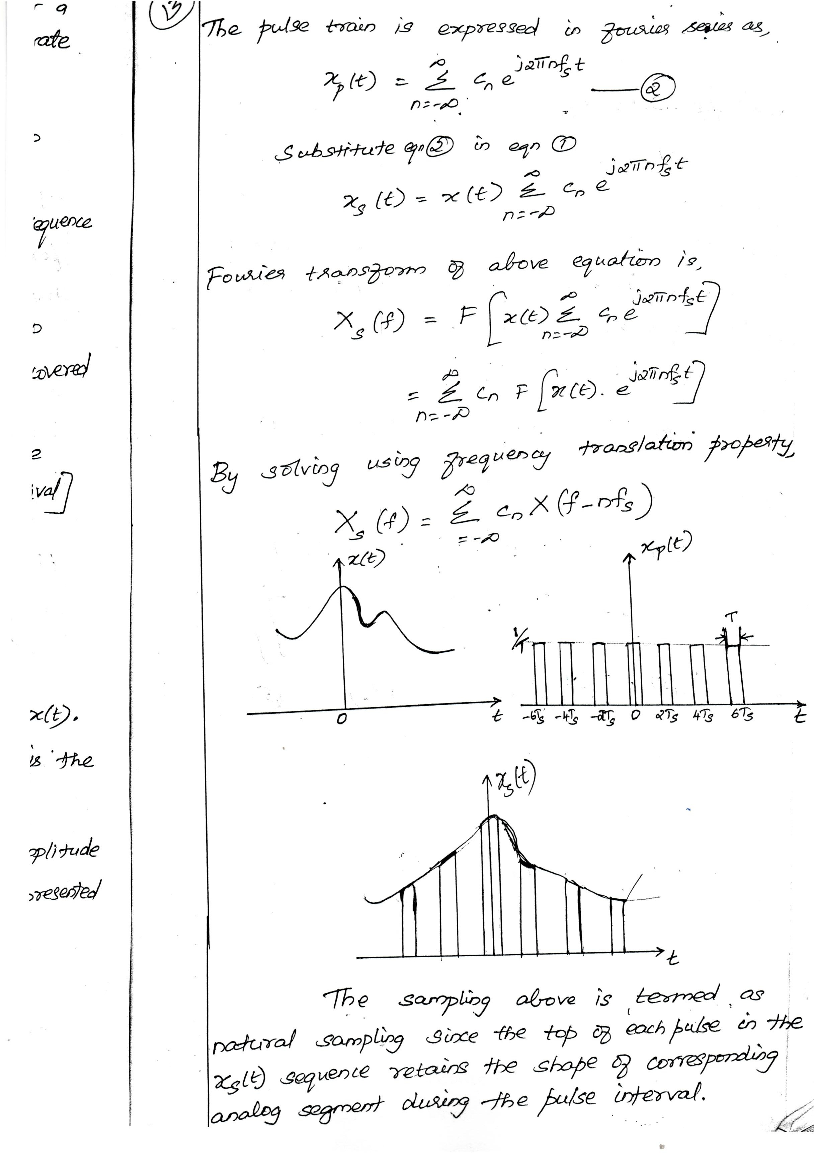Downloaded From : www.EasyEngineering.net

Downloaded From : www.EasyEngineering.net

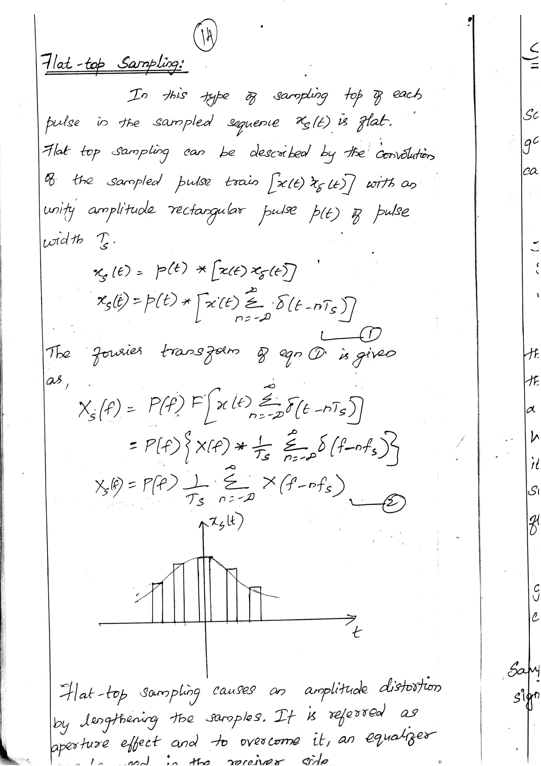Downloaded From : www.EasyEngineering.net

Downloaded From : www.EasyEngineering.net

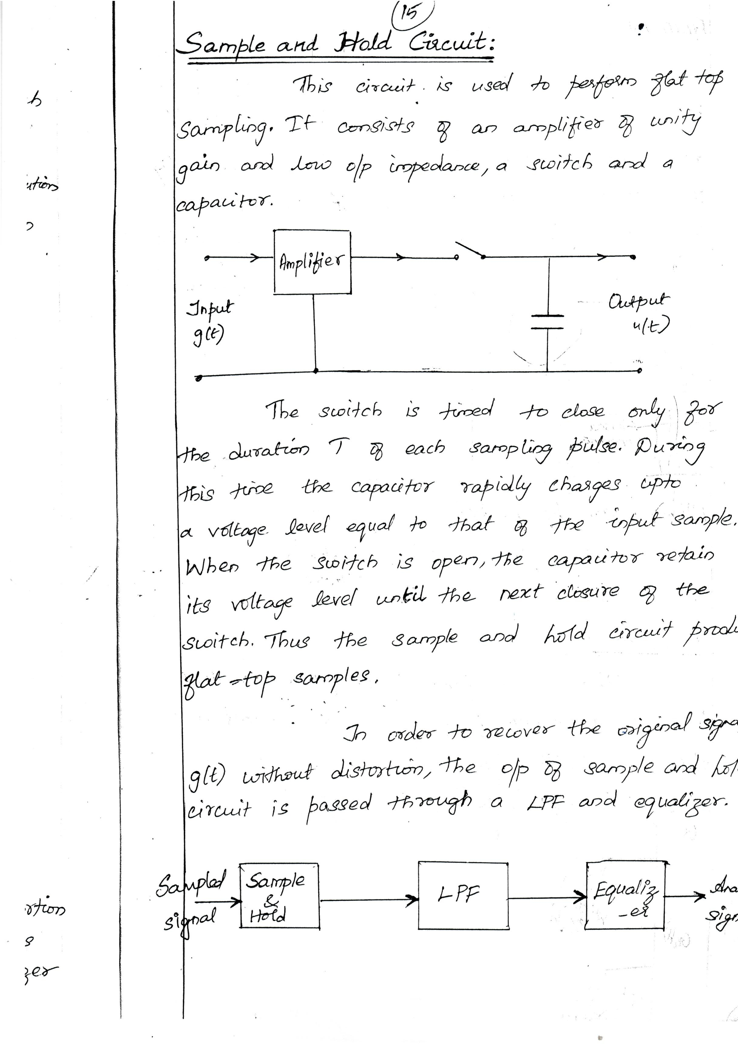Downloaded From : www.EasyEngineering.net

Downloaded From : www.EasyEngineering.net

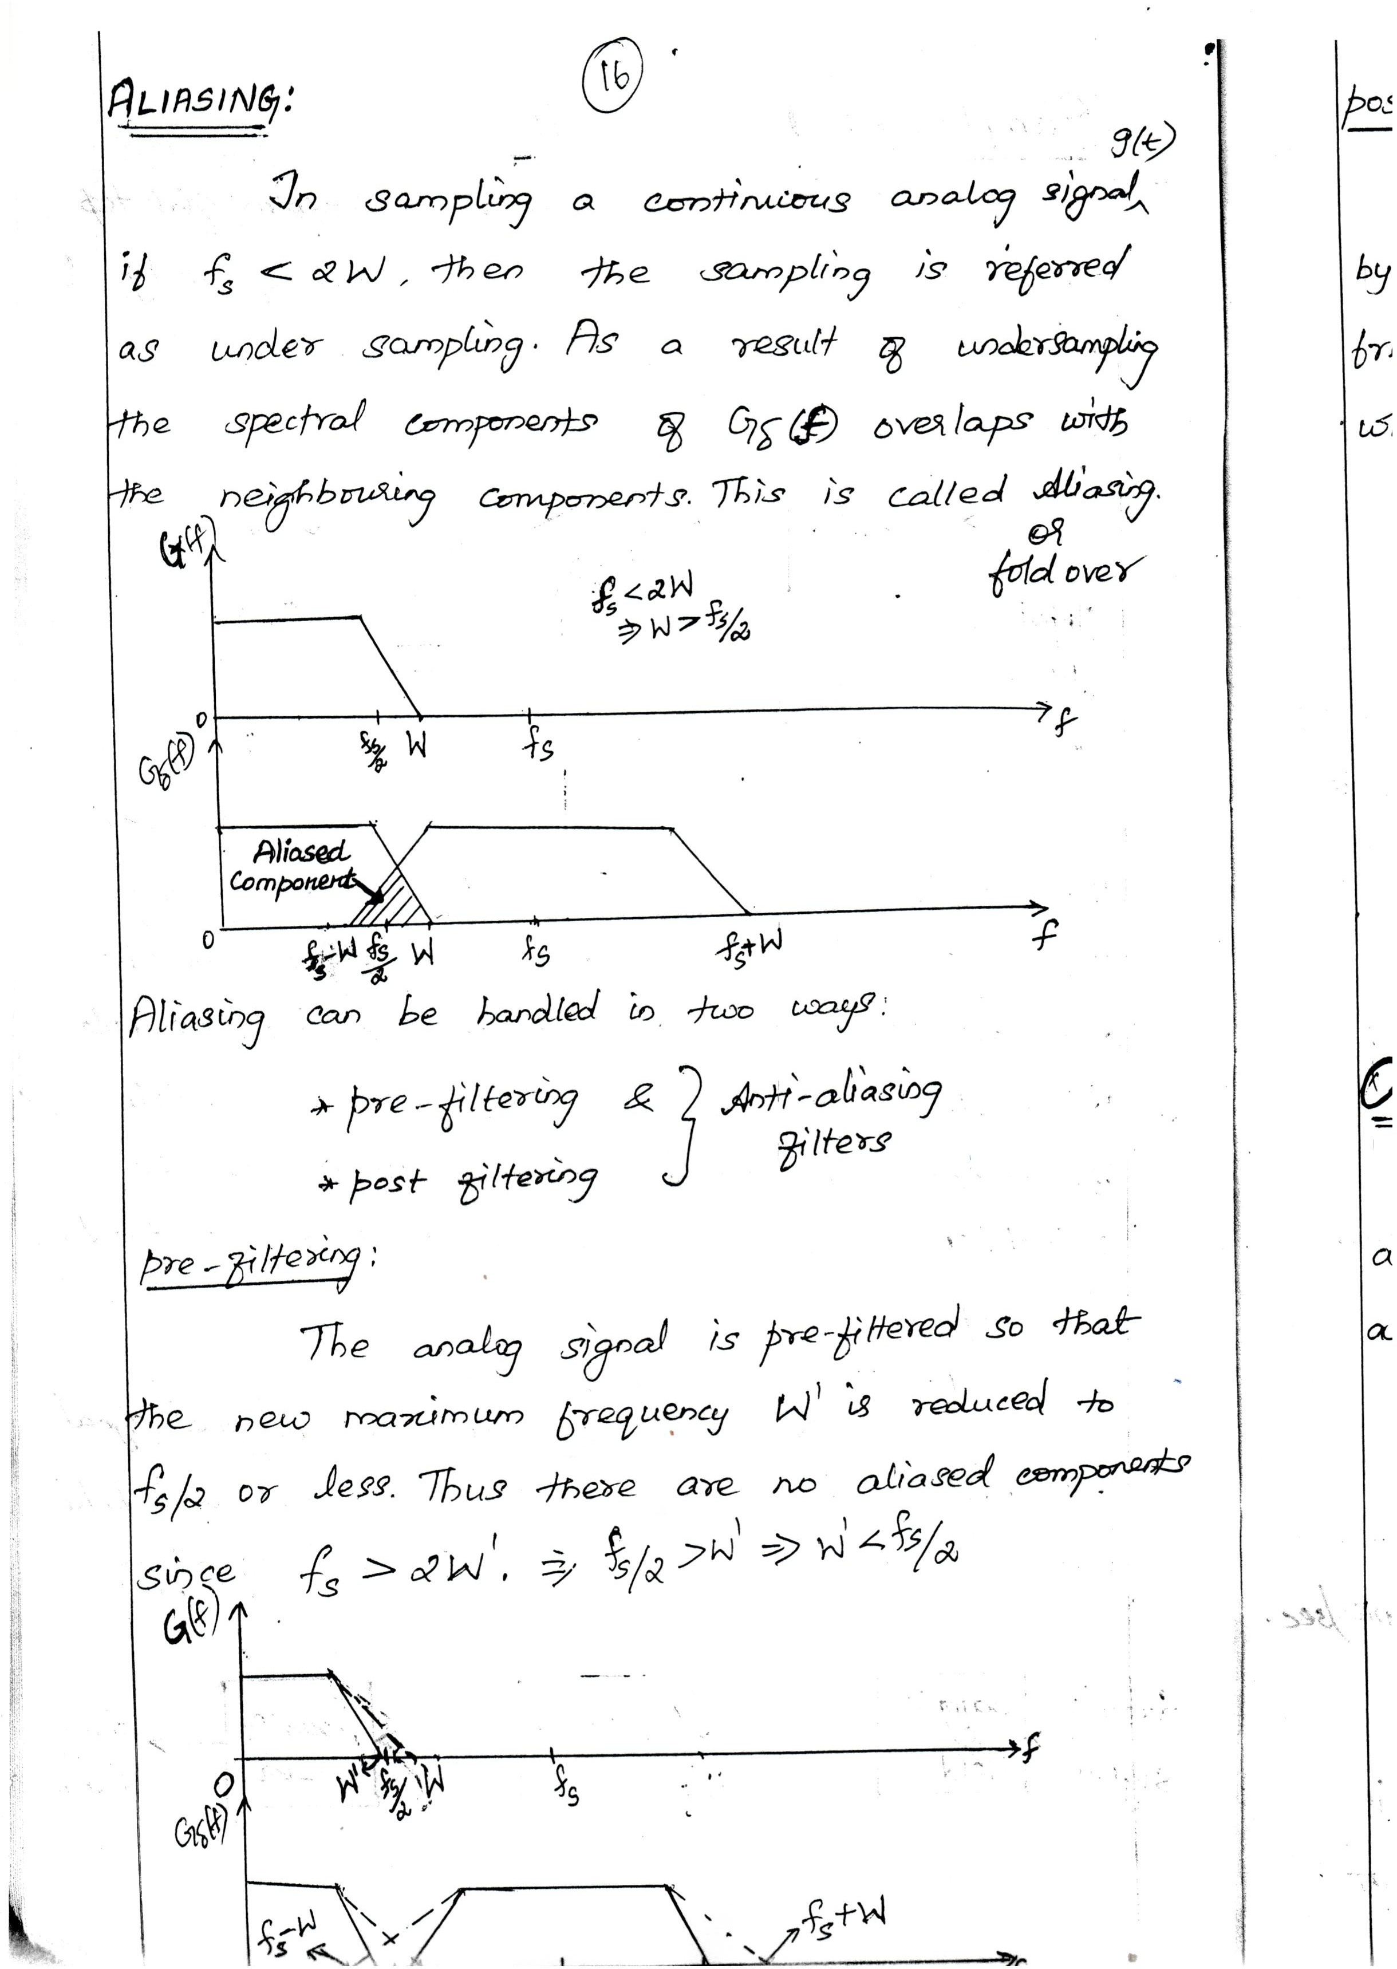Downloaded From : www.EasyEngineering.net

Downloaded From : www.EasyEngineering.net

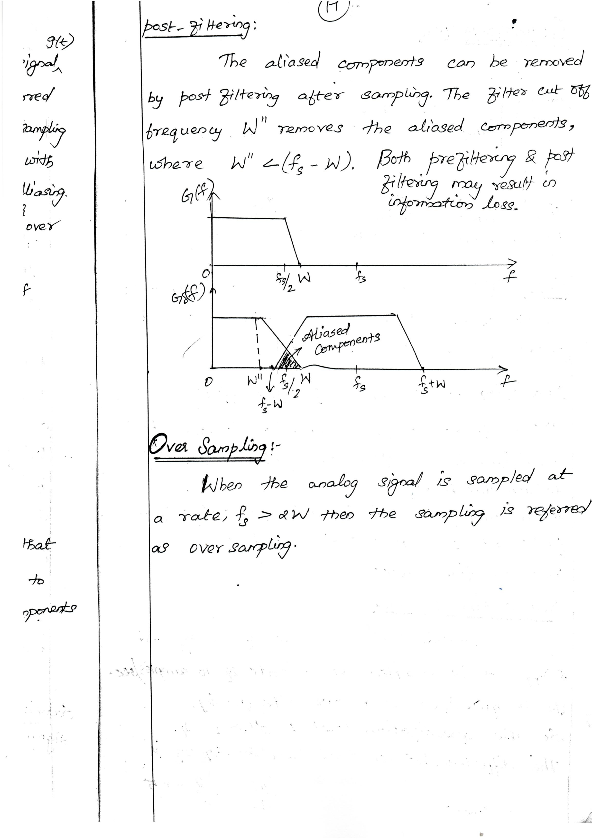Downloaded From : www.EasyEngineering.net

Downloaded From : www.EasyEngineering.net

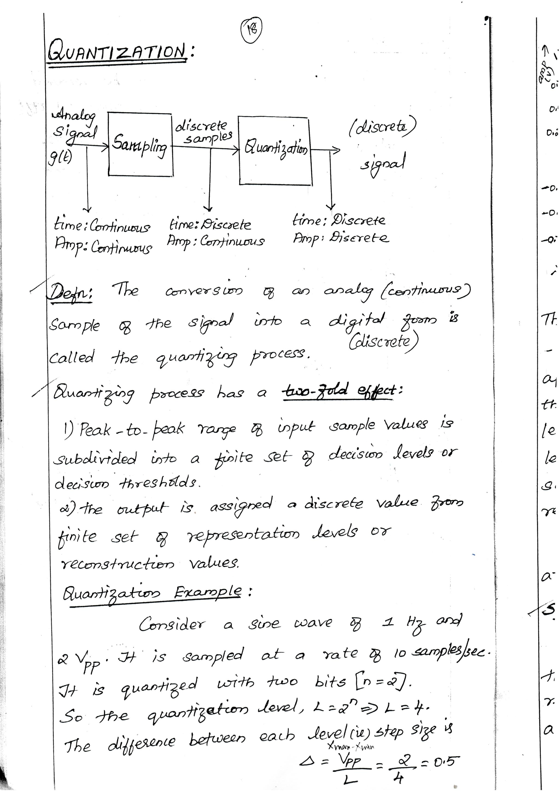Downloaded From : www.EasyEngineering.net

Downloaded From : www.EasyEngineering.net

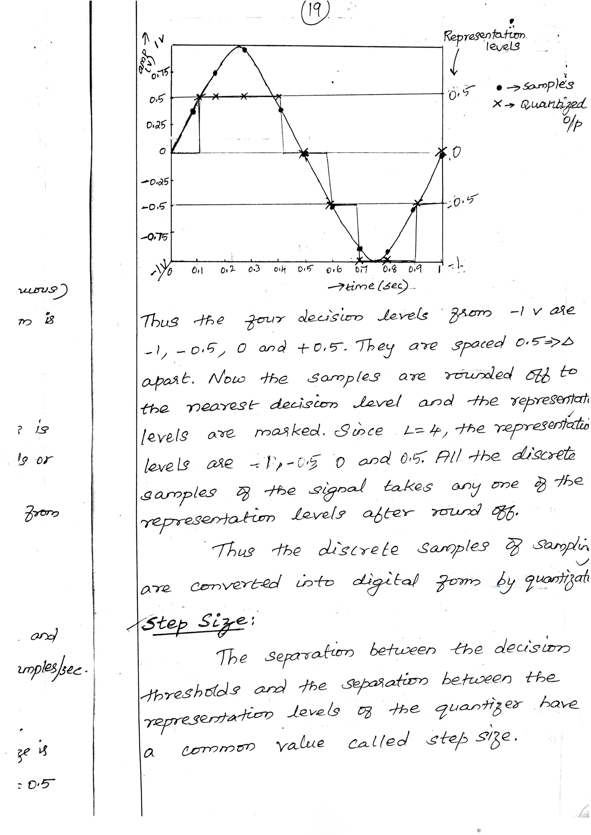Downloaded From : www.EasyEngineering.net

Downloaded From : www.EasyEngineering.net

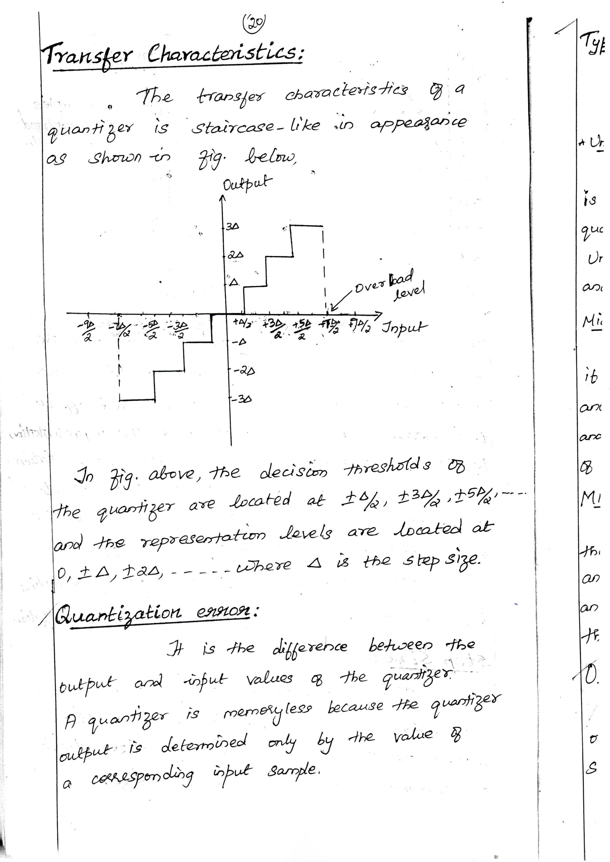Downloaded From : www.EasyEngineering.net

Downloaded From : www.EasyEngineering.net

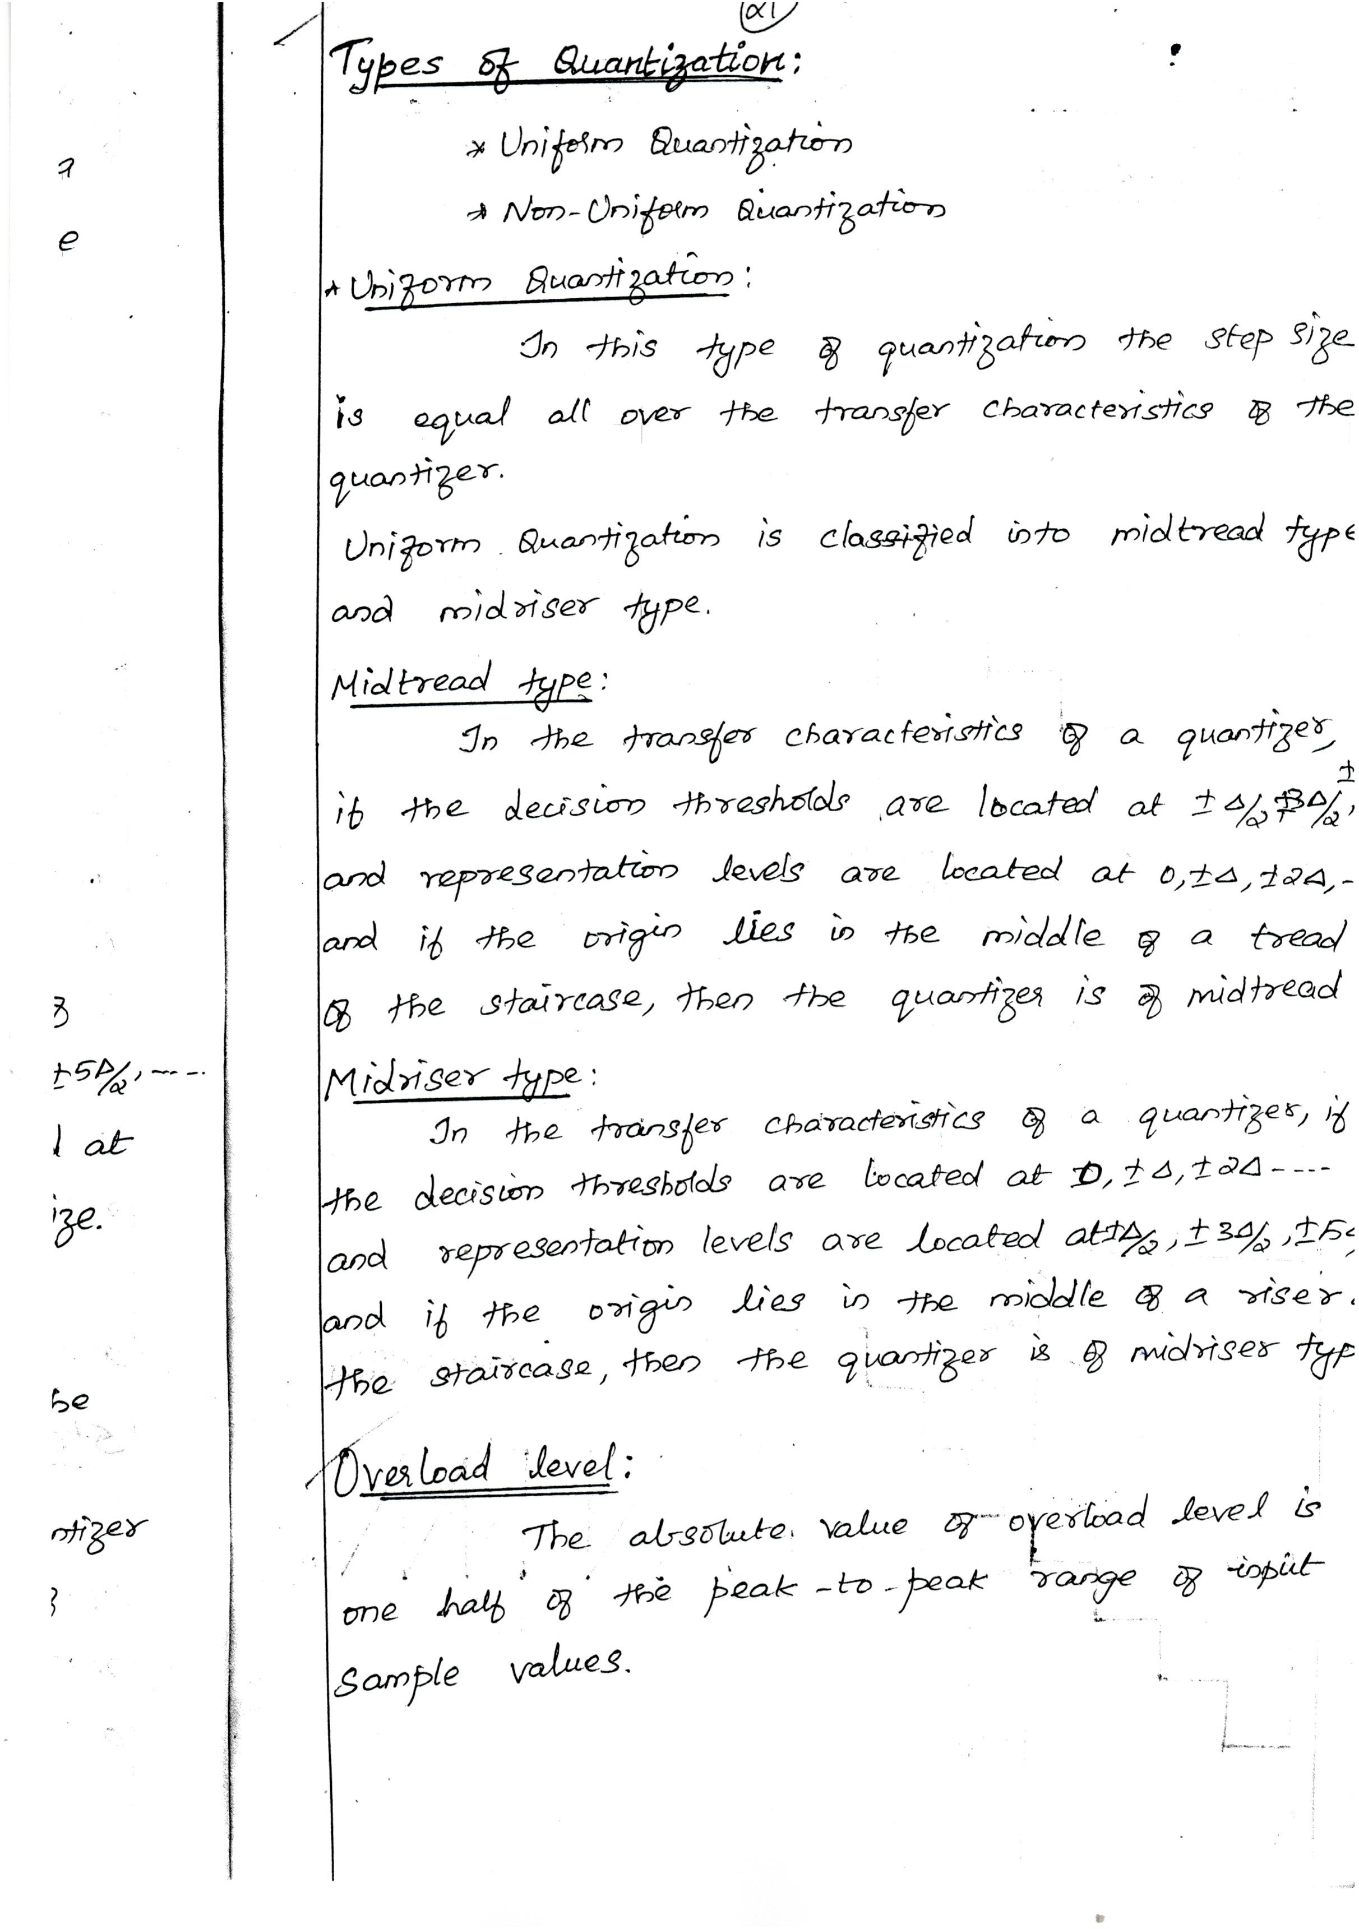Downloaded From : www.EasyEngineering.net

Downloaded From : www.EasyEngineering.net

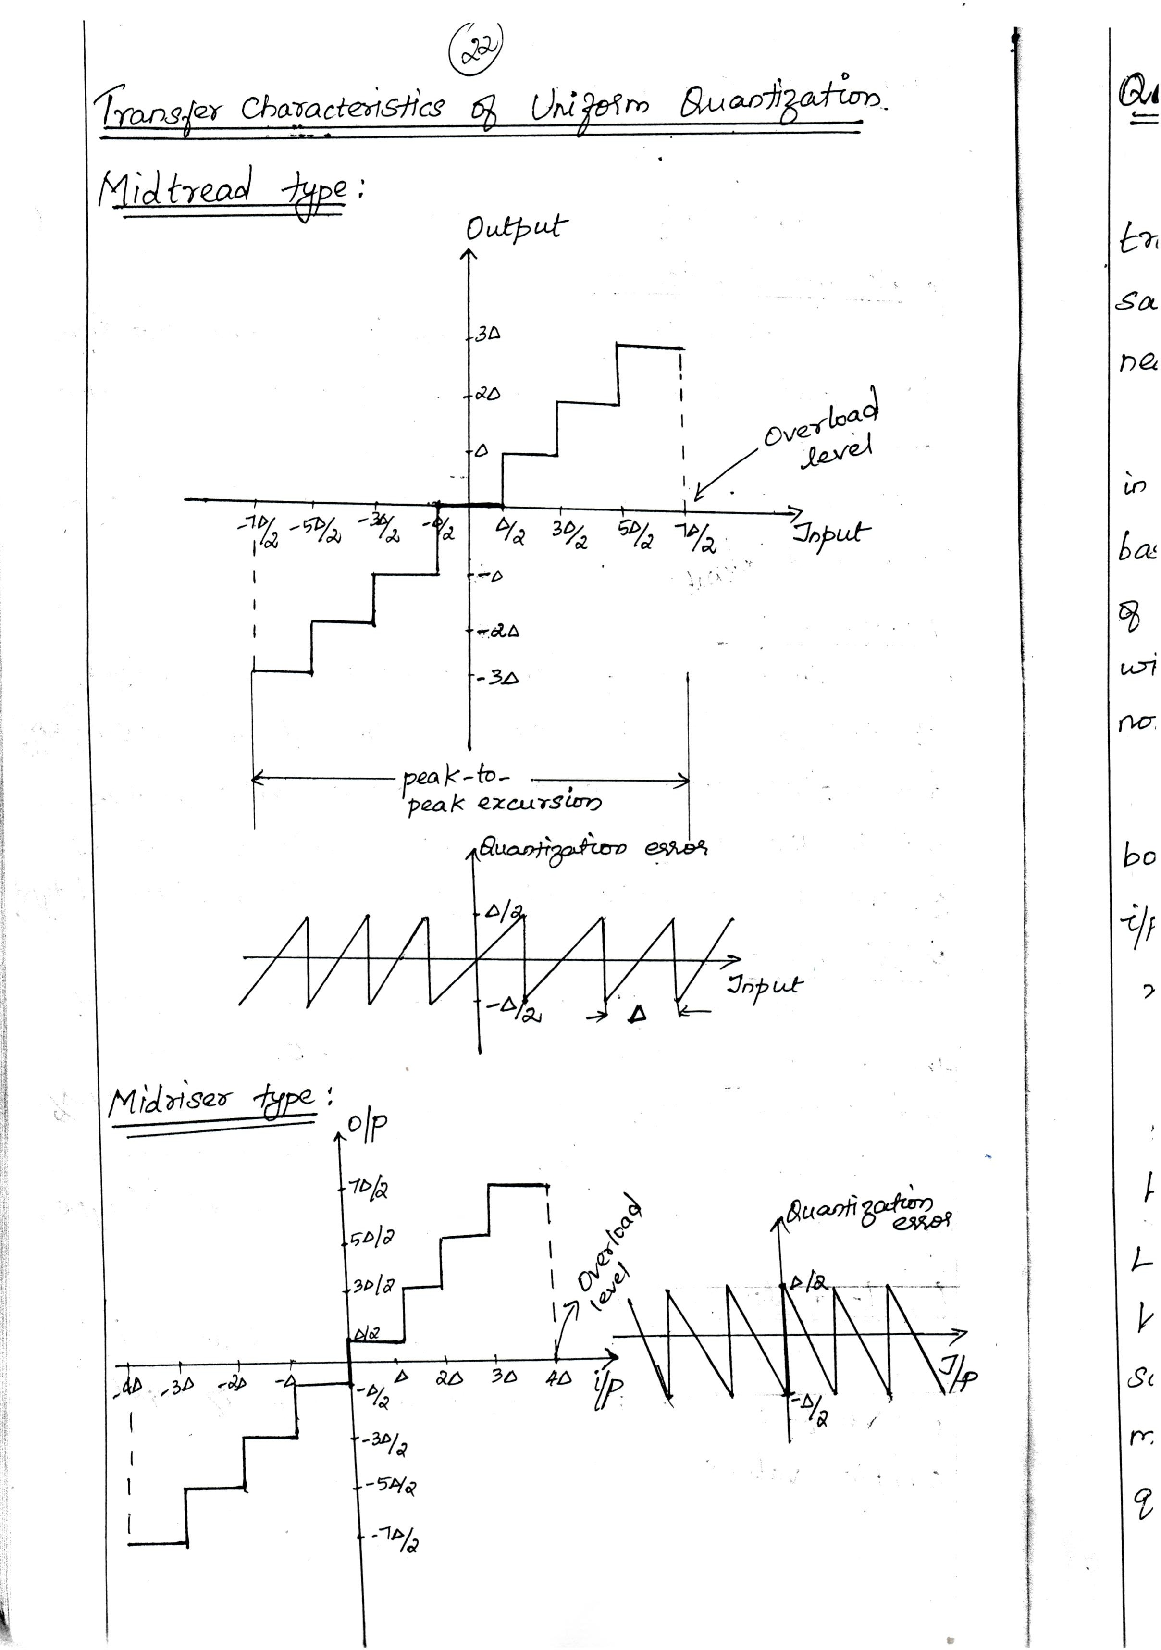Downloaded From : www.EasyEngineering.net

Downloaded From : www.EasyEngineering.net

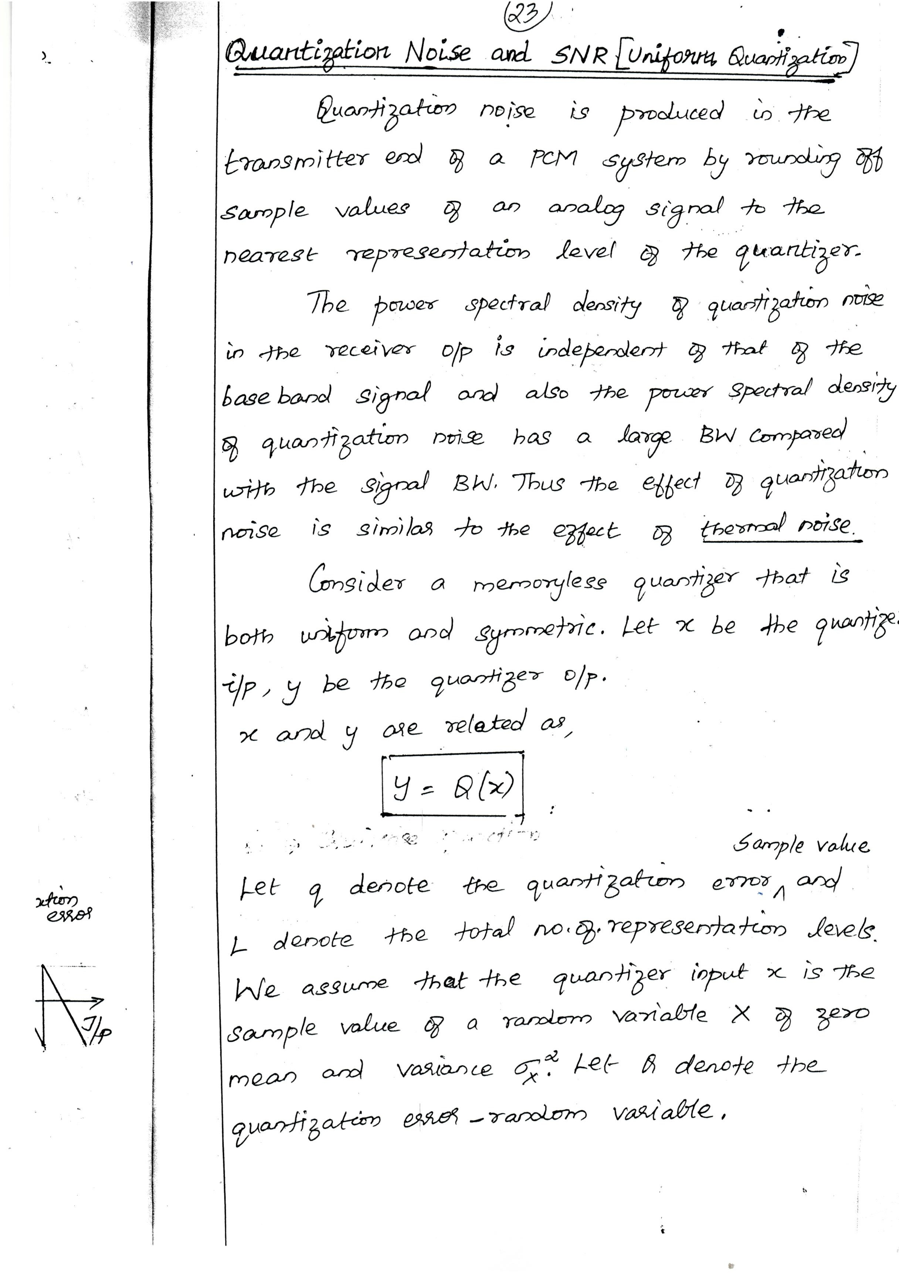Downloaded From : www.EasyEngineering.net

Downloaded From : www.EasyEngineering.net

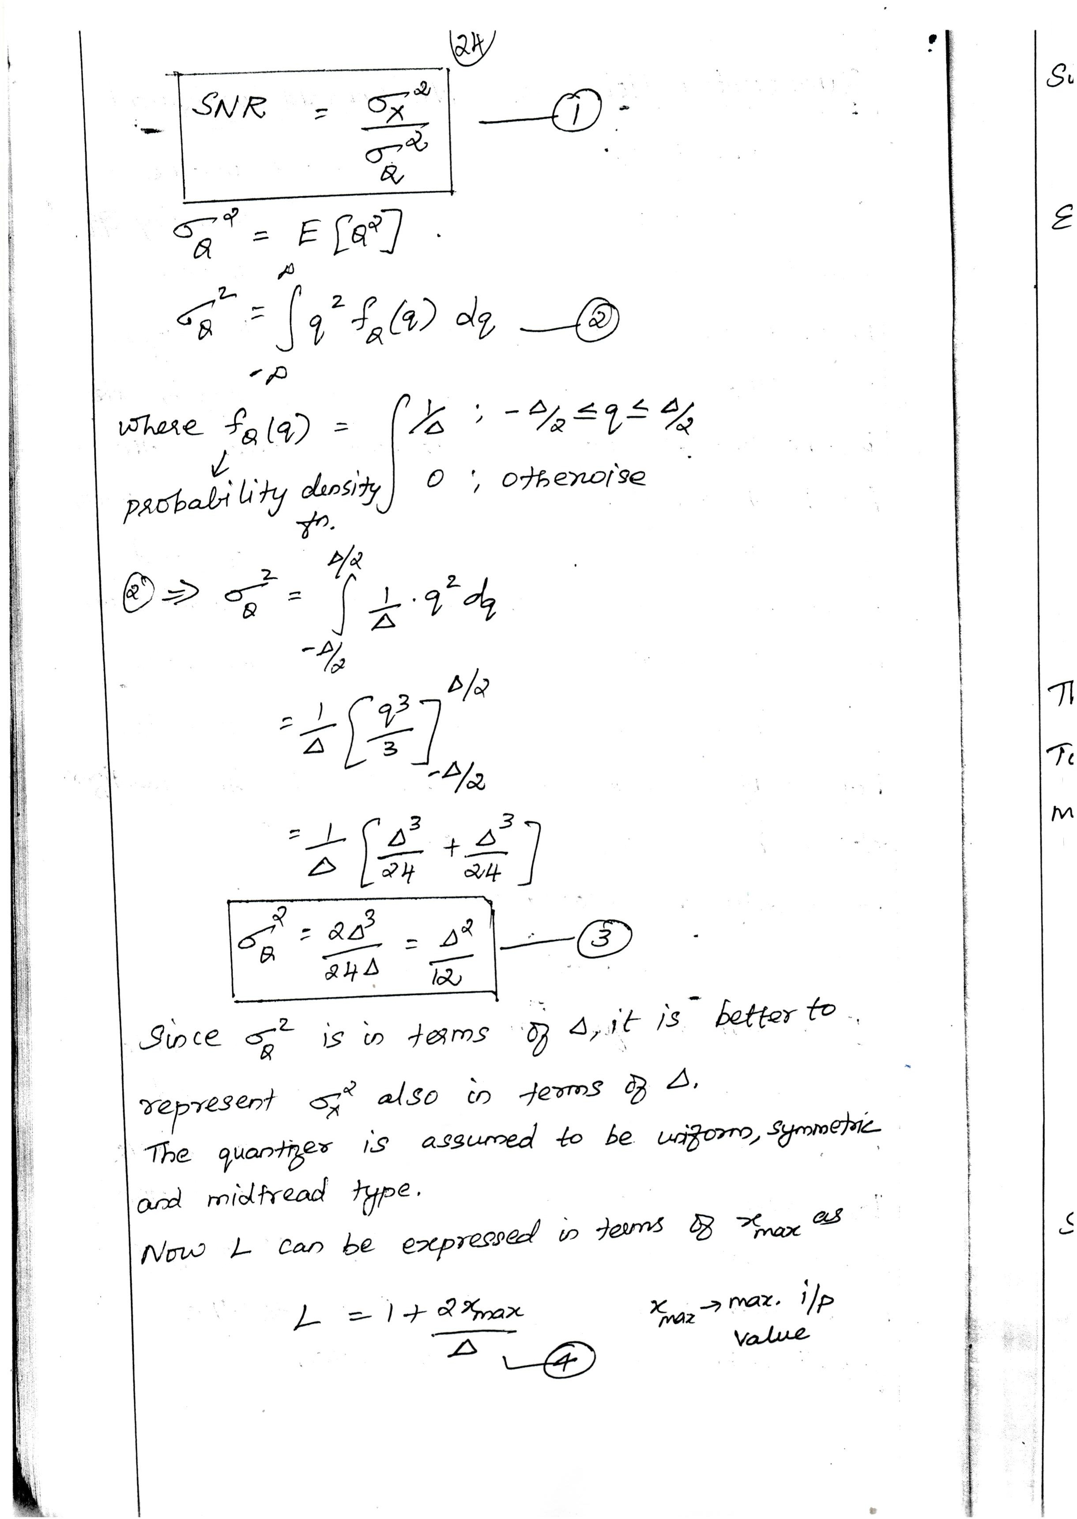Downloaded From : www.EasyEngineering.net

Downloaded From : www.EasyEngineering.net

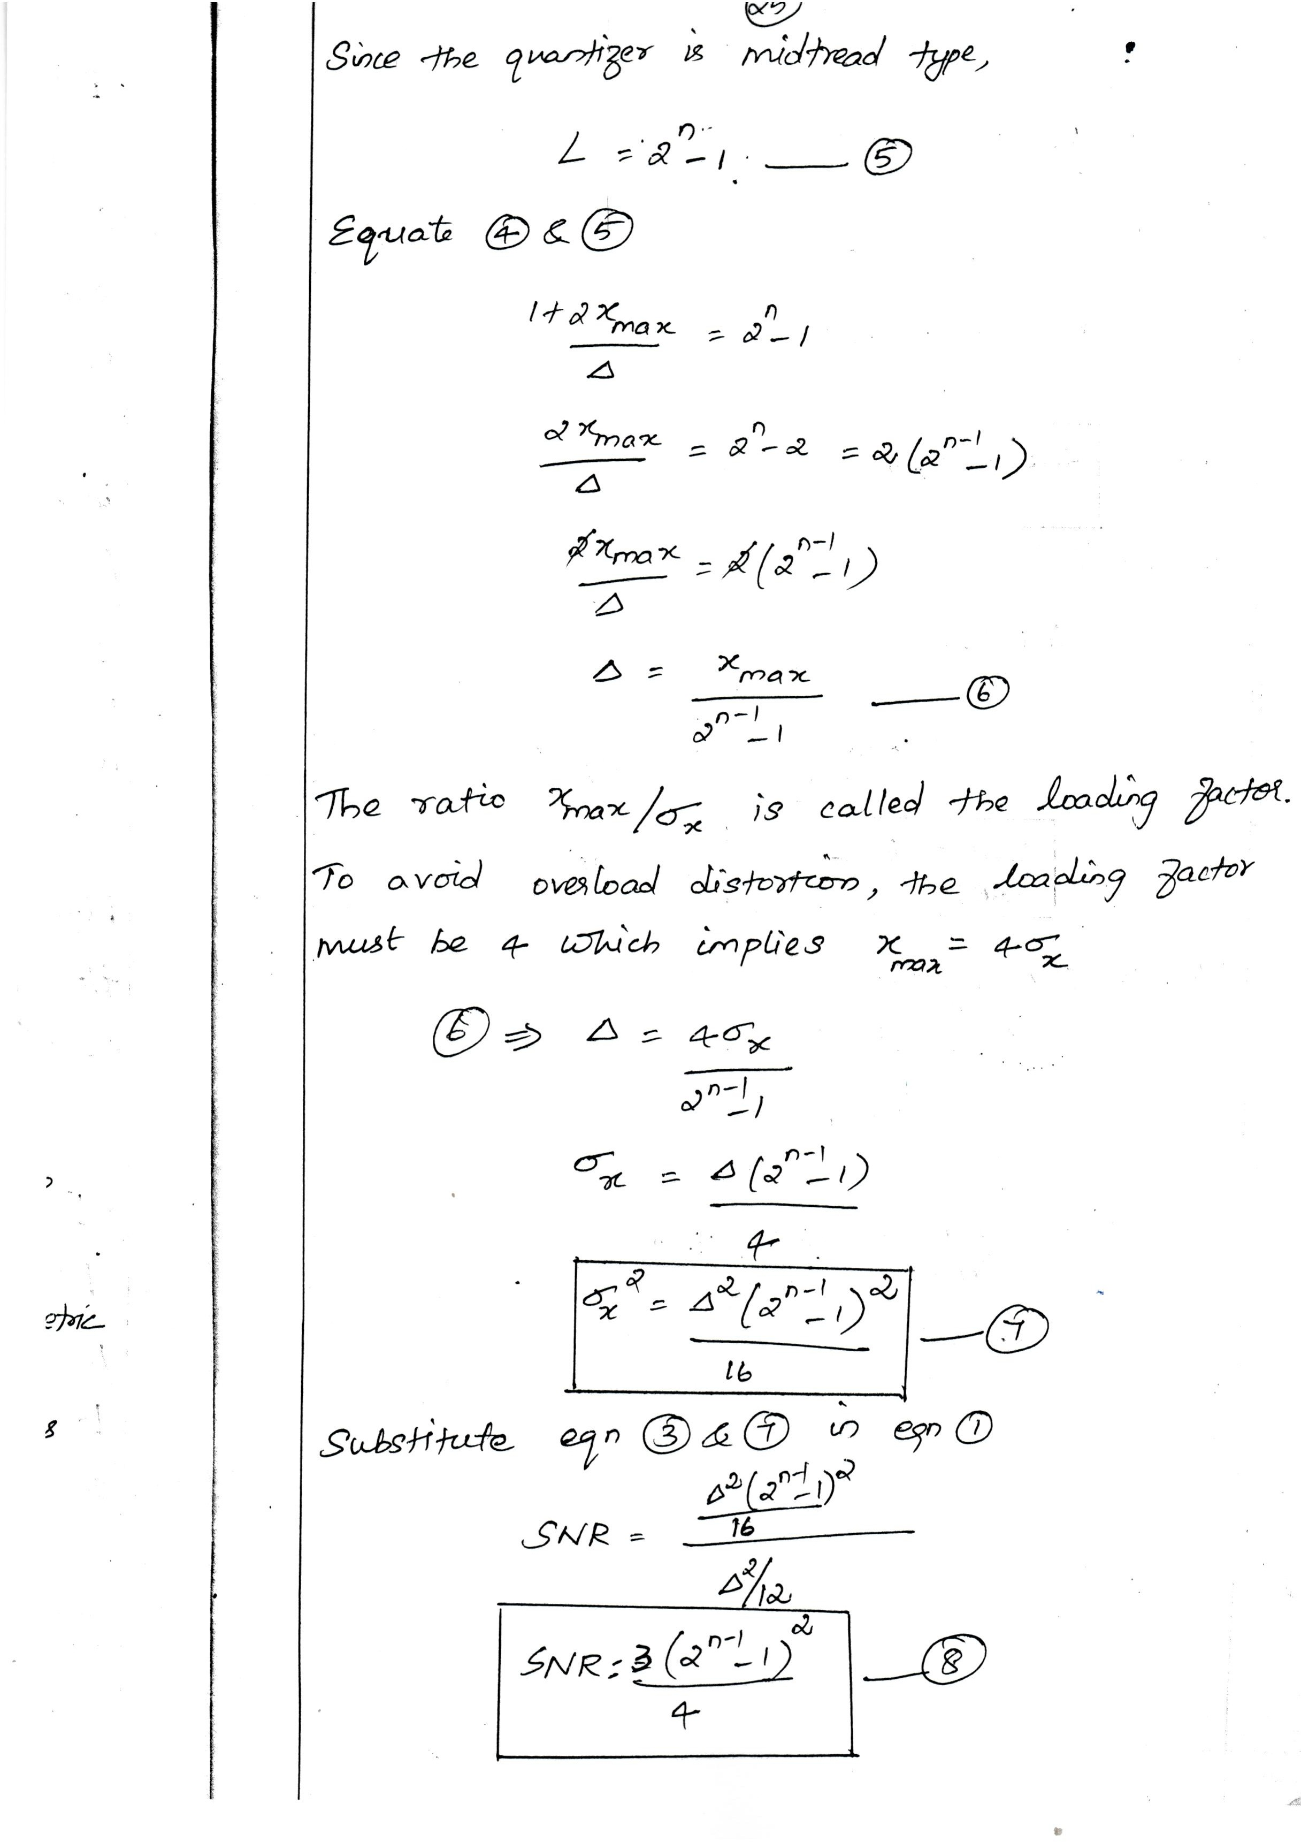Downloaded From : www.EasyEngineering.net

Downloaded From : www.EasyEngineering.net

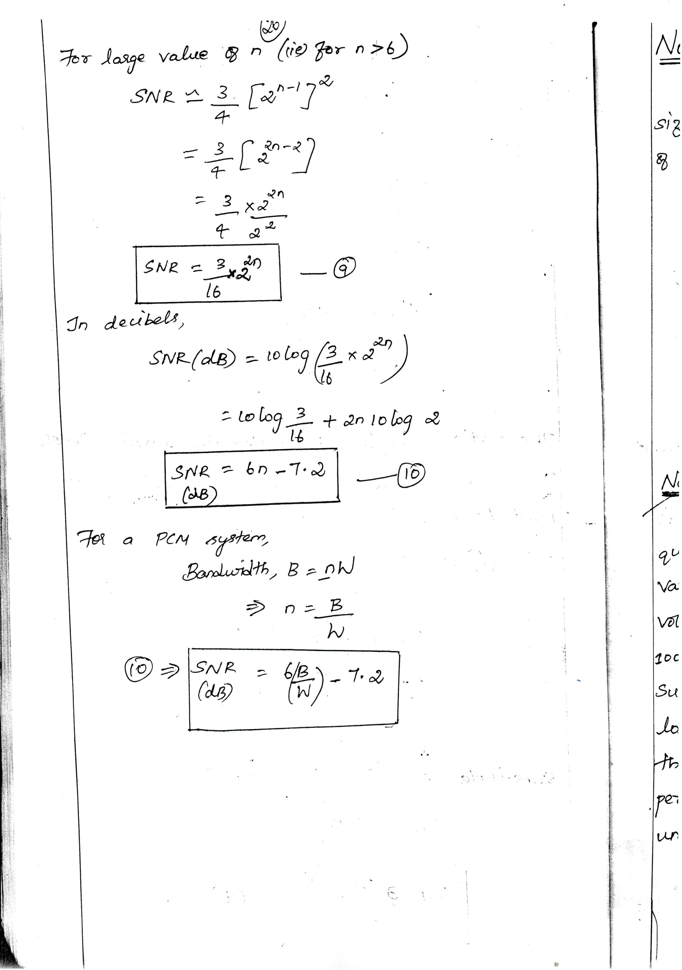Downloaded From : www.EasyEngineering.net

Downloaded From : www.EasyEngineering.net

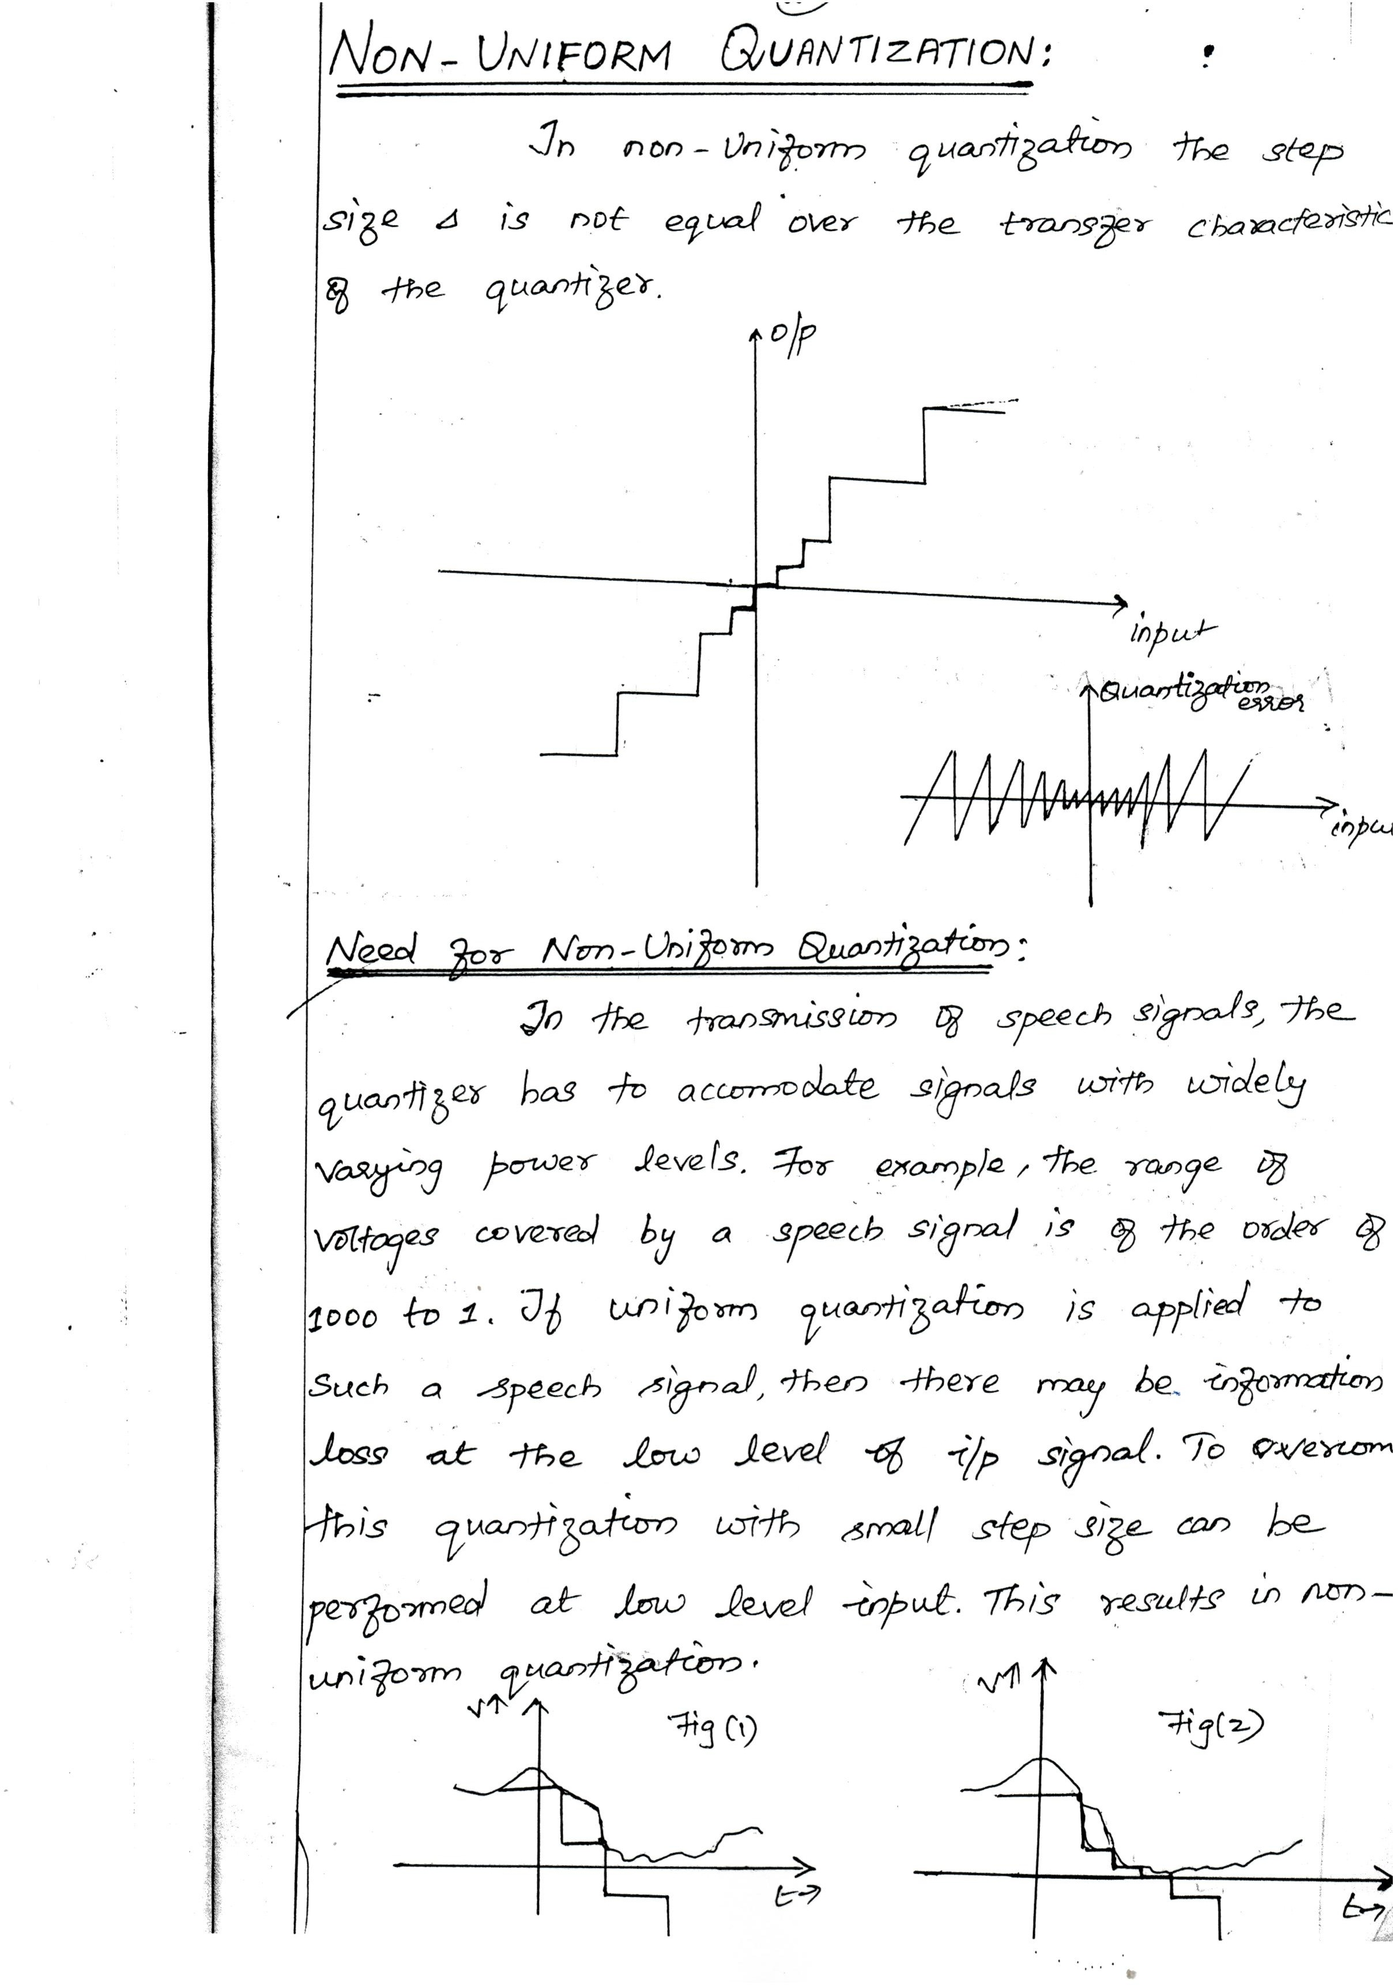Downloaded From : www.EasyEngineering.net

Downloaded From : www.EasyEngineering.net

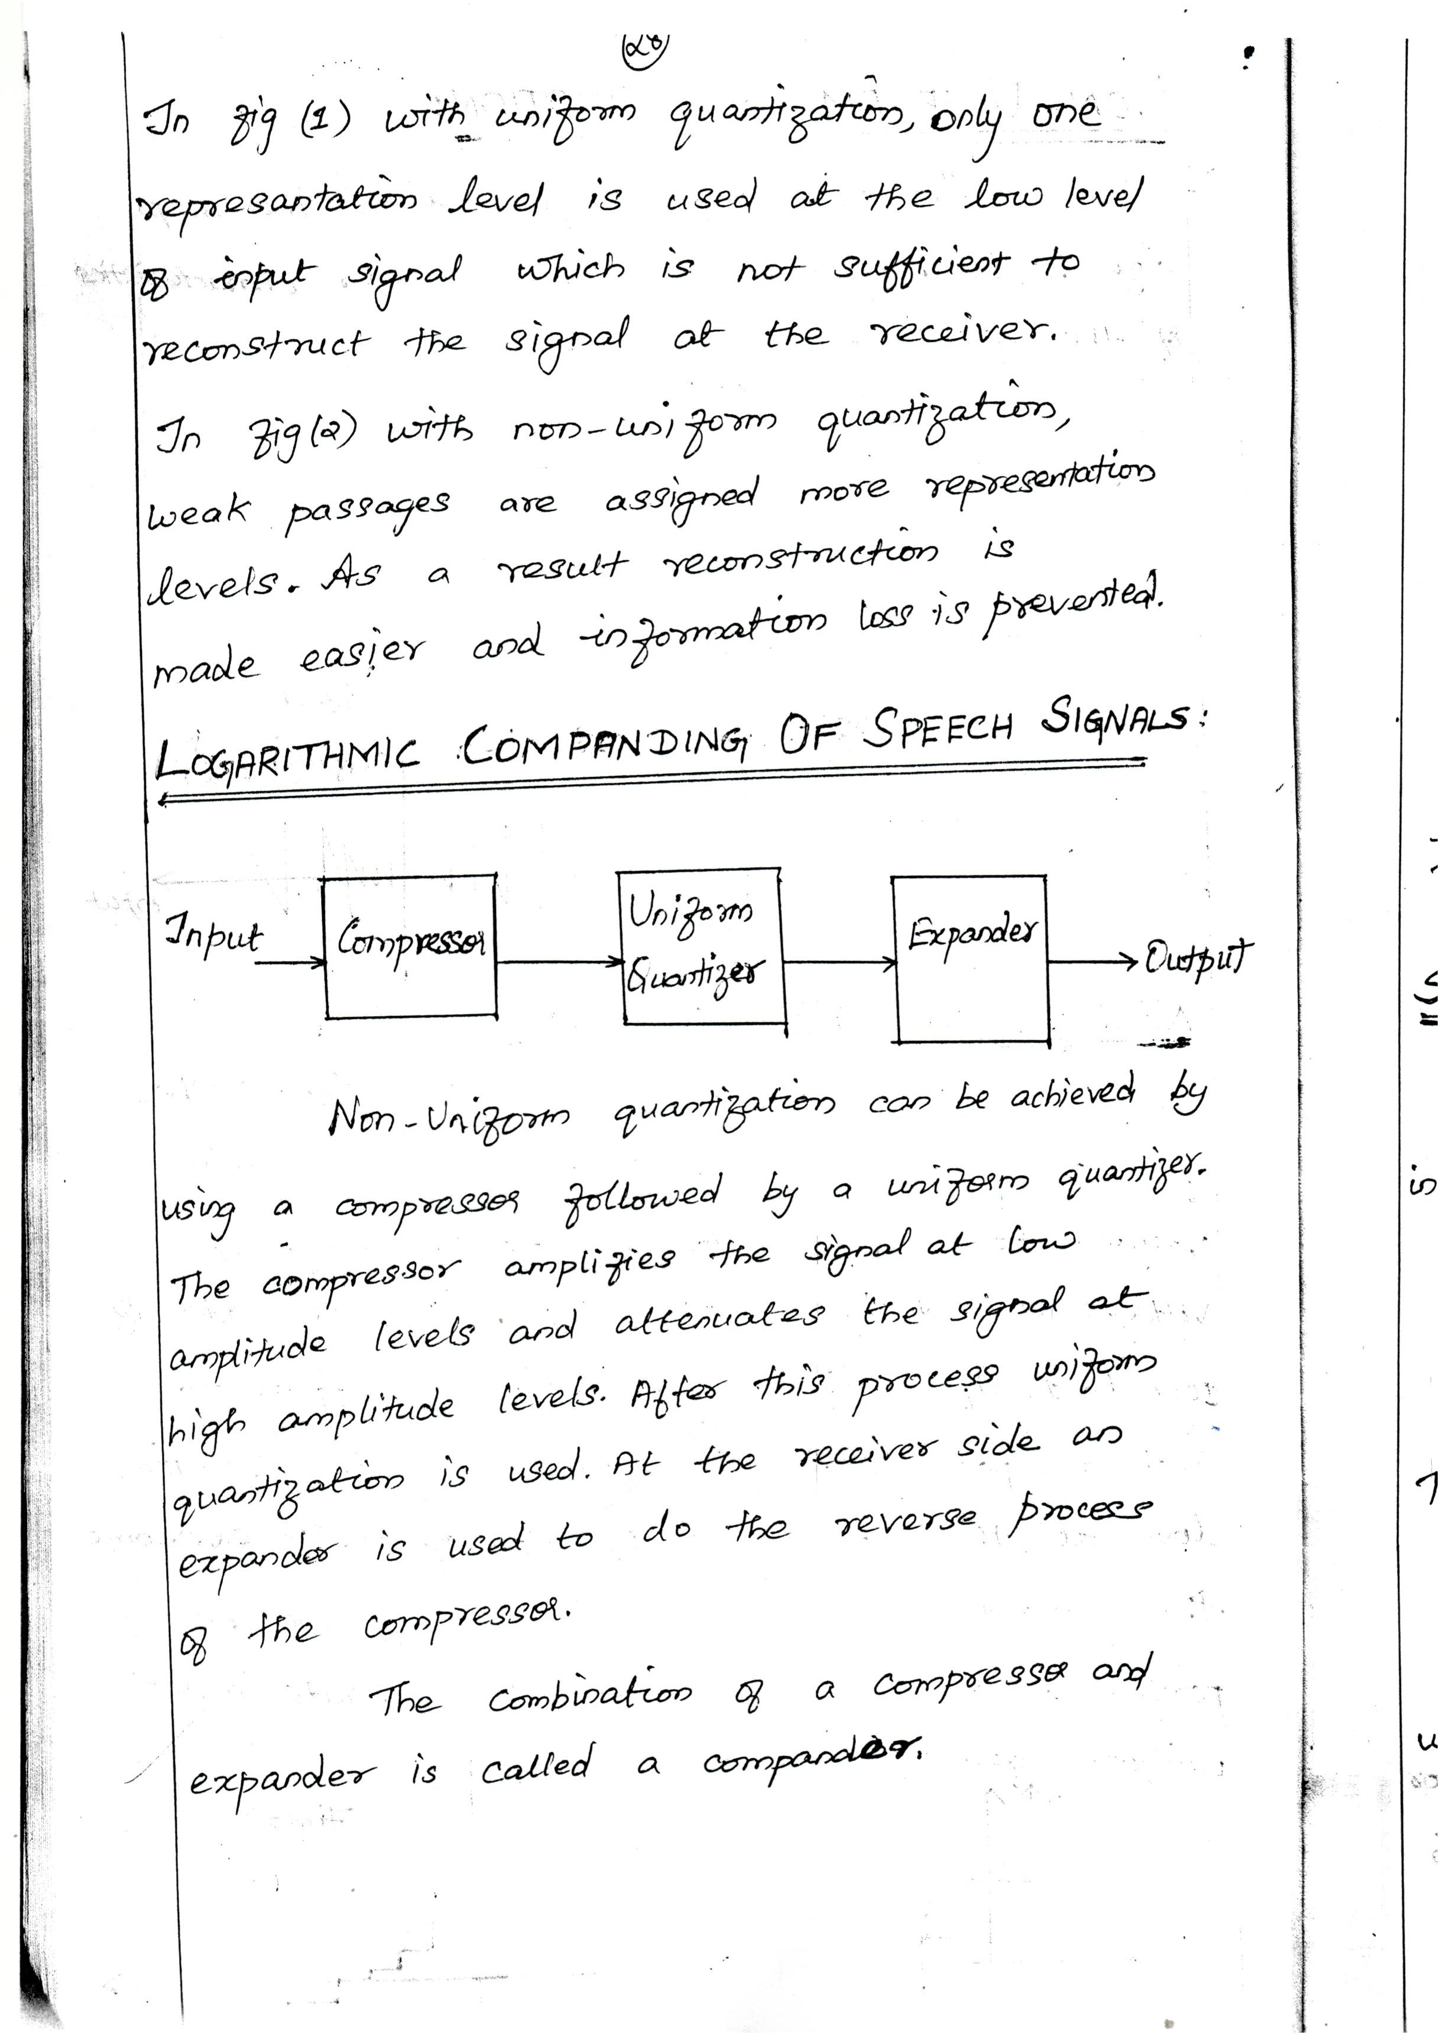Downloaded From : www.EasyEngineering.net

Downloaded From : www.EasyEngineering.net

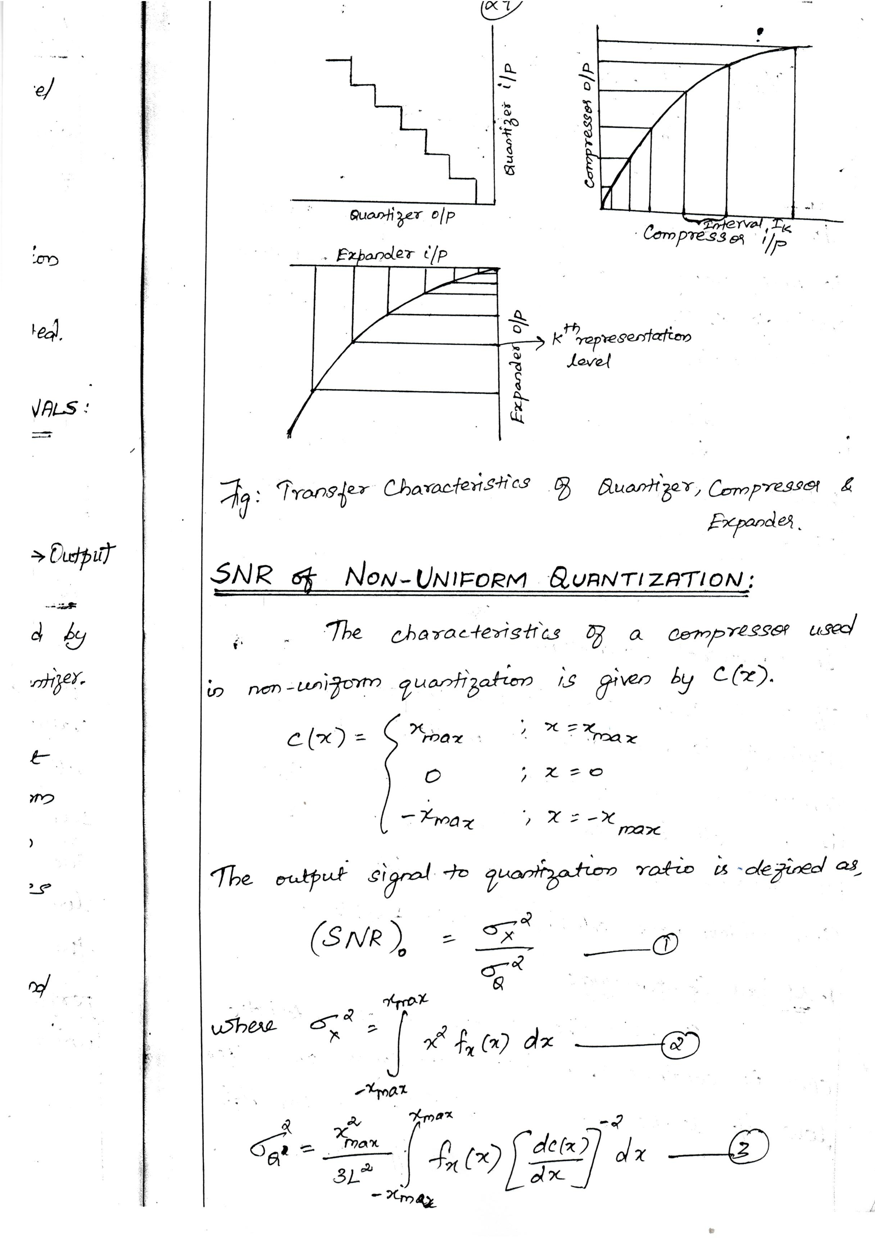Downloaded From : www.EasyEngineering.net

Downloaded From : www.EasyEngineering.net

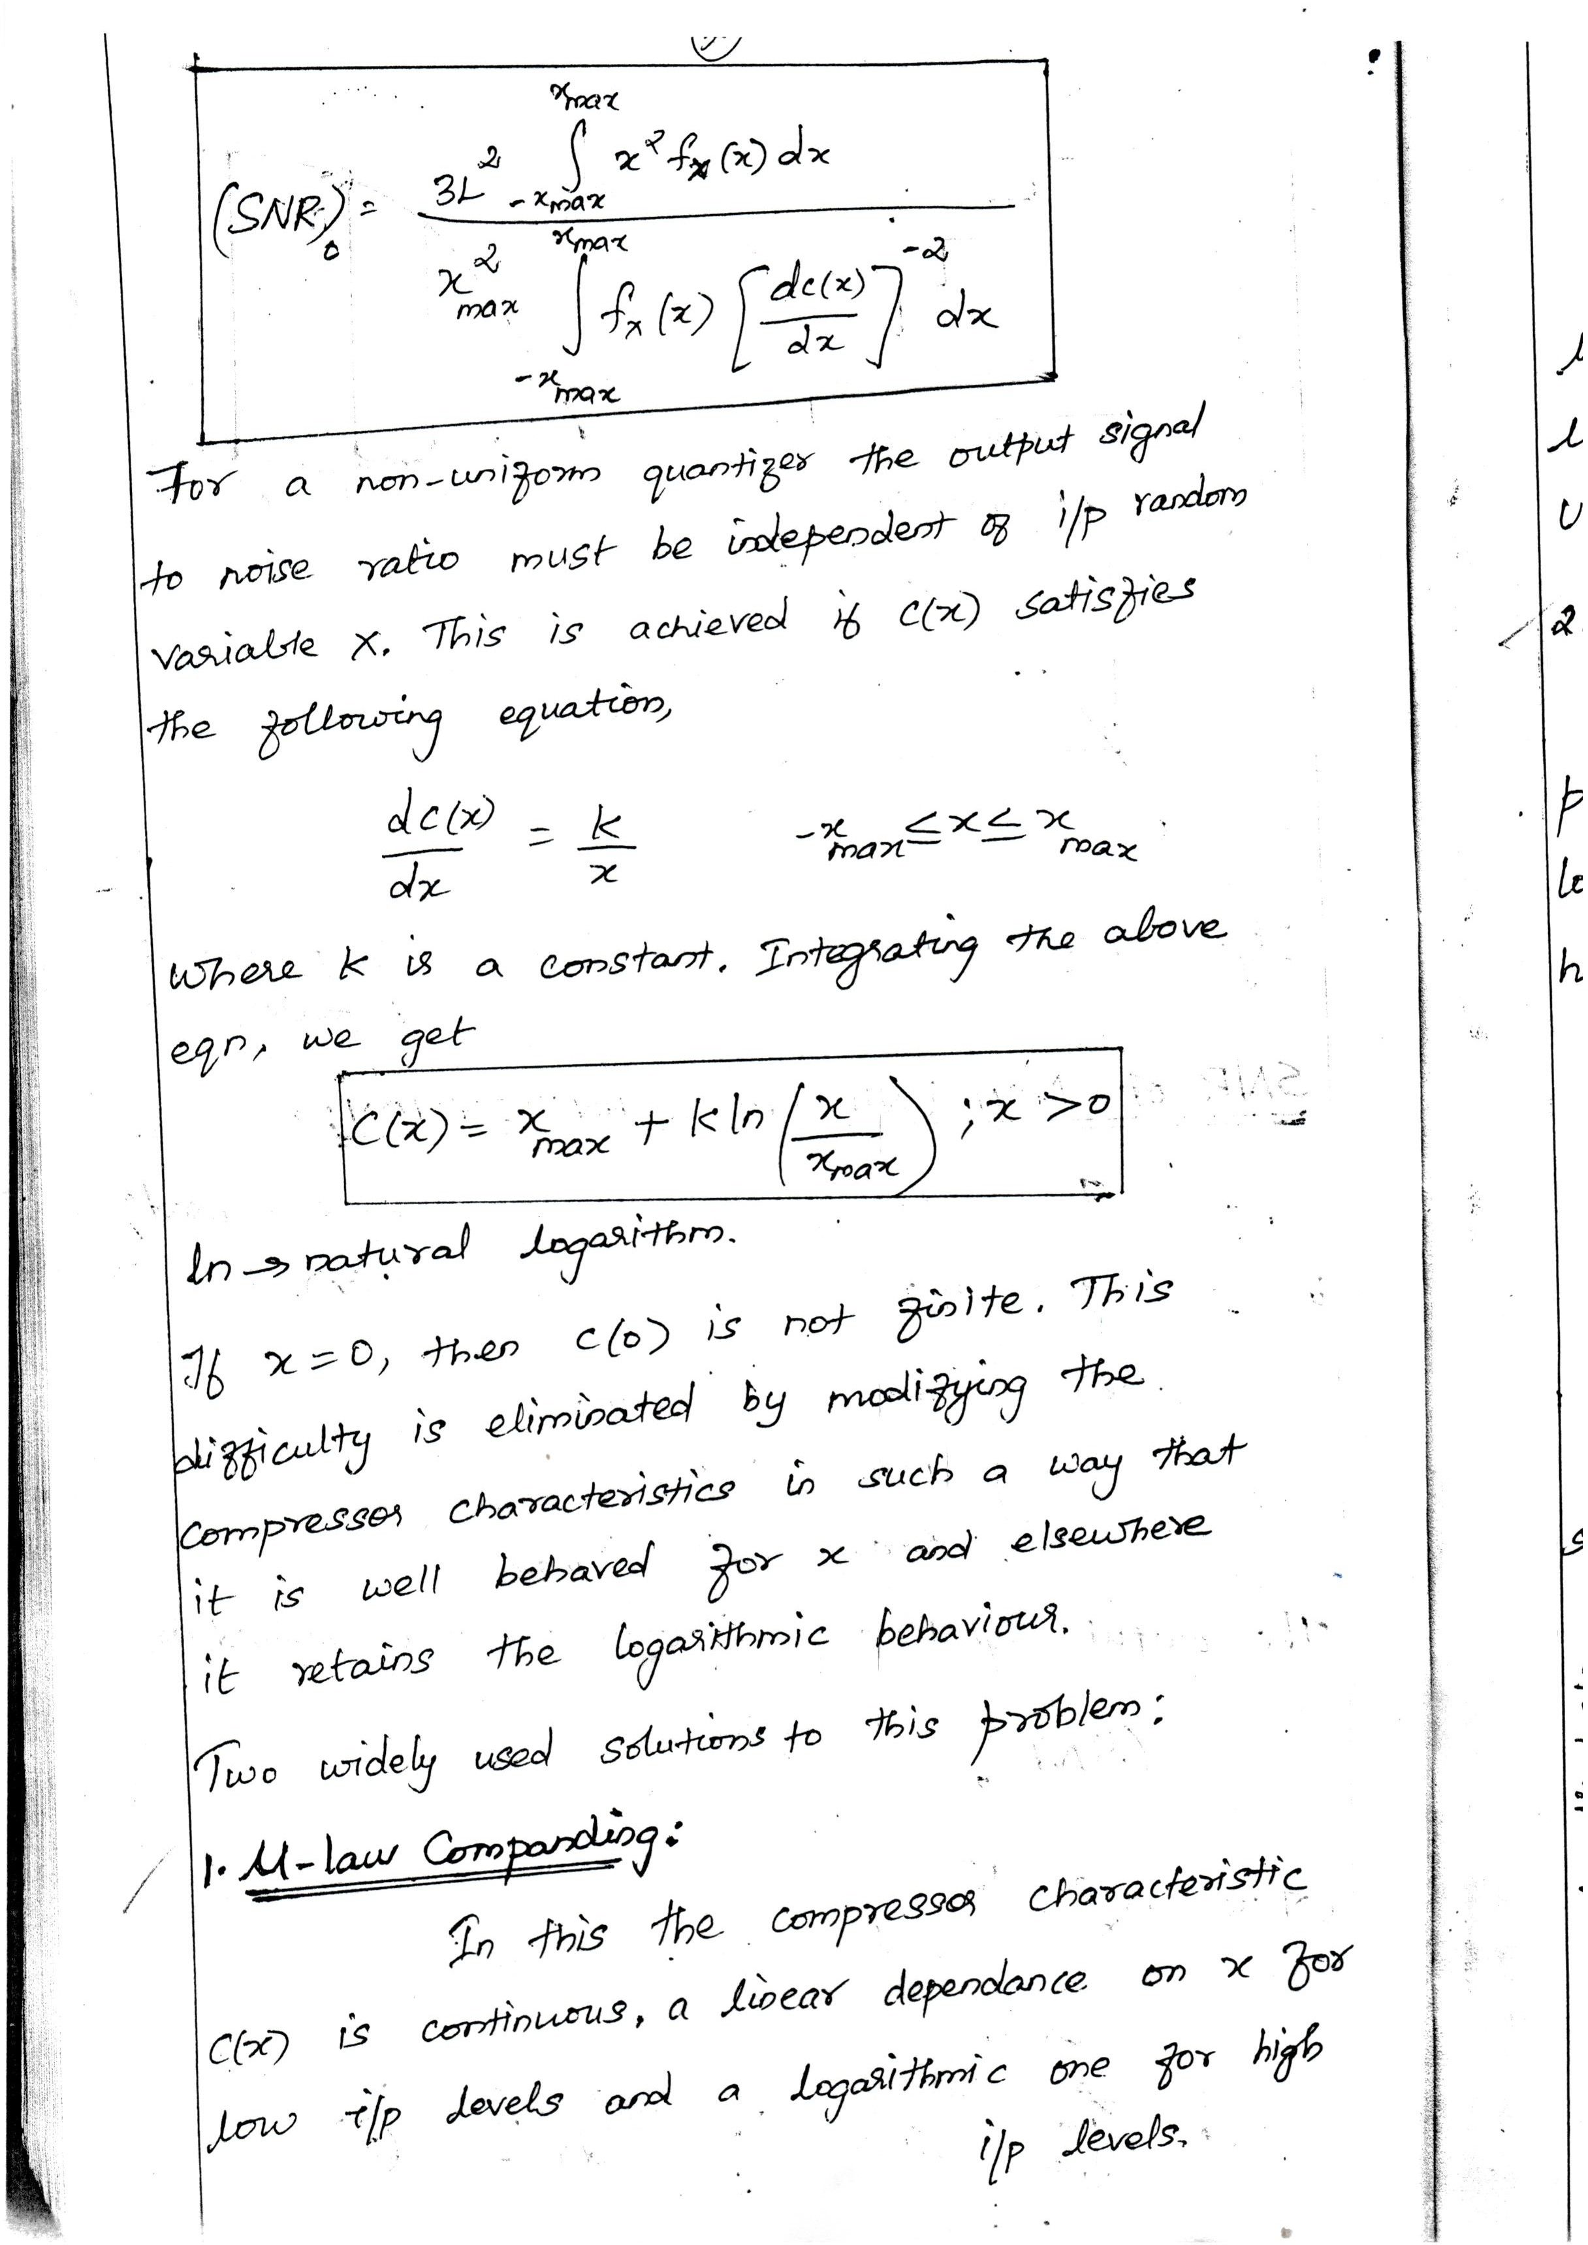Downloaded From : www.EasyEngineering.net

Downloaded From : www.EasyEngineering.net

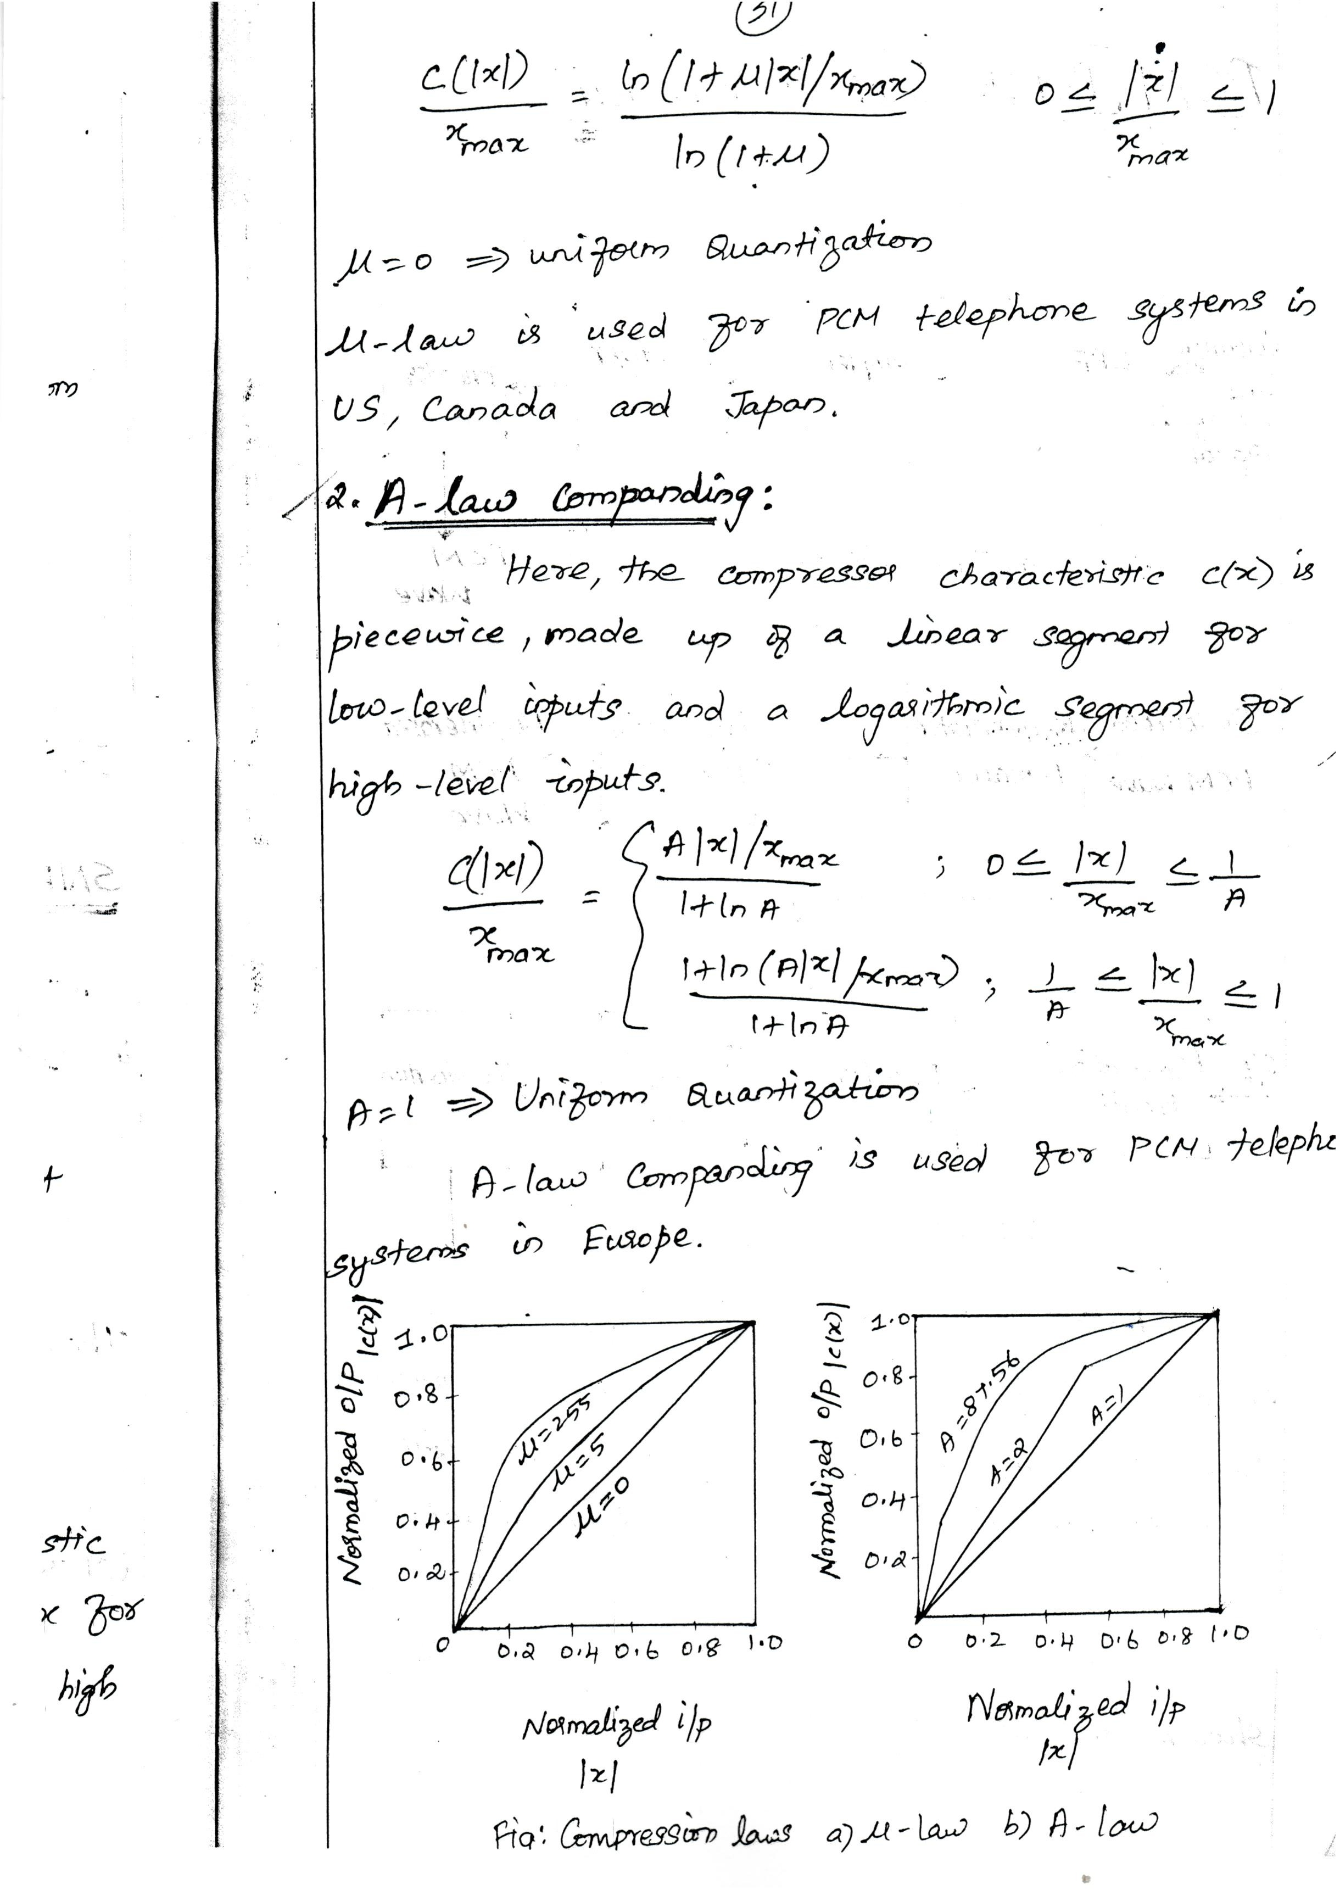Downloaded From : www.EasyEngineering.net

Downloaded From : www.EasyEngineering.net

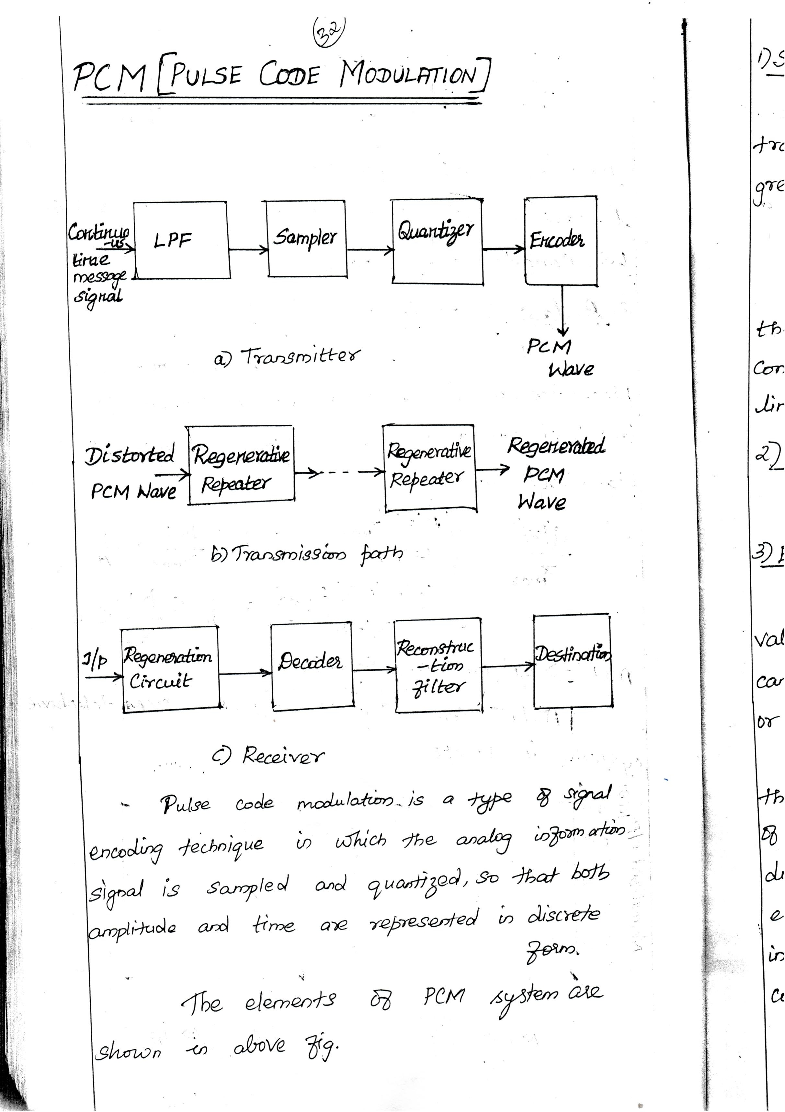Downloaded From : www.EasyEngineering.net

Downloaded From : www.EasyEngineering.net

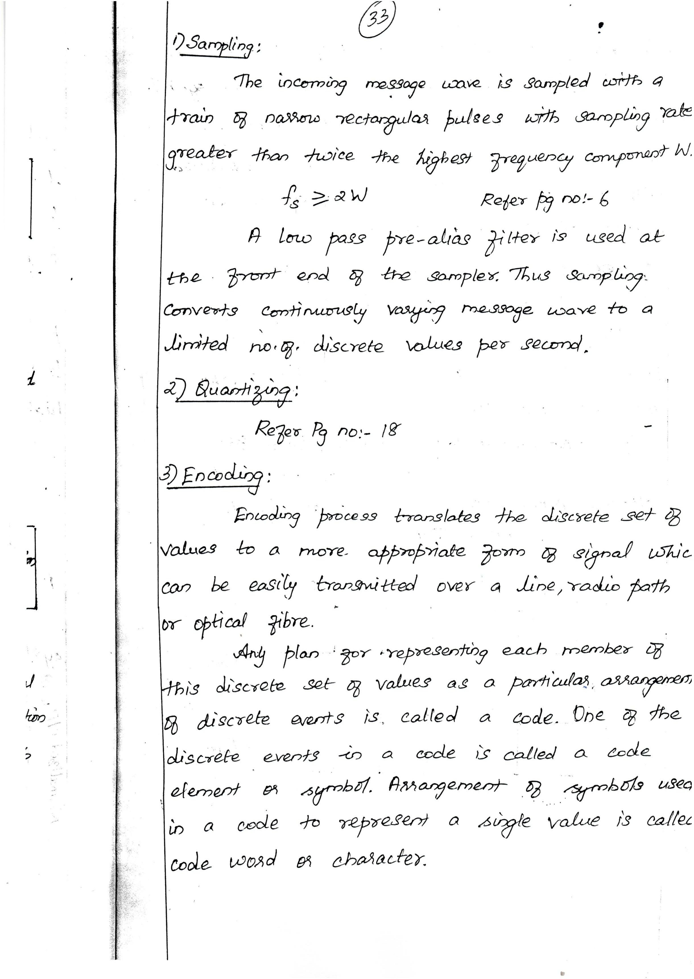Downloaded From : www.EasyEngineering.net

Downloaded From : www.EasyEngineering.net

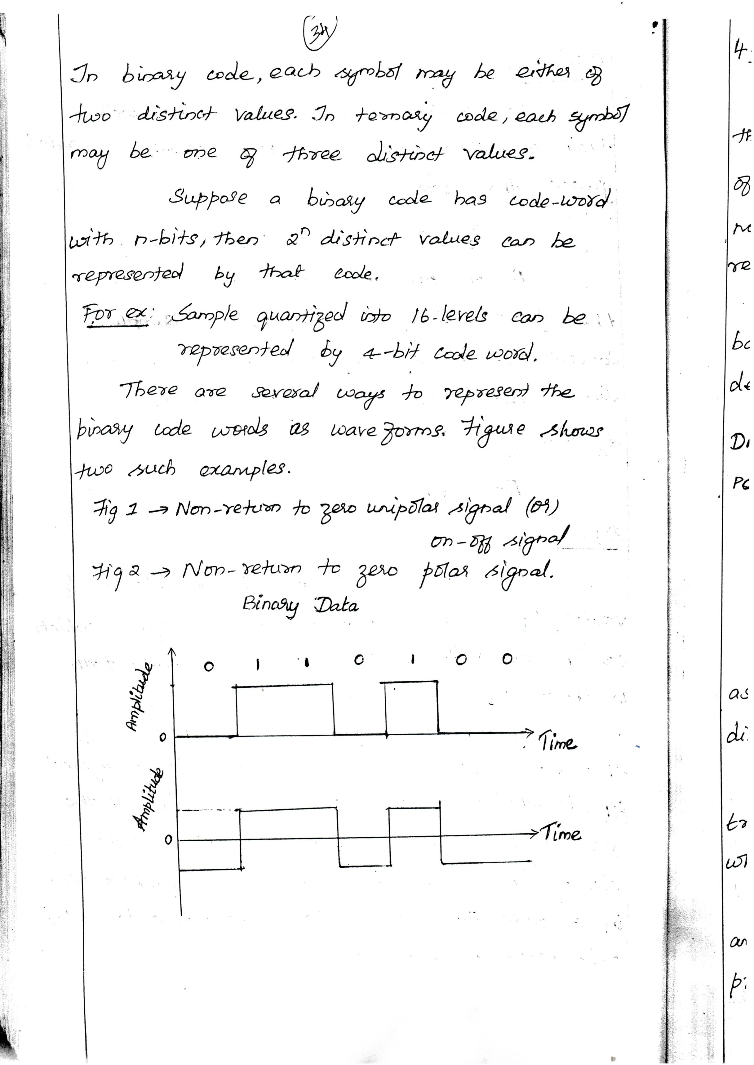Downloaded From : www.EasyEngineering.net

Downloaded From : www.EasyEngineering.net

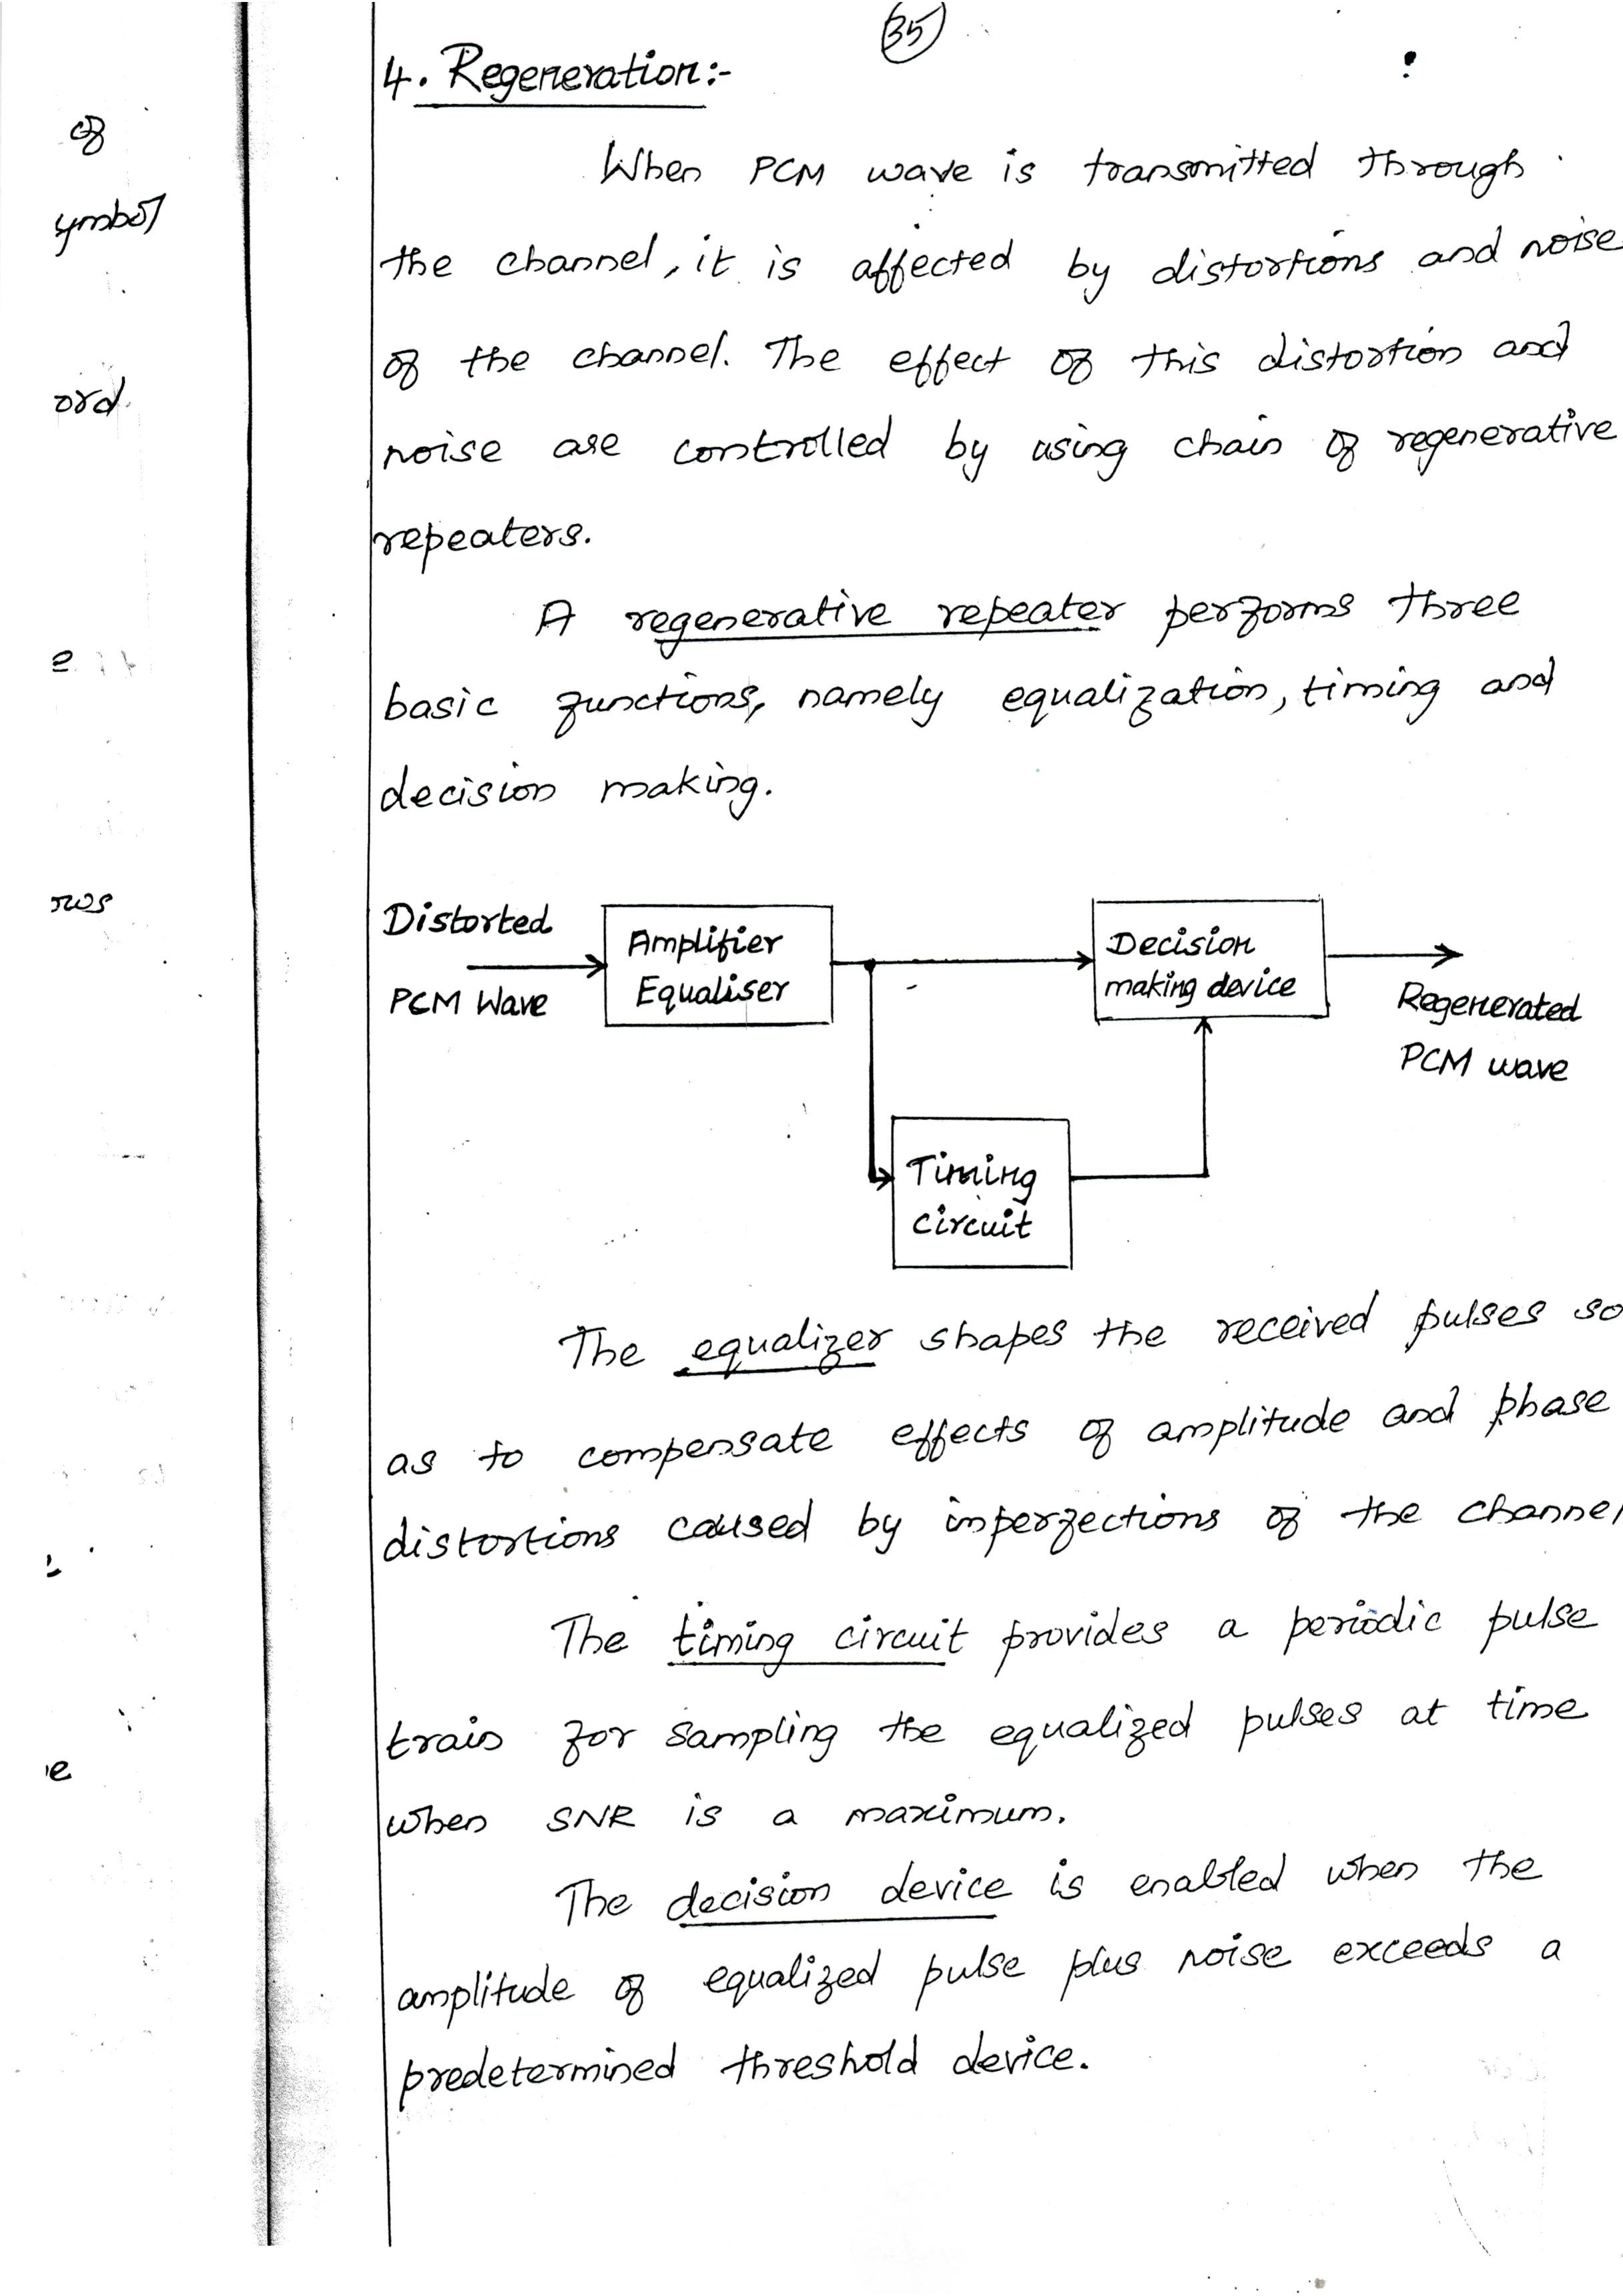Downloaded From : www.EasyEngineering.net

Downloaded From : www.EasyEngineering.net

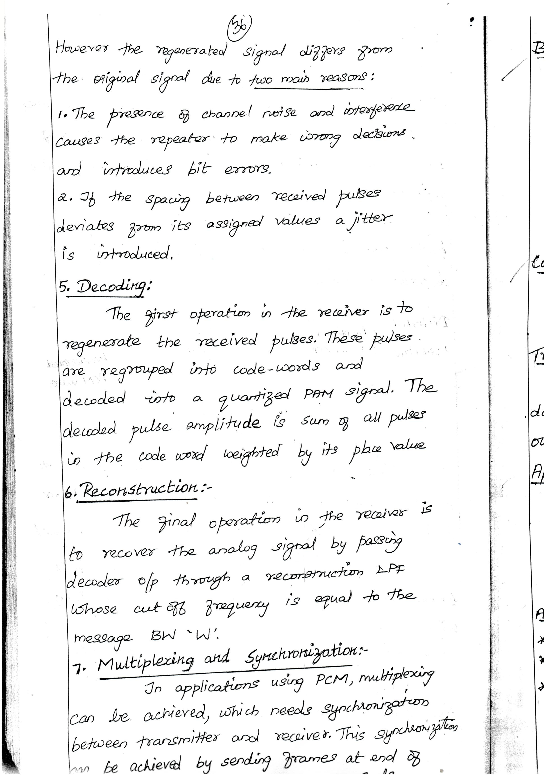Downloaded From : www.EasyEngineering.net

Downloaded From : www.EasyEngineering.net

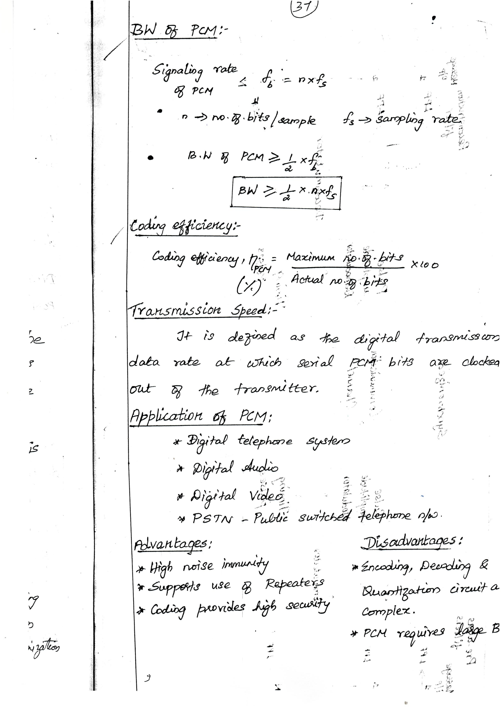Downloaded From : www.EasyEngineering.net

Downloaded From : www.EasyEngineering.net

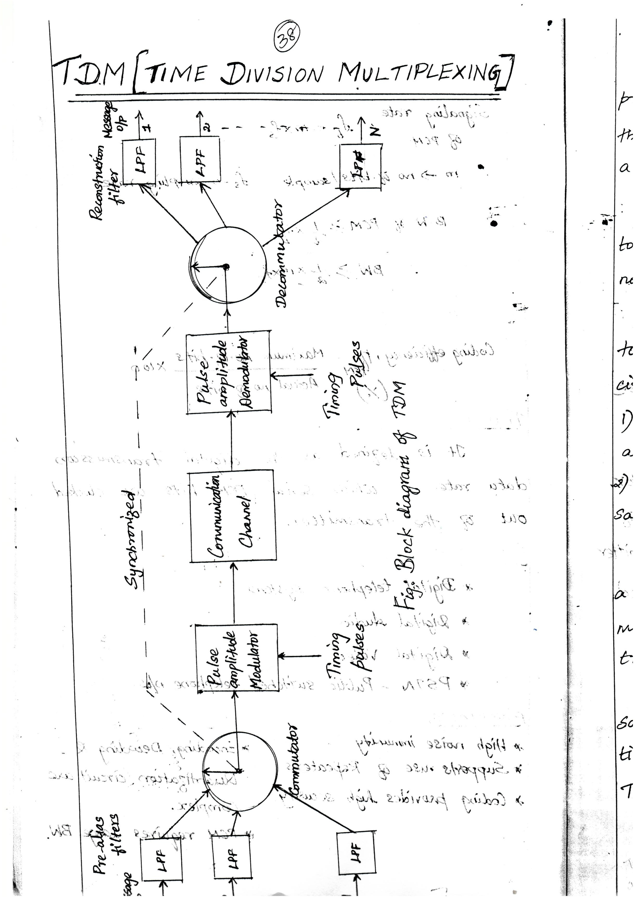Downloaded From : www.EasyEngineering.net

Downloaded From : www.EasyEngineering.net

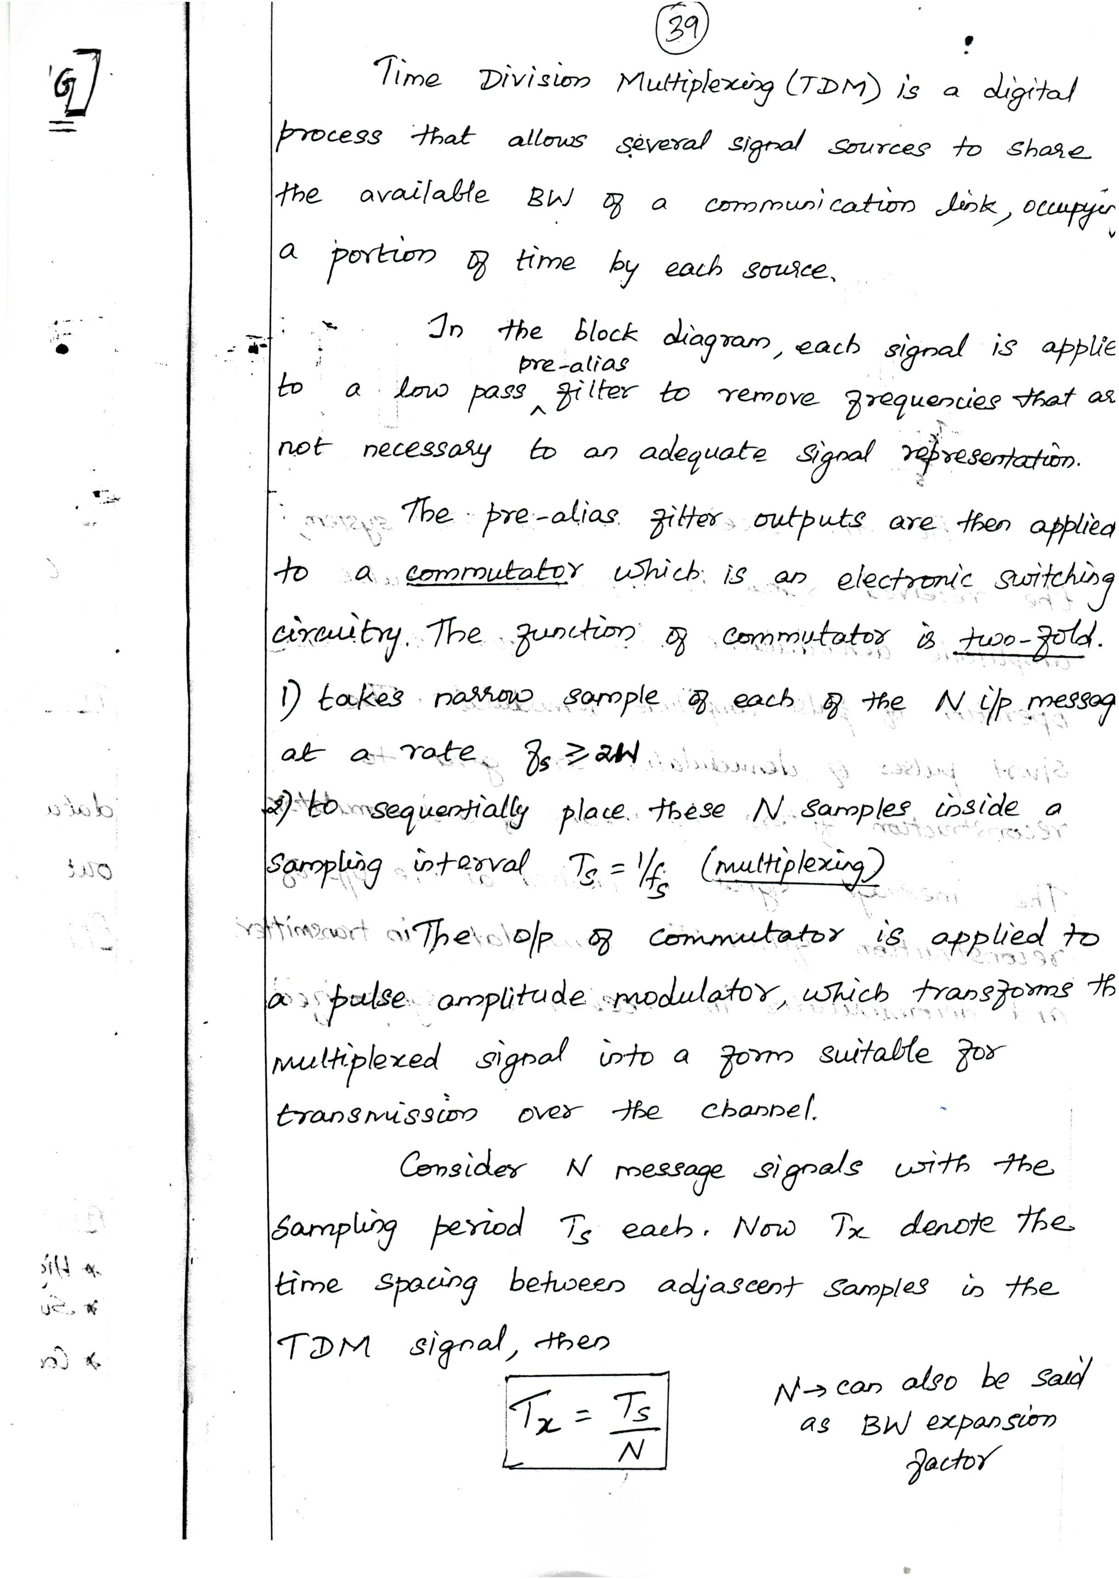Downloaded From : www.EasyEngineering.net

Downloaded From : www.EasyEngineering.net

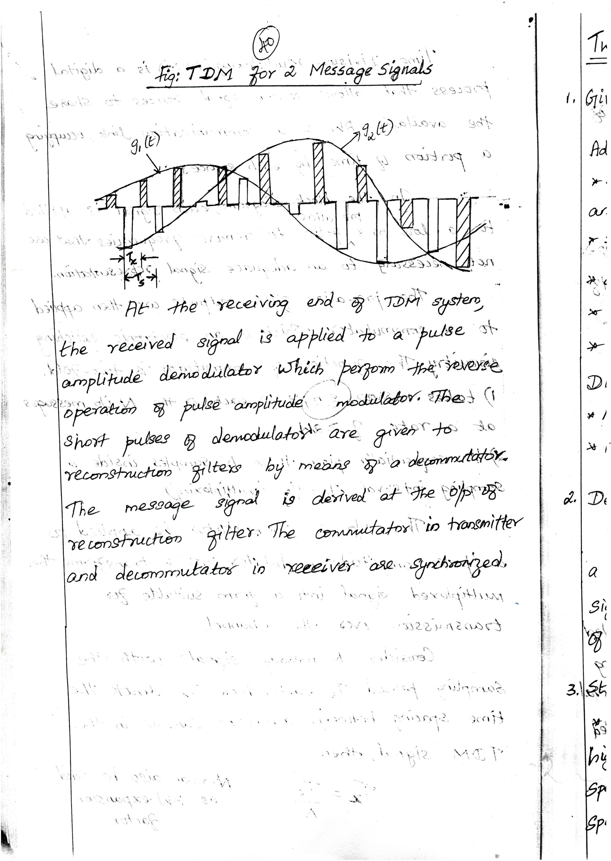Downloaded From : www.EasyEngineering.net

Downloaded From : www.EasyEngineering.net

